NOVELS

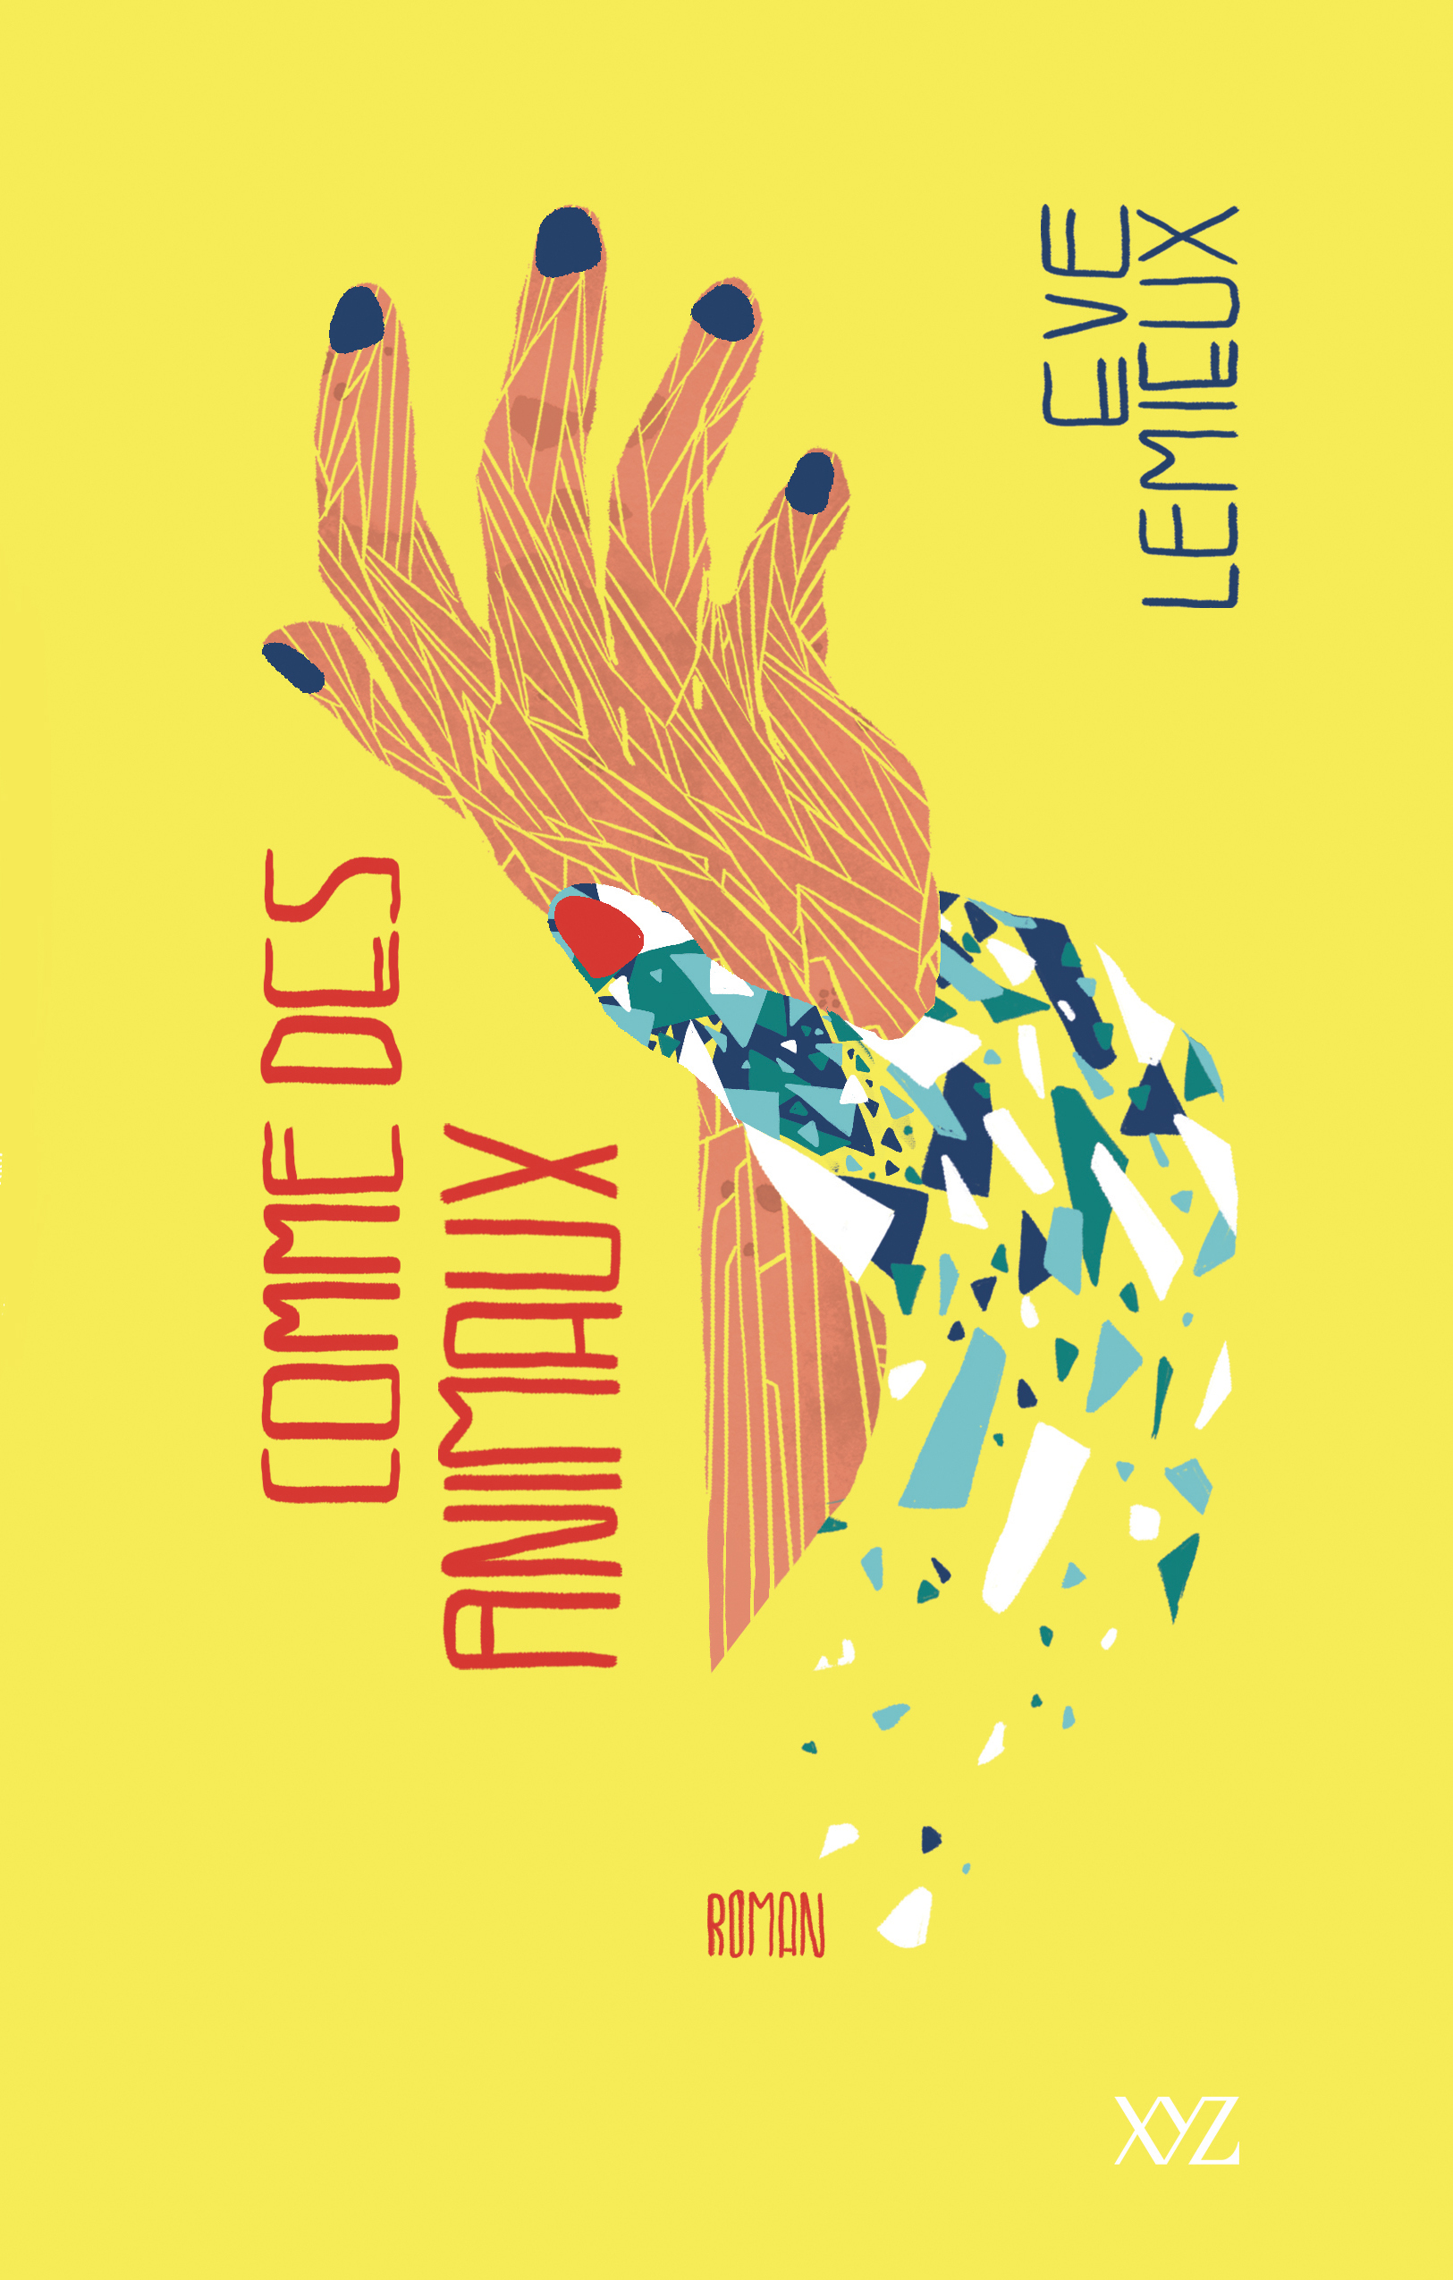
Like Beasts
Ève Lemieux
Publication: September 2019
* Preliminary manuscript available *
Rights available : World

The modern tale of a heroine brandishing her trashy lust for life and her emotional dependency like a torch, at the risk of letting it consume her.

Crude and sharp, the language in Like Beasts isn’t trying to please and doesn’t go in for subtleties: it hits, it hurts, it treats tenderness with contempt. Like her narration, Philomène Flynn doesn’t know softness or restraint. Will the young artist, shaped by the violence of life and love, learn to be with gentle Raphaël, who has the terrible flaw of not being cruel?

Like Beasts is actress Eve Lemieux’s first novel.

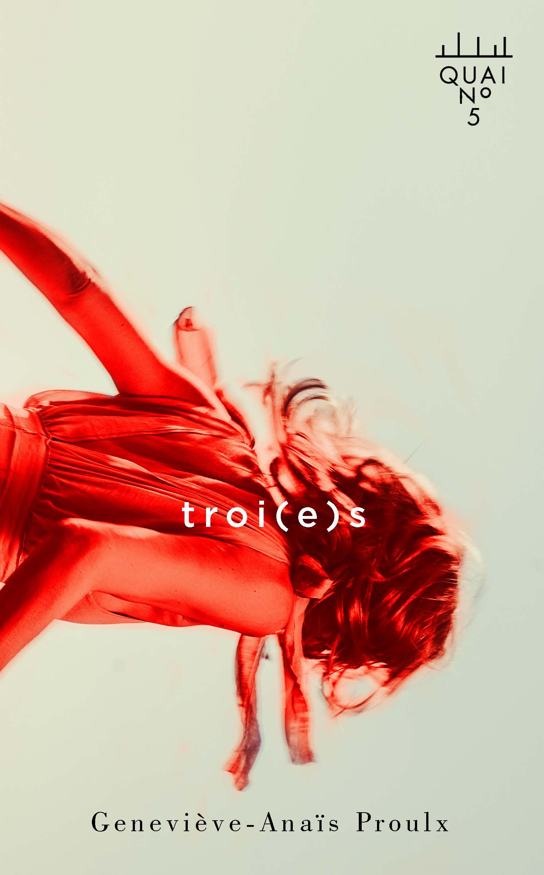
Modern Myths
Geneviève-Anaïs Proulx
Publication: September 2019
Rights available: World

A young woman, Eloïse, is stumbling between reality and legends. How long can you lose yourself in plural loves and impulses of greatness before falling for good?

Eloïse is in her twenties and thirsty for freedom and the absolute. With her friends-lovers Vali, Cassandre, Marika and Gabriel, she refuses the restrictions of the everyday and the slow asphyxia of the ordinary, preferring the exuberance and the imagery of ancient myths. Charged with burning erotism, their story is a contemporary love tragedy soothed by the murmurs of the river Styx.

A promising first novel from a new author.

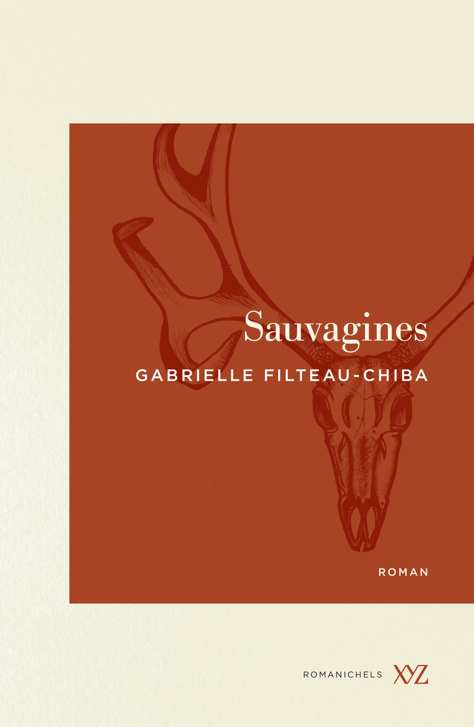
The Wild Ones
Gabrielle Filteau-Chiba
Publication: October 2019
* Preliminary manuscript available *
Rights available: World

The tense yet poetic tale of two women rising against the greed of men.

Anouk and Raphaëlle sought solitude in the woods of Kamouraska, Quebec, one to write, one for the company of animals, which she prefers to that of humans.

United by the growing threat of a poacher, they will soon have to turn the man’s violent methods against him to protect the land they love and assure their own survival.

In 2018, Gabrielle Filteau-Chiba published her first novel, Trapped Inside, which is at its 3rd reprint, has been translated into Italian and was shortlisted for the Jovette-Bernier Literary Prize.

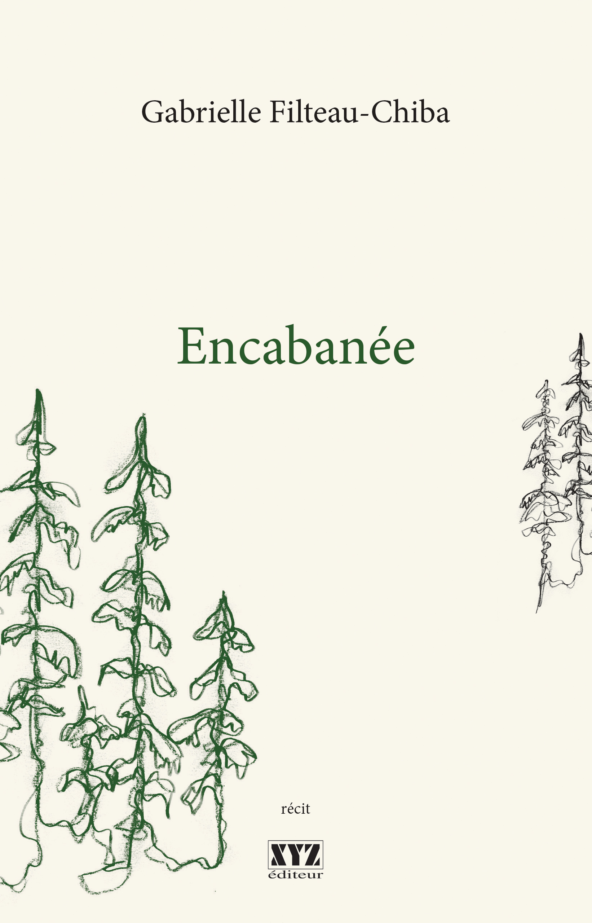

Rights sold : Italian (Lindau)

NOVELS

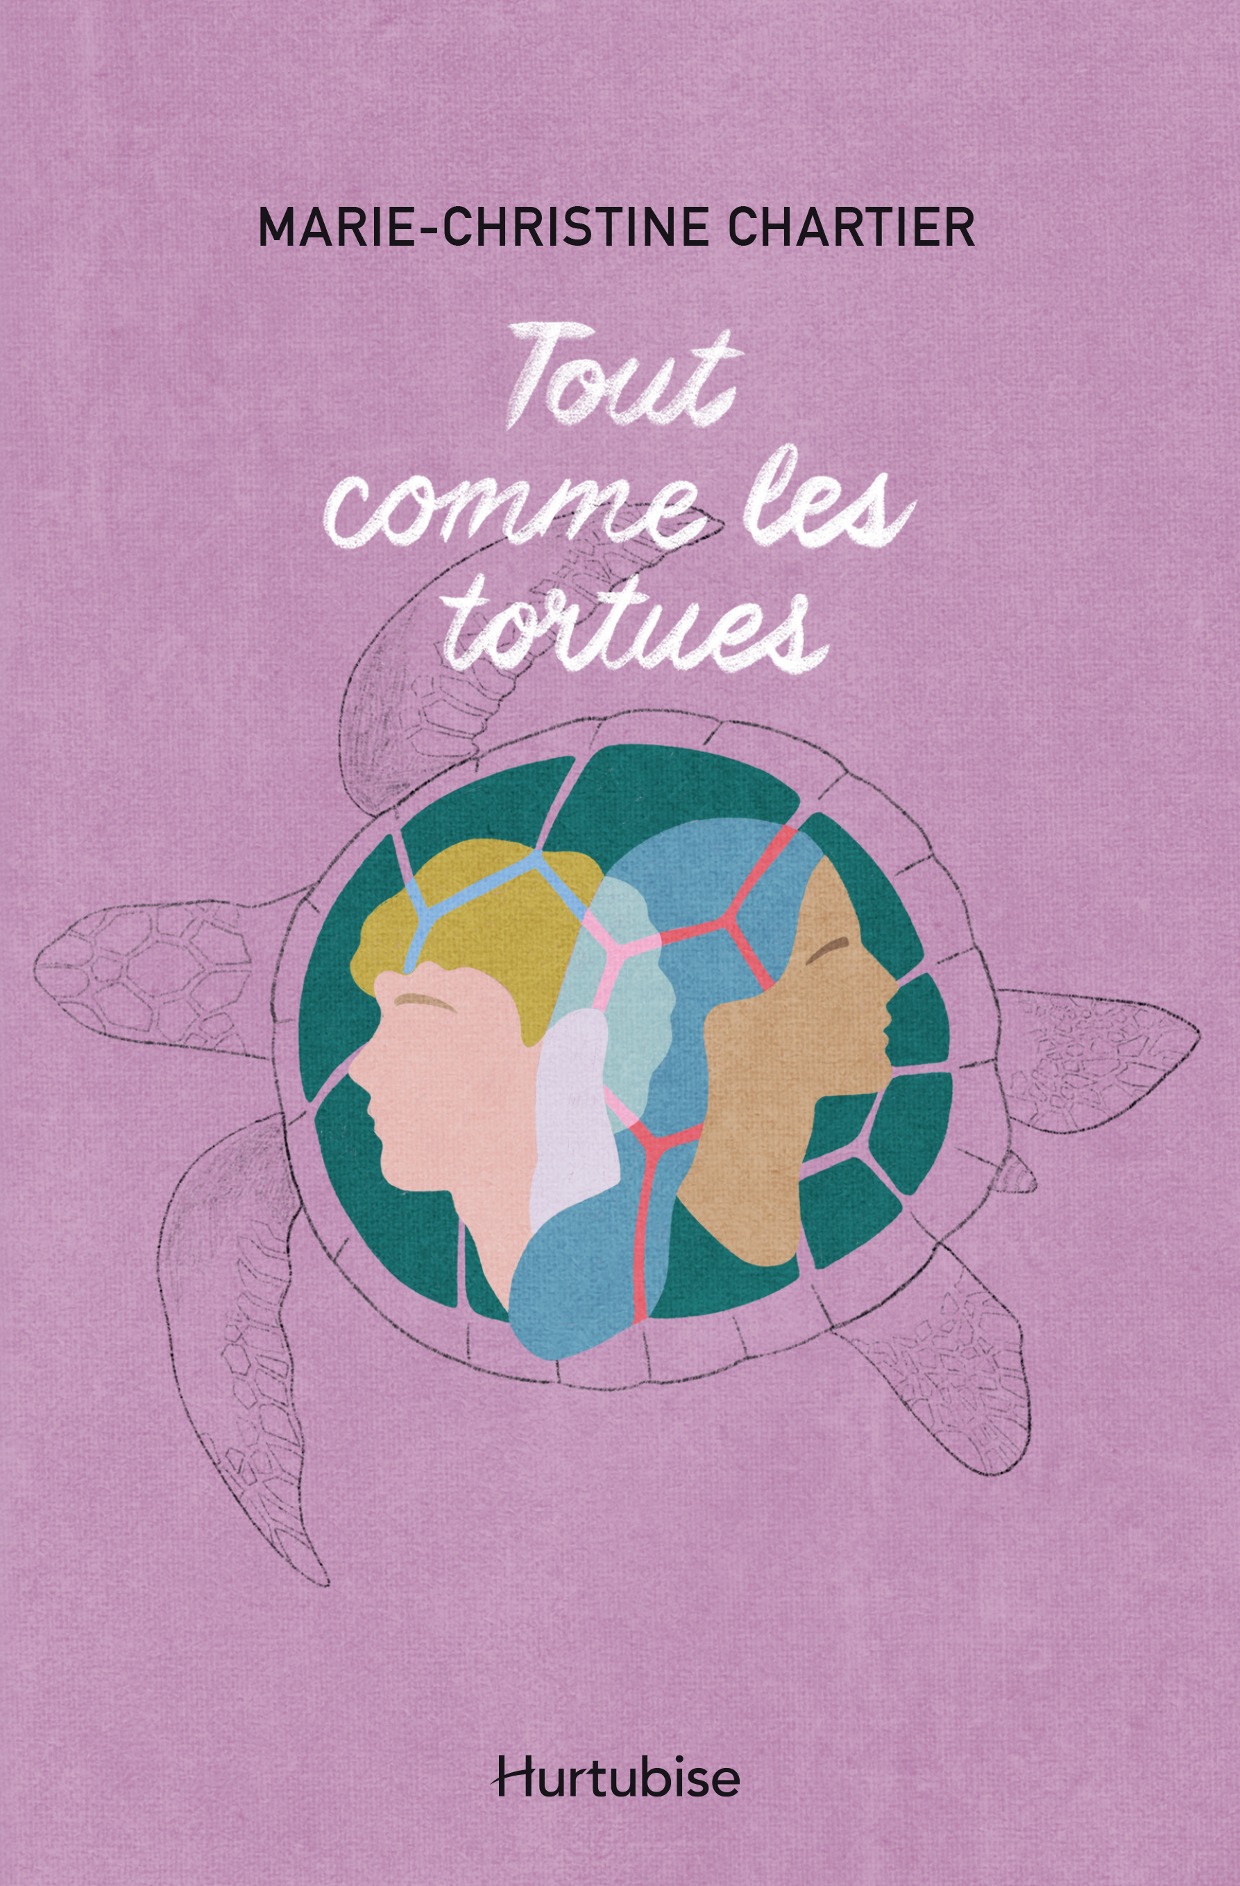
Turtle Steps
Marie-Christine Chartier
Publication: September 2019
* Preliminary manuscript available *
Rights available: World

Just like turtles come back on the beach where they were born, Ariane’s steps bring her back home. Her return will shake up the man she left behind – and the woman who replaced her by his side.

Ariane and Samuel have loved each other for almost all their young lives when a wound too painful to be ignored pushes Ariane to flee to South America. Samuel tries to start a new life with quiet and loving Anaïs, but their fragile balance is threatened when Ariane finally comes back a year later. A tender and touching story of recovery, forgiving, and love.

Just Like Turtles is Marie-Christine Chartier’s second novel; her first, The Allegory of the Rainbow Trout, has received critical acclaim.

Picking Daisy Petals
Isabelle Petit
Publication: October 2019
* Preliminary manuscript available *
Rights available: World

What do you have left when your memories are taken from you one by one? Refusing to resign herself to oblivion, a woman responds to destiny by jumping back into her memories, even if that means crossing the ocean to trace back their flow.

Lorette is 70 when the diagnostic falls: she has Alzheimer’s. Determined to live as fully as she can for the time she has left, she embarks, with her granddaughter Rose, whom she raised after her parent’s death, on a journey to France to find back Lorette’s greatest love. The wise lady also prepared for Rose a notebook containing a weighty secret…

A bright, tender and humorous take on Alzheimer’s and the significance of memory.

NONFICTION

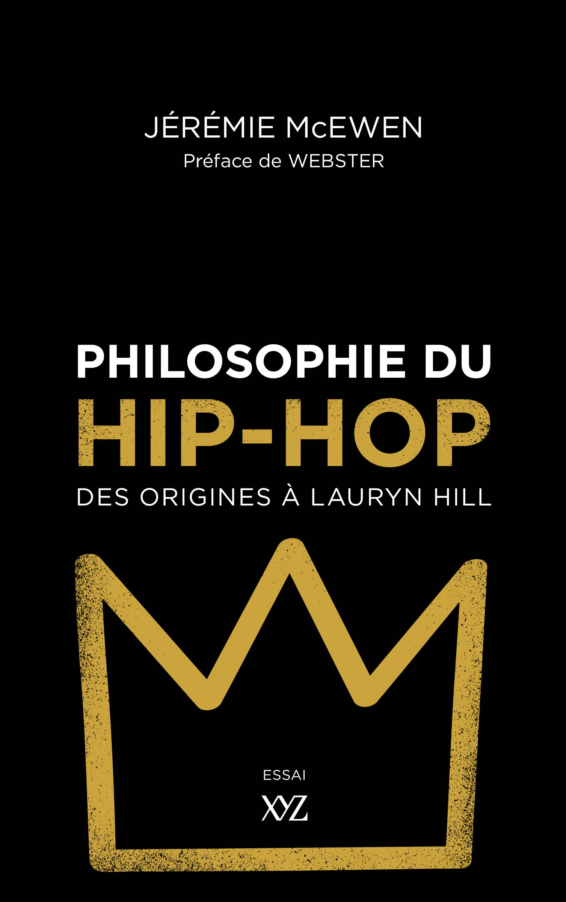

The Philosophy of Hip Hop: From the Origins to Lauryn Hill
Jérémie McEwen
Publication: August 2019
* Final manuscript available *
Rights available: World

A daring topic, an inviting tone, a new perspective on a part of contemporary culture often looked down at.

Mixing Tupac with Machiavel, DJ art with Kant, NWA with Plato? It is the surprising – and successful – bet of Jérémie McEwen, philosopher, professor and hip-hop specialist. In this thorough, accessible and quite original essay, he builds well-supported bridges between two disciplines not often associated with one another. A fascinating read for hip hop and philosophy fans alike.

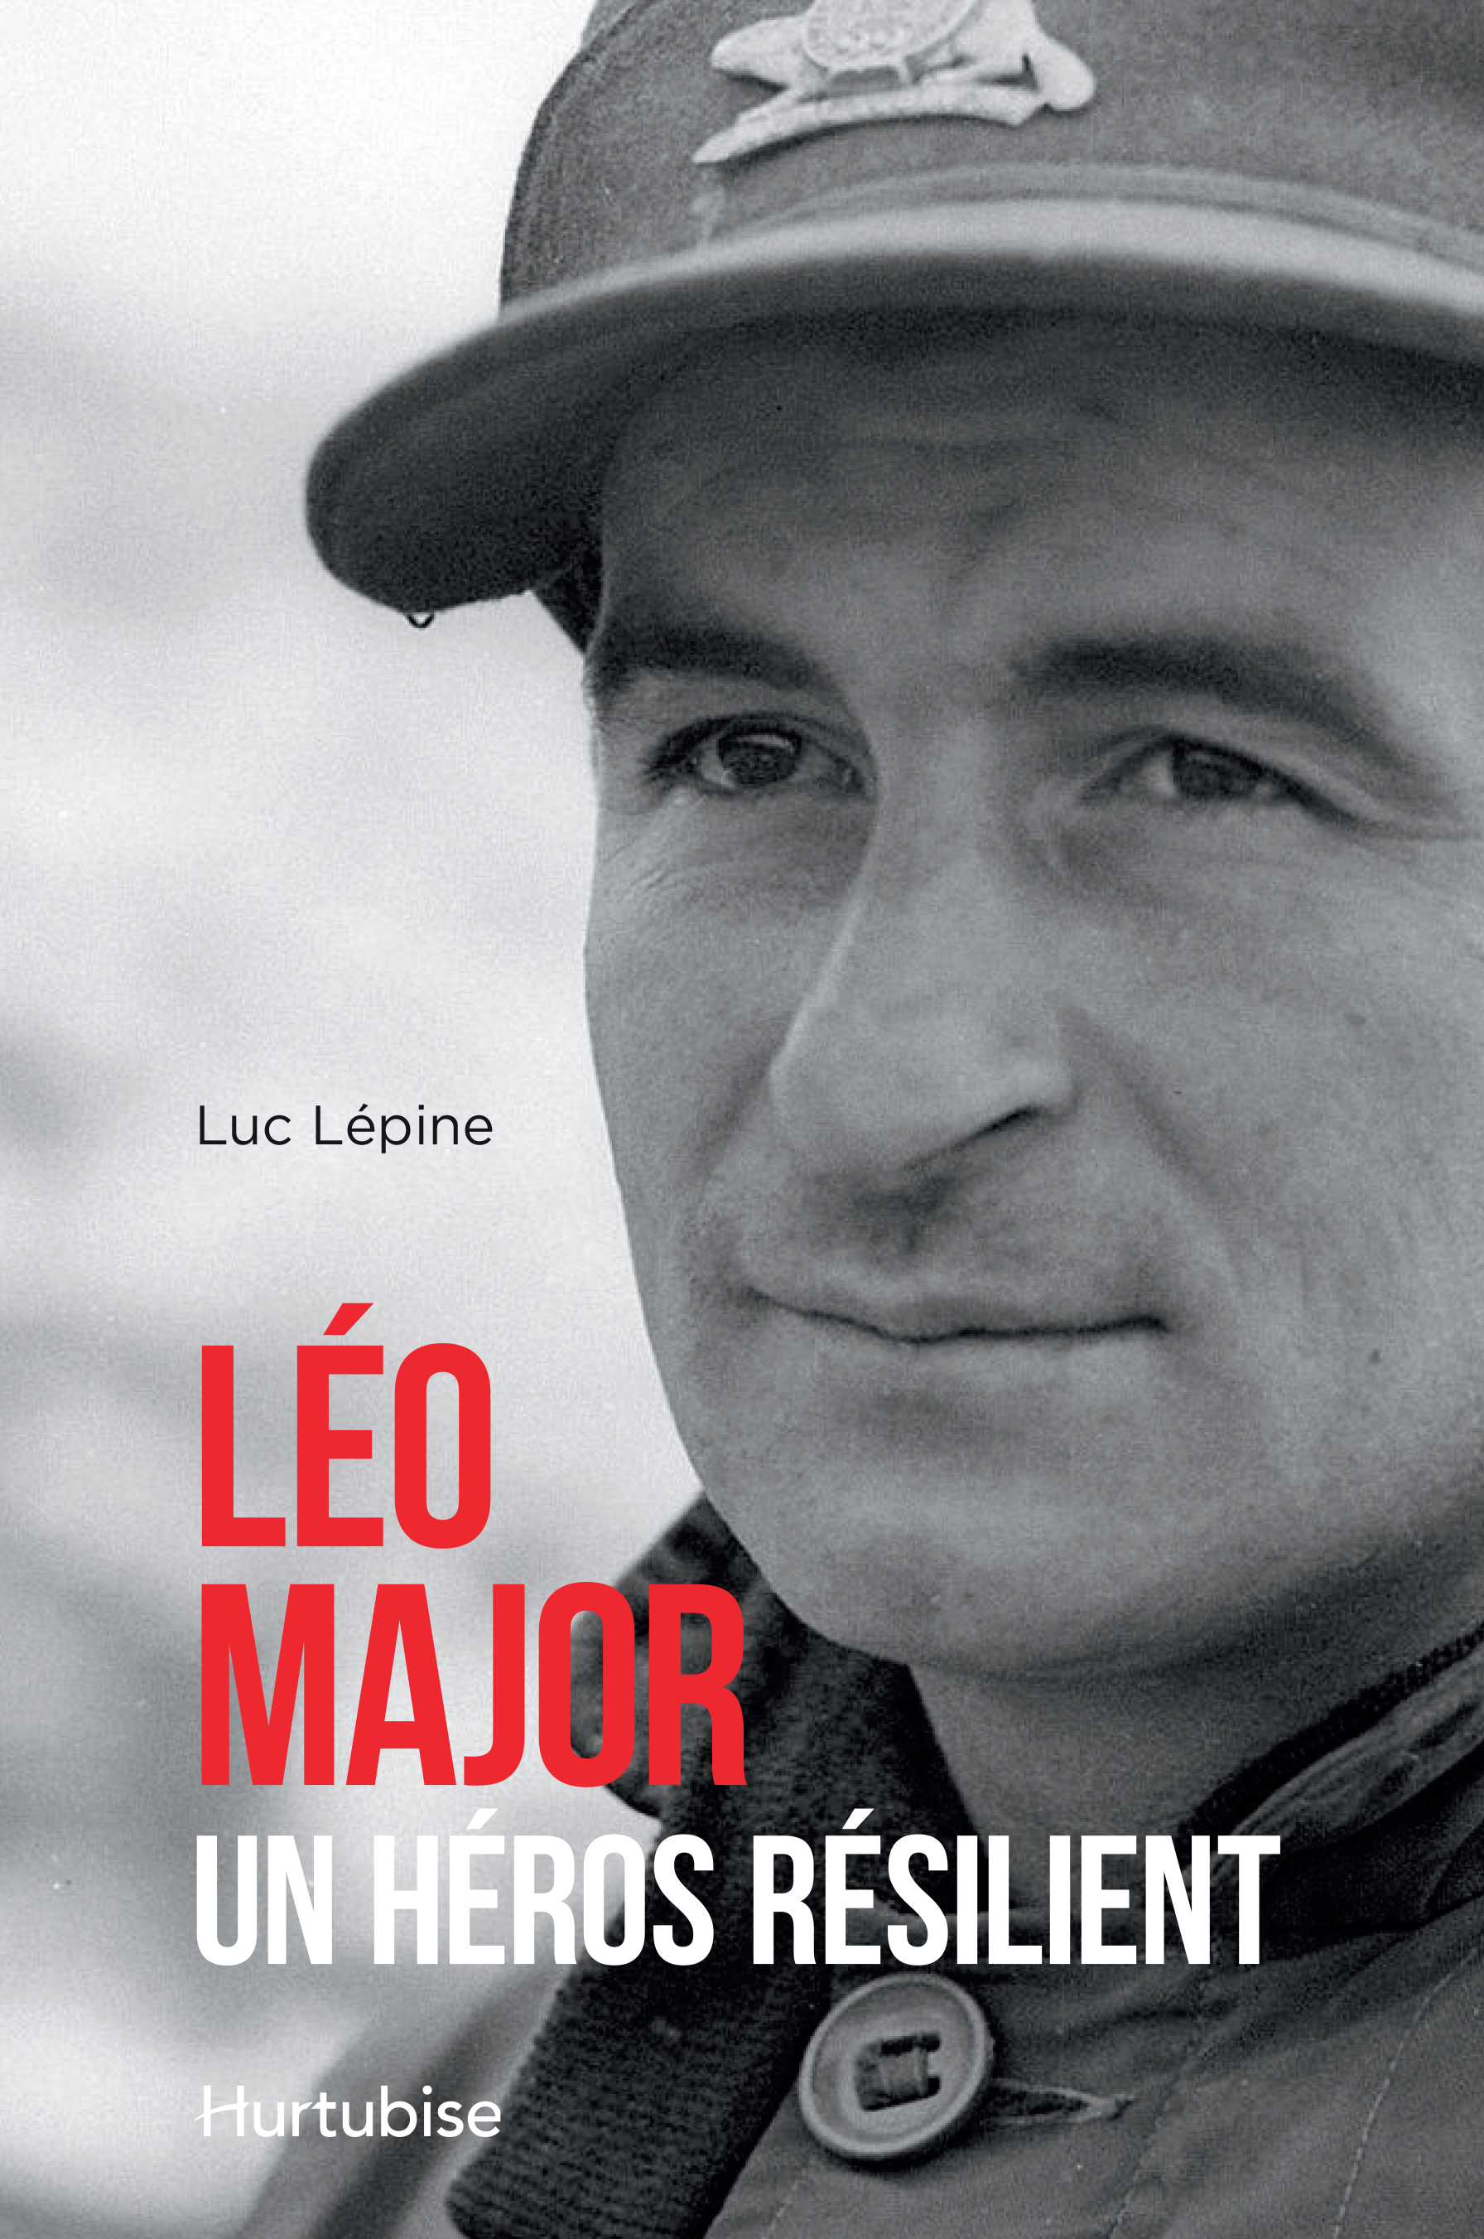

Léo Major: A Resilient Hero
Luc Lépine
Publication: September 2019
* Preliminary manuscript available *
Rights available: World

Far from today’s boasting superheroes, soldier Léo Major was a remarkably humble man: even his wife didn’t know about his achievements until many years after their wedding! Yet his exploits would seem too much even for an action movie.

Léo Major was the eldest of a large family living in a poor Montreal neighborhood during the Great Depression. Major’s father said he would never do anything good, but his son, who left home at 14, brilliantly proved him wrong.

Léo Major’s tours-de-force, which earned him two Distinguished Conduct Medals, include capturing a German tank by himself on D-Day and retaking a key hill during the Korean War with his 18 men against 14 000, but he is mostly known for liberating – single-handedly! – the Dutch city of Zwolle during WWII.

CHILDREN’S BOOKS

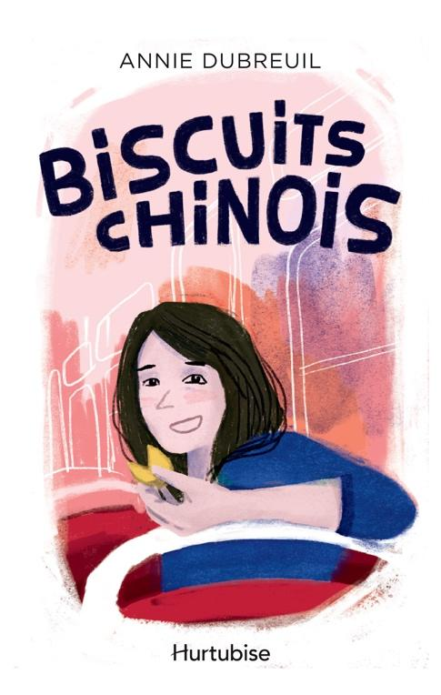
Fortune Cookies
Annie Dubreuil
Publication: September 2019
* French manuscript available *
Rights available: World
Age: 9 years old and up

Romie, thirteen years old, has two passions in life, which she shares with her friend Flavie: DIY clothing projects and the silly messages found in fortune cookies. But when she changes school, she finds a fascinating and quite unexpected third one…

Since she has been awarded a scholarship to study in a posh private school, Romie struggles to find her place among her new schoolmates, being of more modest upbringing. Finding herself interested in her school’s student radio, she throws herself into her radio show, and will need all her will and creativity to convince the headmaster to support her ambitions.

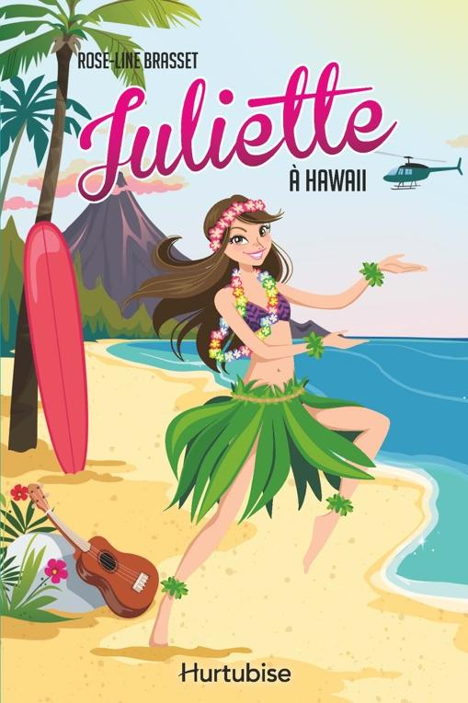
Juliette series vol. 12 – Juliette in Hawaii
Rose-Line Brasset
Publication: October 2019
* French manuscript available *
Rights sold: French (excl. North America), Chinese, Dutch.
Age: 10 years old and up

Juliette, thirteen years old and already a seasoned globetrotter, comes back for a twelfth adventure! Rediscover the world of this sparkling and curious young girl, who accompanies her journalist mother in her trips around the globe.

After New York, San Francisco and Hollywood, here’s Juliette in the United States again! This first trip without her mother brings her to Hawaii, on the invitation of Gino’s mother, who has recently become her boyfriend. Between surf and Hawaiian dance lessons, the young girl tries to understand the relationships between boys and girls, which she finds more complicated than expected…

A series that has already won over more than 500 000 young readers in Canada and in Europe, to be devoured in order… or not!

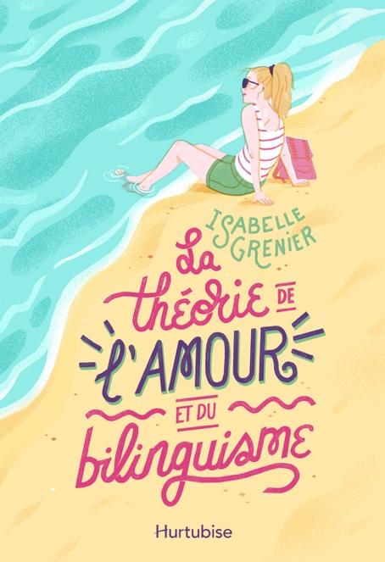
The Theory of Love and Bilingualism
Isabelle Grenier
Publication: September 2019
* French manuscript available *
Rights available: World
Age: 12 years old and up

To improve her English for college, a singular teenager with the interests of a fifty-something – among which psychology and middle-aged French crooners – kicks herself out of her comfort zone, where she’ll learn much more about life and herself than she expected.

Alicia, 16, almost 17, decides to go in English immersion in Vancouver for her last high school year. The shock is immediate and, between a host family quite different from what she expected and the too rainy city, the young women struggles to find her bearings. Until her first drama class and her meeting with Philippe, a young French man also in immersion…

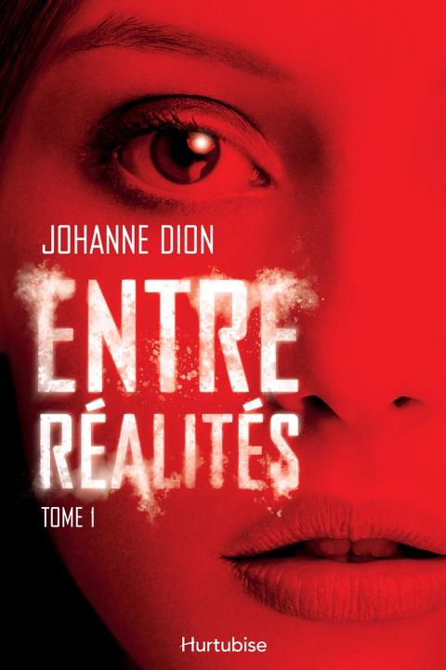
Between Realities – Vol. 1
Johanne Dion
Publication: November 2019
* French manuscript available *
Rights available: World
Age: 14 years old and up

A riveting thriller!

Summer’s beginning and Jordane, 16, intends to have fun and enjoy her holidays. When she meets Alex, attractive and mysterious, she immediately feels drawn to him, and the crush seems shared. But what started like the perfect summer romance takes a troubling turn when Jordane learns that Alex holds a terrible secret, that only she can share…

A series in two volumes.

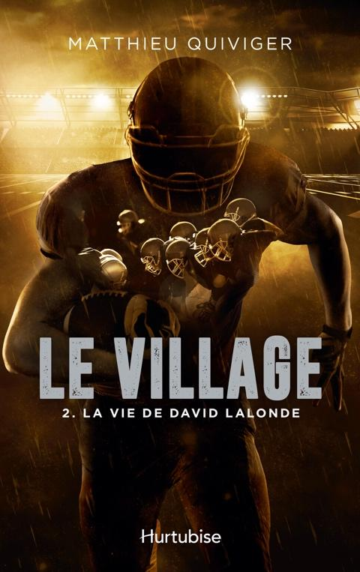
The Village series, vol. 2 – The Running Back
Matthieu Quiviger
Publication: September 2019
* French manuscript available *
Rights available: World
Age: 14 years old and up

A football team is like a village: everyone has his role, and the good functioning of the whole depends on the implication of each. In the first volume of the series, readers were following the progression of defender Jonathan Biron; this time, it’s from running back David Lalonde’s perspective that they’ll meet again the Poodles of Sainte-Agathe-des-Monts.

David Lalonde, a talented skier pushed towards an Olympic career by a multimillionaire sociopath father, finds himself an unexpected passion for American football. Carried by his success and supported by his teammates, he’ll have to make a difficult choice: should he choose skiing or footballing? And will he be able to confront his tyrannical father to take back control of his life?

A series in three volumes written by and for football fans!

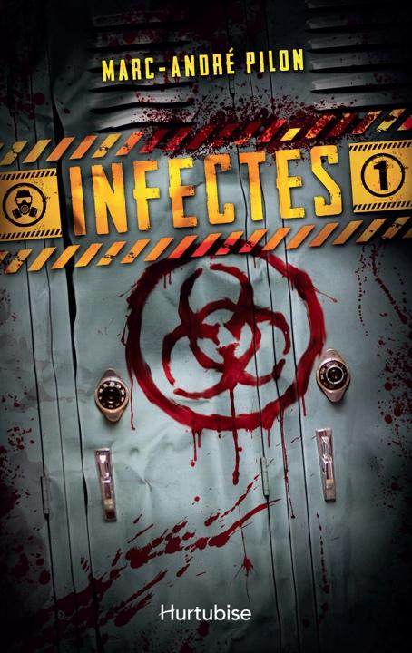
Infected – Vol. 1
Marc-André Pilon
Publication: October 2019
* French manuscript available *
Rights available: World
Age: 14 years old and up

For Zac, Camille and Dilkaram, September 1st marks the beginning of their last high school year. What they do not know is that it also marks the beginning of a mysterious epidemic, the most devastating humanity has ever faced.

Strange videos start going viral on the internet, showing people – apparently seized by a fit of madness – attacking others with an extreme violence. What at first appears like a prank becomes brutally real when one of their teachers transforms into a bloodthirsty cannibal under their eyes and deadly attacks one of their classmates. How will the three teenagers manage to survive when the world as they know it collapses and everyone around them become one of these lethal “infected”?

An original take on the zombie theme by an author mastering the codes of horror with a touch of humor!
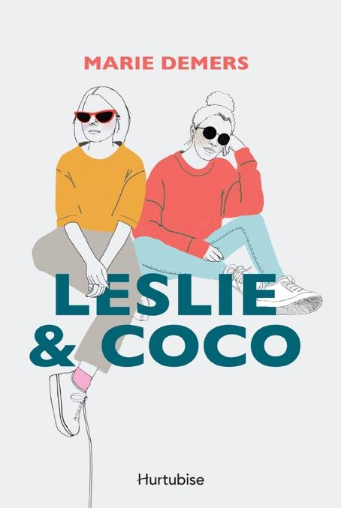
Leslie & Coco
Marie Demers
Publication: October 2019
* French manuscript available soon *
Rights available: World
Age: 14 years old and up

Between beautiful but remote Gaspésie and urban Montreal, two friends on the edge of adult life: Leslie, fragile and gifted, and Coco, confident and with a furious appetite for life. In the space of a summer, they’ll live experiences that will change the course of their lives.

Summer’s beginning and the two childhood friends, who pride themselves on writing letters to each other instead of emails or texts when they are apart, meet again at Leslie’s apartment in Montreal for ten blissful days of celebration. Their reunion is coming to an end when bewitching encounters shake their carefree attitude. Despite the distance again between them, the two young women will need each other more than ever to face the upcoming upheaval.

GRAPHIC NOVEL

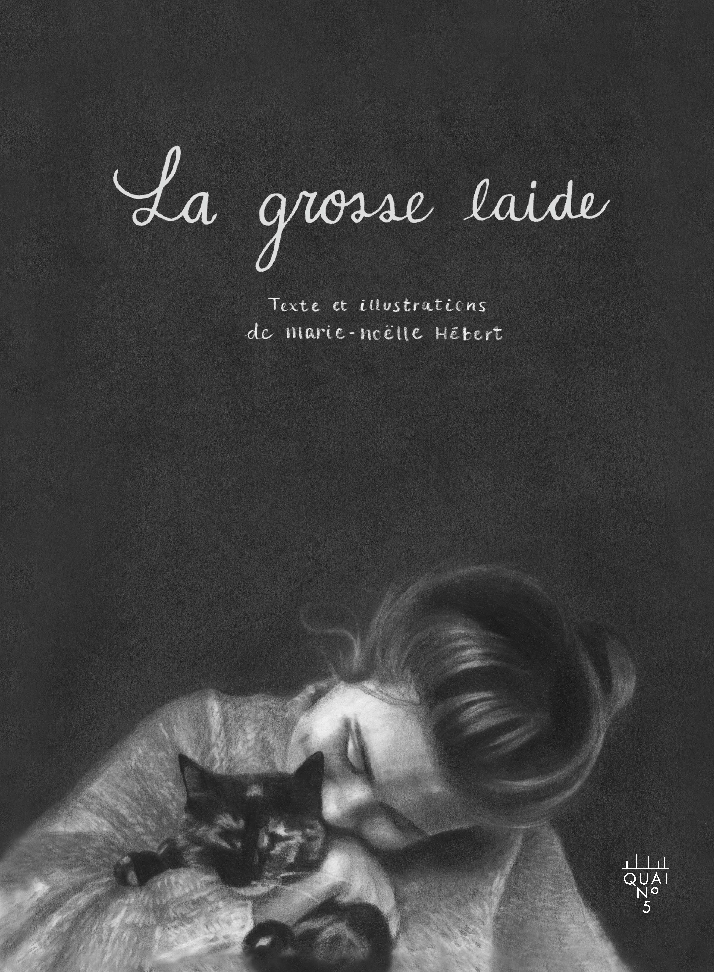
Fat & Ugly
Marie-Noëlle Hébert
Graphic Novel / illustrated, B&W
Publication: October 2019
* Final French manuscript available *
Rights available: World

“I stopped my dance lessons. I don’t know how to do it anymore and the costumes are too small. Alone in my room, I sometimes imitate the poses and movements seen in videoclips. I turn on my stereo system and dance in front of my mirror. I become Ashanti, J.Lo or Christina Aguilera. I am beautiful.”

A powerful and necessary story in which many girls and women will recognize themselves, breathtakingly rendered by Marie-Noëlle Hébert’s precise and sensitive drawings.

For almost as long as she can remember, Marie-Noëlle has always hated her body. Soon labeled “fat” and trapped into beauty ideals she could never match, the young girl grows up deeply scarred by the constant little reminders that she is failing to look like what she think is beautiful and thus worthy of love. How do you make peace with yourself when self-loathing has been intimately part of your identity for so long?
