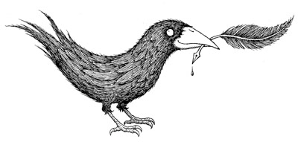

Upstart Crow Literary &

Rights Guide/Available Titles

Frankfurt Book Fair September 2017

Upstart Crow Literary The Inkhouse
244 5th Avenue, 11th floor
New York, NY 10001 212.686.5834
Inquiries: michael@upstartcrowliterary.com

OLIVER, Alison | PICTURE BOOK
Spring 2018  Picture book Clarion Books/HMH Hardcover  ISBN: 1328781607 | The picture book debut of Alison Oliver, illustrator of the perennially popular BABY LIT board books  MOON  Alison Oliver  Moon leads a busy life. School, homework, music lessons, sports, and the next day it all begins again. Then, one night, Moon meets a wolf. The wolf takes her deep into the dark and fantastical forest … and there begins an extraordinary adventure. This simply worded and stunningly illustrated story reveals the joy to be found in play, nature, and most of all, embracing the wild in all of us.  Alison Oliver is the illustrator of the hugely popular BABY LIT board books, of which there are twenty, and which have sold into nearly a dozen languages. Moon is the first book she has both written and illustrated. pure-sugar.com  Review materials: PDF | NEW TITLE
PENFOLD, Alexandra | PICTURE BOOK
Fall 2018  Picture book  Knopf/Penguin Random House Hardcover  ISBN: tk | An exuberant, joyous reminder that the strongest community is the one that embraces all of its members.  ALL ARE WELCOME  Alexandra Penfold (represented by Writers House)  illustrated by Suzanne Kaufman (represented by Upstart Crow)  No matter how you start your day, What you wear when you play,  Or if you come from far away. All are welcome here.  Inspired by a viral classroom poster created by artist Suzanne Kaufman, this lyrical picture book celebrates kindness, inclusivity and diversity in the classroom. With vivid illustrations and a gently reassuring text, the story is the perfect back-to- school read for young students from all backgrounds.  Alexandra Penfold is the author of Eat, Sleep, Poop!, and We Are Brothers, We Are Friends. She lives in Brooklyn, New York.  Suzanne Kaufman is an illustrator who has provided art for several books, as well as written her own Confiscated! suzannekaufman.com  Review materials: Manuscript, sketches, and sample art | NEW TITLE
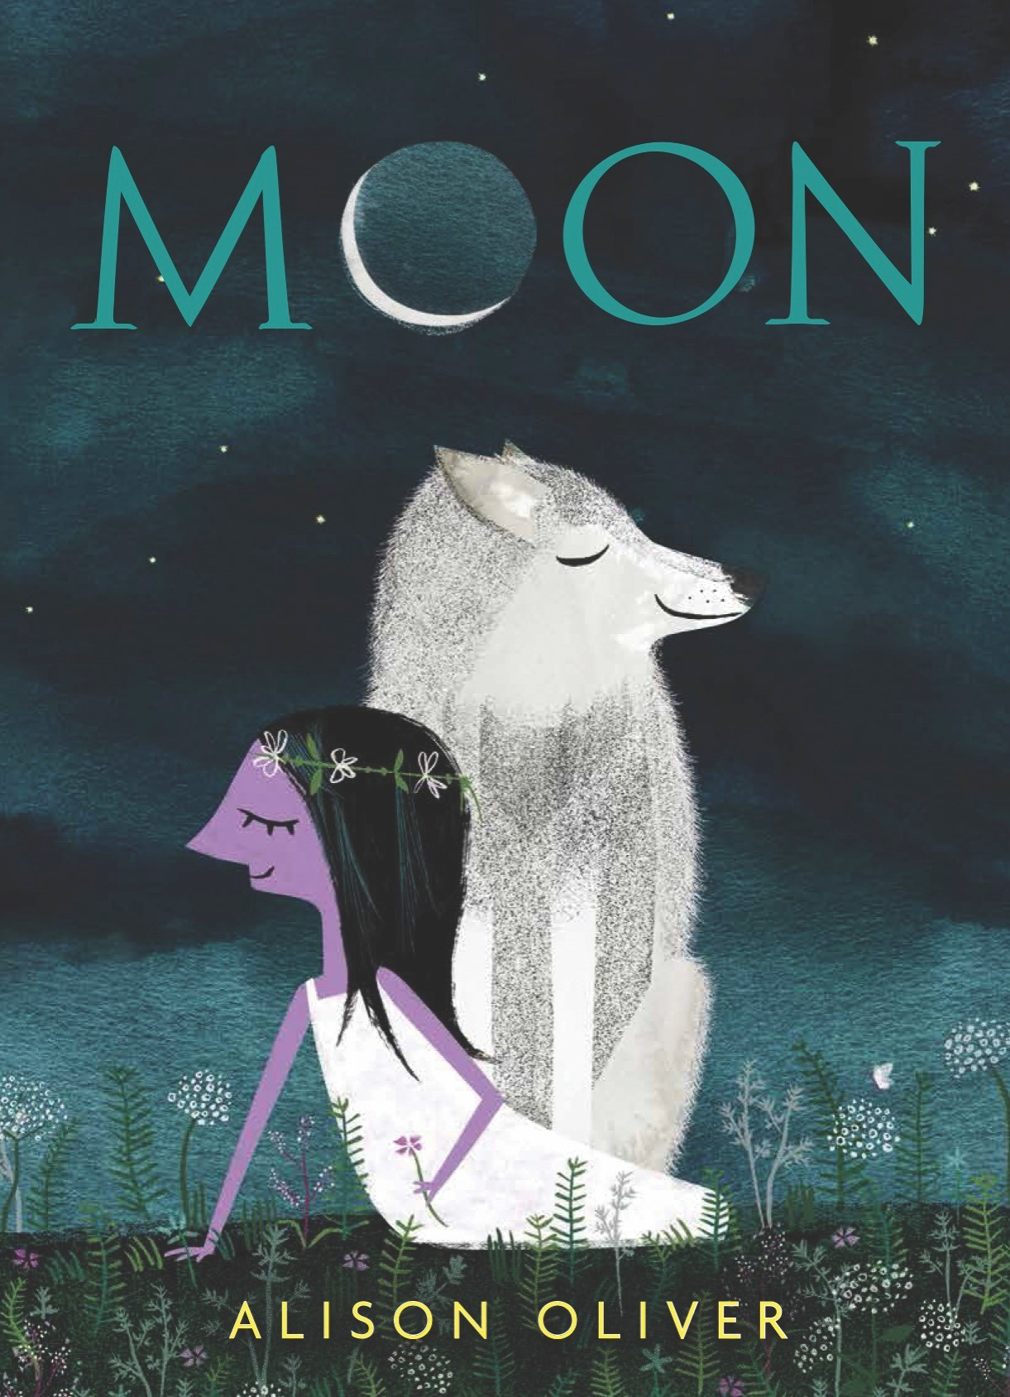
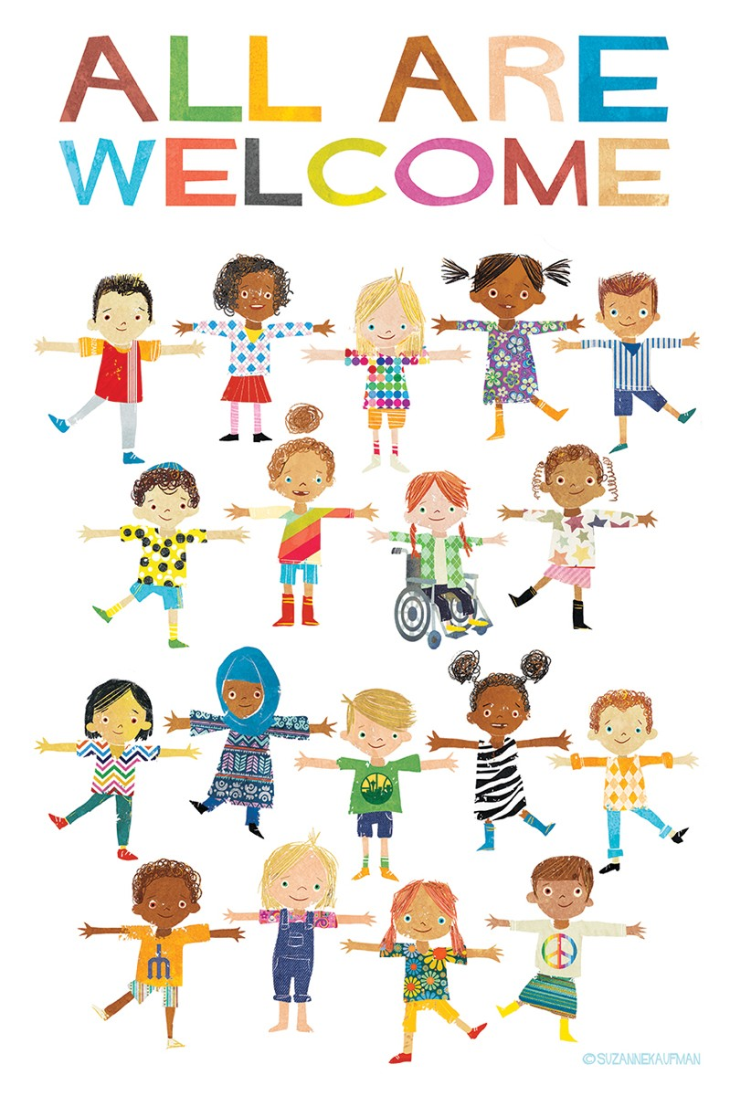
Inquiries: rights@upstartcrowliterary.com p. 1

ACAMPORA, Paul | MIDDLE GRADE FICTION
COVER NOT FINAL  May 29, 2018  Middle Grade fiction (12 and up) Scholastic  ISBN tk | A comedy/drama about the tension between fathers and daughters.  CONFUSION IS NOTHING NEW  Paul Acampora  Ellie is figuring out what it means to be a girl in the world today—especially when the one role model she could have had (her mother) was never around and she was raised by her hardworking single father who doesn’t exactly keep the lines of communication open. Fueled by the bighearted sounds of '80s rock and roll, Confusion is a lighthearted coming of age story about fathers and daughters, and also about girls who understand that it's good to make things, but breaking things is okay too. In fact, sometimes breaking things is required.  Praise for Paul Acompora’s HOW TO AVOID EXTINCTION  “Memorable characters, intelligent banter, and wry humor reminiscent of Richard Peck or Gary Paulsen … unforgettable.” – School Library Journal  Paul Acampora’s books are known for laugh-out-loud humor, rollicking dialogue, and heartfelt characters. He lives in Pennsylvania. www.paulacompora.com  Review materials: Copyedited manuscript | NEW TITLE
HAUTALA, Beth | MIDDLE GRADE FICTION
February 2018  Middle Grade fiction (8 and up) Philomel (US)  Hardcover  ISBN 9780399546082 | A poignant, heartwarming tale about the difficulties of siblinghood  THE OSTRICH AND OTHER LOST THINGS  Beth Hautala  Eleven year-old Olivia Grant has a knack for finding lost things. But there’s one thing she has never been able to find: her autistic brother Jacob’s toy ostrich. Because of Jacob, Olivia has had to give up a lot, but acting in a local theater’s production of Peter Pan gives Olivia a chance to do something for herself. But nothing goes as she’d hoped—onstage or off—and Olivia becomes convinced that if only she can find her brother’s toy, everything will go back to normal. Yet what does normal even mean? And is everything lost meant to be found?  Beth Hautala is the author of Waiting for Unicorns. She lives in Northern Minnesota with her husband, four children, and a gray cat. www.bethhautala.com  Praise for Beth Hautala’s debut, WAITING FOR UNICORNS  “Lyrical and evocative…. Written by an author to watch.”—Kirkus Reviews  Review materials: typeset pages, ARC | NEW TITLE
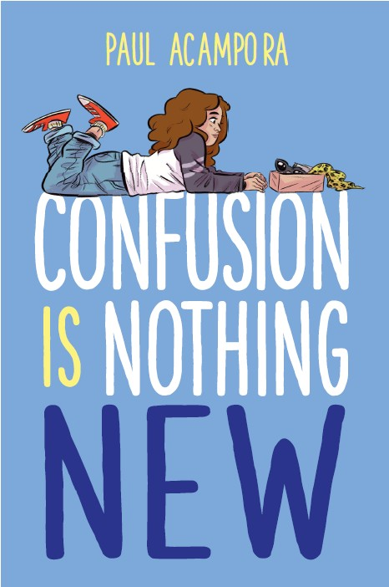
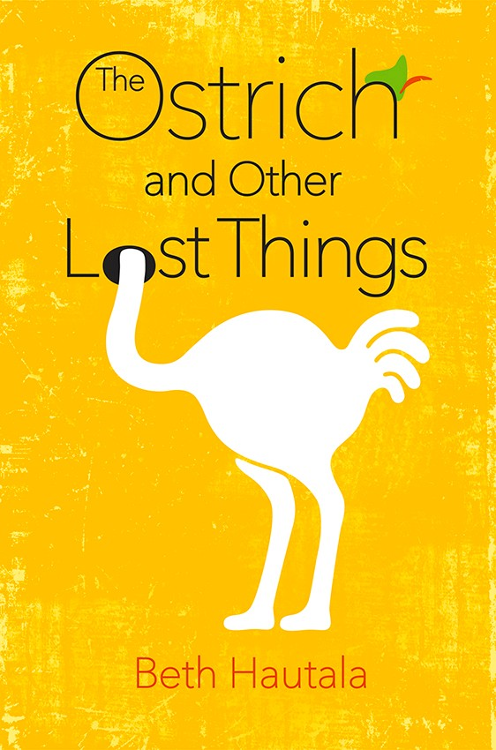

Inquiries: rights@upstartcrowliterary.com p. 2

HOLT, Catherine | MIDDLE GRADE FICTION
 | First in a spooky new series perfect for fans of Mr Limoncello’s Library | NEW T
 | MIDNIGHT REYNOLDS AND THE SPECTRAL TRANSFORMER | ITLE
 | Catherine Holt
 | When twelve year-old misfit Midnight Reynolds takes a job helping eccentric Miss
 | Appleby in the mansion down the street, she never imagines her work will involve
 | battling ghosts. Turns out Midnight and her new employer have quite a bit in
 | common—they were both born on Halloween and have the power to see spirits of
 | the dead. Soon a discovery about the history of her town makes Midnight wonder if
 | she’s fighting on the right side….
 | Catherine Holt lives in New Zealand and writes romance, young adult, and middle
 | grade fiction.
 | Praise for MIDNIGHT REYNOLDS
 | “A fast-paced ride…. Readers [may] be blindsided by a plot twist or two that they
September 2017  Middle Grade fiction (12 and up) | just didn’t see coming.”—Booklist
Albert Whitman Hardcover | “Old-fashioned spooky fun.”—Kirkus Reviews
ISBN 978-0807551264 | Review materials: PDF
KALMAR, Daphne | MIDDLE GRADE FICTION
June 19, 2018  Middle Grade fiction (12 and up) Feiwel & Friends/Macmillan Hardcover  ISBN: 978-1250154989 | Set in 1927 rural Vermont, this debut novel is perfect for fans of Clare Vanderpool’s Newbery-winning Moon Over Manifest  A STITCH IN TIME  Daphne Kalmar  Eleven-year old Donut is orphaned when her father dies, and her Aunt Agnes moves in—bringing along her lumpy oatmeal, her knitting, and a despised-by-Donut plan to drag Donut off to Boston forever.  Donut stands to lose everything: her friends, her village, her home, and the woods where the memories of her dad are stored up like the bread and butter pickles in canning jars on the shelf. So she and her best friend Tiny plan to keep her right where she belongs: Donut paddles away in her dad’s last invention, a folding tin boat. Donut hopes Aunt Agnes will throw in the towel and leave Vermont without her, but Donut isn’t counting on a bear, a leaky boat, or an ache that won’t go away.  A STITCH IN TIME is shot through with gorgeous, evocative language, and gets right to Donut’s heart – her hurt, her strength, and her struggle to make sense of loss.  Daphne Kalmar lives in Vermont. This is her first novel.  Review materials: unedited manuscript | NEW TITLE
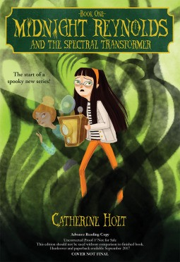
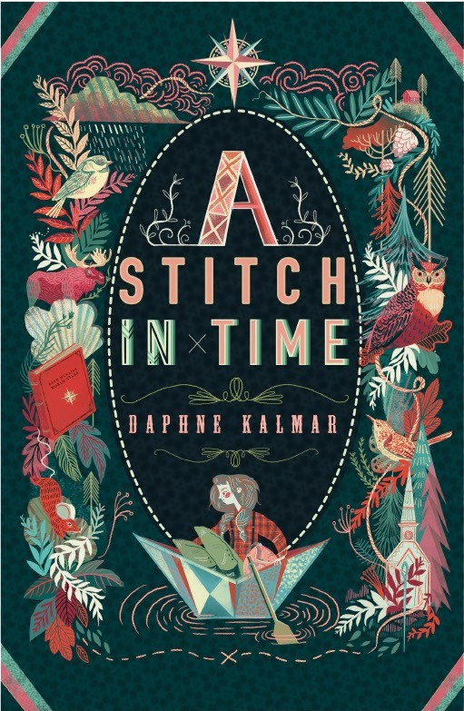

Inquiries: rights@upstartcrowliterary.com p. 3

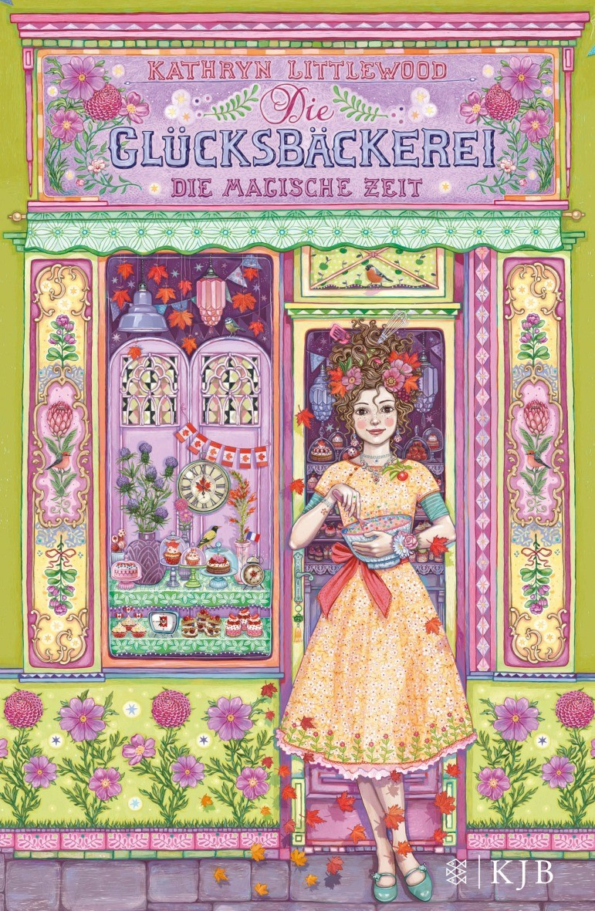
MAGIC BY THE MINUTE
LITTLEWOOD, Kathryn MIDDLE-GRADE FICTION
November 2017
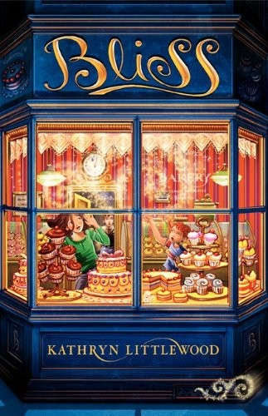
Middle-grade (10 and up) Fischer Verlag/Germany Hardcover ISBN tk

In Development in Europe as a feature film by Senator Films!
By popular demand: the sixth entry in the internationally bestselling series!
NEW TITLE

MAGIC BY THE MINUTE: A BLISS NOVEL (Book 6)
Kathryn Littlewood

Rosemary Bliss thought she had already achieved the rank of Master Baker—but apparently the Bliss Family Cookery Booke has other ideas: she discovers that her contribution to the Booke has been stamped with a paw print PENDING APPROVAL BY THE DOG, and until she wins the Dog’s approval, her spells won’t work.

The Dog is the embodiment of the Booke itself, and he requires that every would- be Master Baker accompany him on an apprentice-level test—to prove to the Dog that the baker can work baking magic all by herself. He spirits Rose away to a town where time itself is running backwards and where, if she fails her test, thousands of people may soon cease. But Rose has no ingredients and no help from her family and time is running out!

Kathryn Littlewood is a writer, actress, comedienne, and bon vivant who lives in New York City, works often in Los Angeles, and has a sweet tooth for middle-grade readers. She is working on a seventh BLISS novel.

!

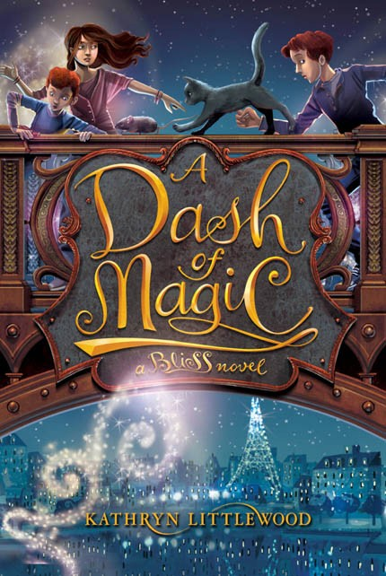
The first five magical, madcap adventures of the Bliss family

BLISS (Book 1), A DASH OF MAGIC (Book 2), BITE-SIZED MAGIC (Book 3), MAGIC BY THE MOUTHFUL (Book 4), and
MAGIC IN THE MIX (Book 5, cover not shown)

Reviews and Praise for the BLISS series:

"Hilarious... Readers will savor this... Fantastic fantastical fare."—Kirkus Reviews (starred review)

“Quite delicious and very funny”—Wall Street Journal

“[A] delicious and exciting book”—The Washington Post

“This lighthearted family adventure offers a well-meaning and believably insecure heroine, as well as boisterous sibling interactions”—Publisher’s Weekly

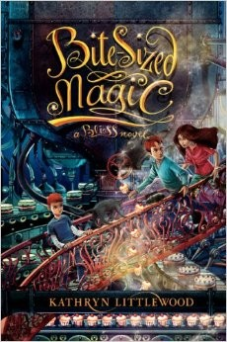
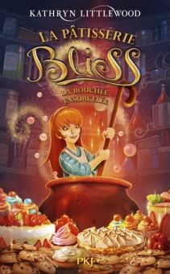
BLISS
February 2012
Middle-grade (10 and up) Harper Collins/NA
HC 978-0062084231
PB 978-0-06-208424-8
A DASH OF MAGIC
February 2013
Middle-grade (10 and up) Harper Collins/NA
HC 978-0062084293
PB 978-0062084309
BITE-SIZED MAGIC
February 2014
Middle-grade (10 and up) Harper Collins/NA
HC 978-0062084262
PB 978-0062084279

Rights Information: Brazil (Moderna), China (Citic), Finland (Otava), France (Pocket Jeunesse), Germany (Fischer), Greece (Psichogios), Indonesia (Mizan), Italy (Mondadori), Netherlands (Holkema & Van Warendorf), Norway (Cappelen Damm), Poland (Egmont Polska), Portugal (Galivro), Spain (Ediciones B), Sweden (Alfabeta), Taiwan (Omnibook), Turkey (Kadikoy), UK (Harper UK), US+C (HarperCollins/Katherine Tegen Books), Film: Senator Films

Inquiries: rights@upstartcrowliterary.com Film/TV inquiries: eddie@gotham-group.com p. 3

Middleton, Dana | MIDDLE-GRADE FICTION
October 2017  Middle Grade fiction (12 and up) Feiwel & Friends / Macmillan Hardcover  ISBN 978-1250085726 | Three friends find a box buried by a dead girl & set out to solve her mystery  OPEN IF YOU DARE  Dana Middleton  Like Birdie Adams didn’t have enough problems this summer. But if a long-buried box has "Open if you dare" written on its lid, then Birdie and her best friends, Ally and Rose, are going to open it. And now, along with everything else that’s going on―Ally’s pitching slump, Rose’s banishment to Britain, and Birdie’s annoying younger sister being, you know, annoying―the best friends are caught up in solving a mystery planted by a dead girl forty years ago.  Dana Middleton grew up in Georgia and now lives in Hollywood, CA. She is also the author of The Infinity Year of Avalon James  Praise for Dana Middleton’s THE INFINITY YEAR OF AVALON JAMES  ★ “A fine, tenderly nuanced tale of the remarkable power of friendship.”―Kirkus Reviews  ★ “Avalon’s first-person narrative is forthright and engaging.”―Booklist  Review materials: PDF of typeset pages | NEW TITLE
MYKLUSCH, Matt | MIDDLE GRADE FICTION
Spring 2019  Middle Grade fiction (8 and up) Aladdin/S&S (US)  ISBN TK | A hilarious series about embracing the power of good old-fashioned magic  MAJESTIC: THE MAGICIAN’S ASSISTANT  Matt Myklusch  Joey Kopecky isn’t the smartest 12-year-old in the state of New Jersey. But everyone thinks he is. So when Joey’s perfect test scores and ability to “see through tricks” get him out of summer school and qualify him to try out for a job at the Majestic Theater working for Redondo the Magnificent, he is thrilled. Joey soon learns there is more to magic than putting on a good show. Dark magicians intent on destroying Redondo and wreaking havoc on the magical world are closing in, and it’s up to Joey to save them all—if only he can find a way to truly believe.  Matt Myklusch is the author of the JACK BLANK trilogy (S&S/Aladdin) and the SEABORNE duet (Lerner), and hosts the Other Side of the Story podcast. www.mattmyklusch.com  Praise for JACK BLANK  “A fun mix of adventure, fantasy, and science fiction that will easily attract young male readers longing to be from another world.”—Booklist  “Like Harry Potter and Luke Skywalker before him, Jack Blank is a mythic hero.” –  San Francisco Book Review  Review materials: finished manuscript available April 2018 | NEW TITLE
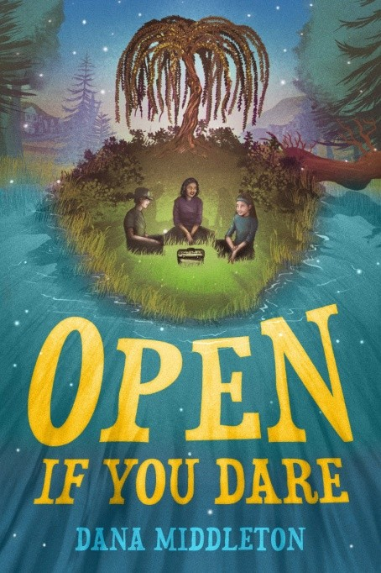
Inquiries: rights@upstartcrowliterary.com p. 5

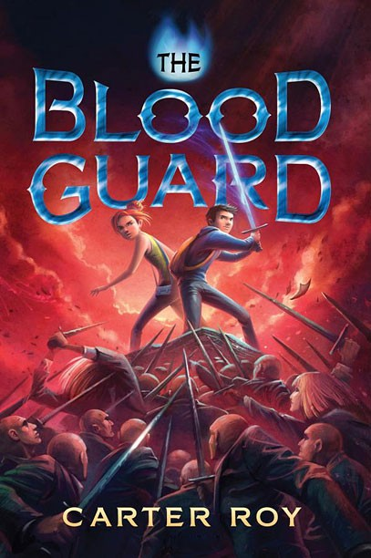
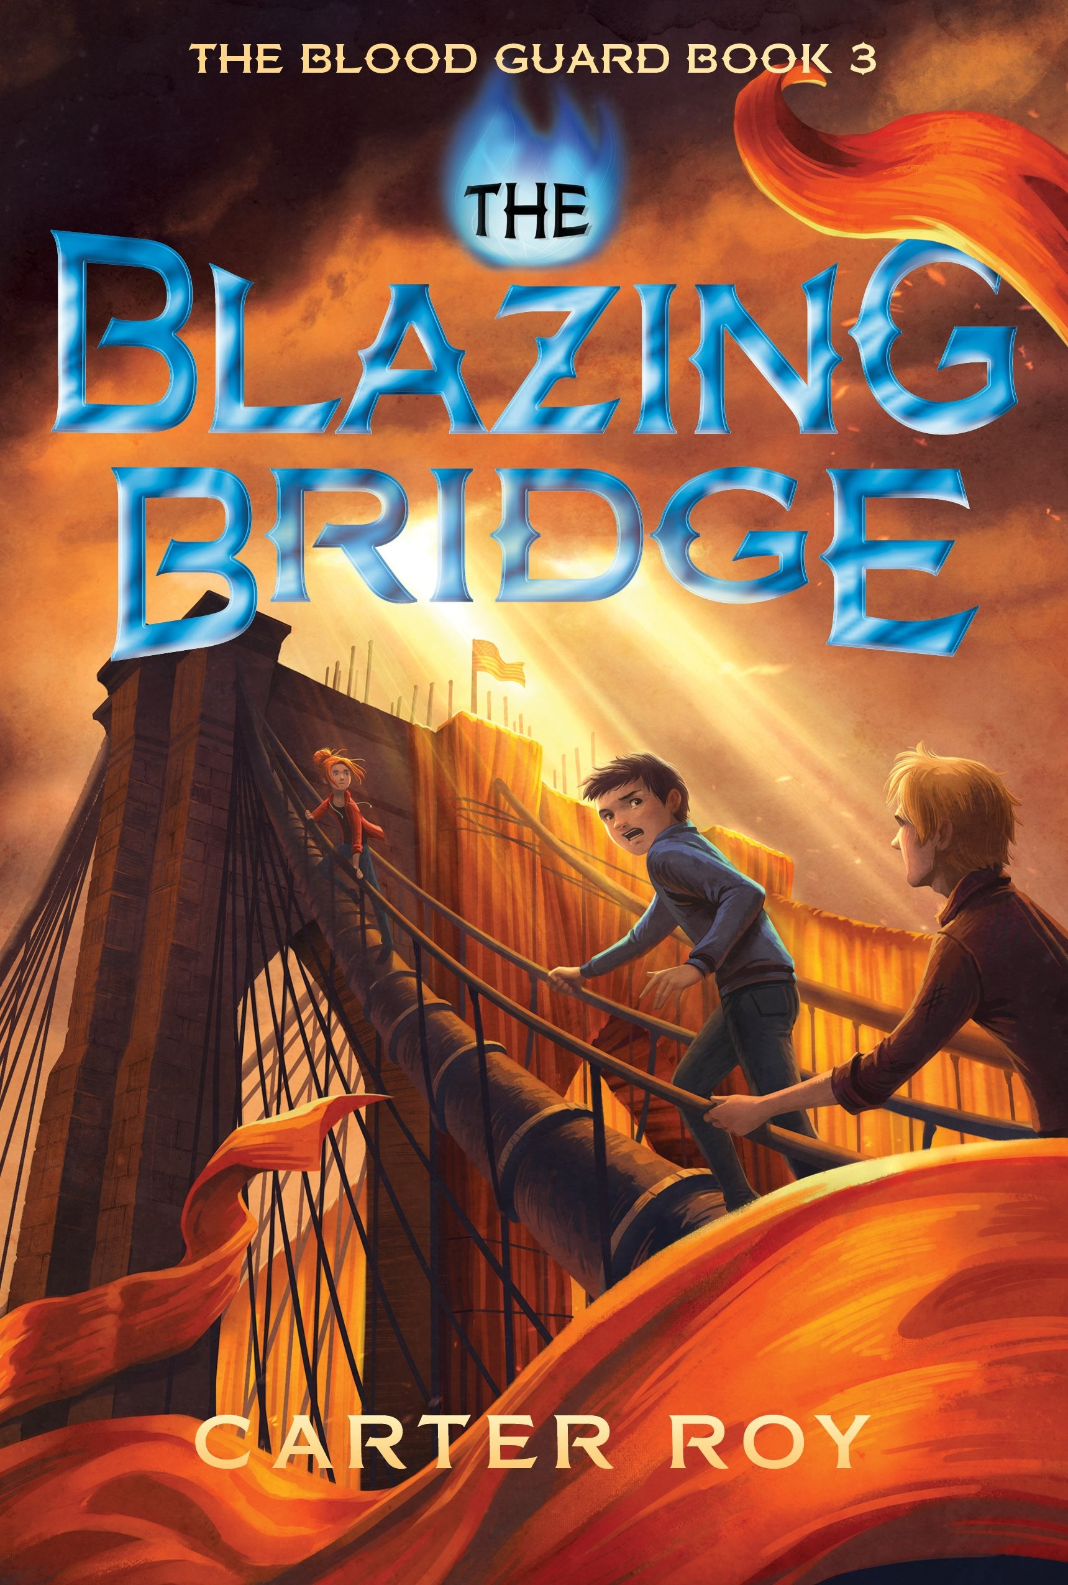
March 2013
ROY, Carter MIDDLE-GRADE FICTION
The capstone entry in the award-winning adventure trilogy  THE BLAZING BRIDGE (The Blood Guard, Book 3)  Carter Roy  Ronan Truelove’s best friend, scrappy smart aleck Greta Sustermann, has no idea that she is one of the thirty-six Pure souls crucial to the safety of the world. But Ronan’s evil father has figured it out—and he’s leading the Bend Sinister straight to Greta. But they’re going to have to go through Ronan first. Standing with Ronan are plucky hacker Sammy; witty, unkillable Jack Dawkins; and a sharp-tongued woman named Diz, who drives a dangerously souped-up taxi. One breathless close call after another leads to an ugly showdown: Ronan alone against his father, with the fate of Greta, his friends, and the entire world hanging in the balance.  By turns heart-stopping and hilarious, The Blazing Bridge brings the Blood Guard trilogy to a surprising, clever, and altogether thrilling conclusion.  “A strong and satisfying conclusion to a wild and hilarious ride.” —Kirkus Reviews  March 2017 Carter Roy is an award-winning short story writer and longtime children’s book  Middle-grade fiction (12 and up) reader. He lives in Brooklyn. www.carterroybooks.com  Two Lions/Amazon Publishing (US) HC 978-1477827178  PB 978-1477827062 | NEW TITLE

HC 978-1477847251
PB 978-1477816202

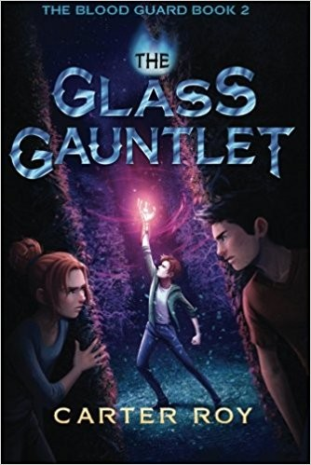
August 2014
HC 978-1477826263
PB 978-1477827154

Praise for the first two entries in the thrilling series …

THE BLOOD GUARD & THE GLASS GAUNTLET
Finalist for five reader’s awards in the United States, and winner of the Northern Ireland Book Award.

“A superbly written adventure [with] just the right amount of sarcastic humor and genuine heart.... It is a great start … and a must-have."
—VOYA, 5Q [Highest Rating]

“Breathless action, witty dialogue, and unabashed fun”—Publishers Weekly

“Will have readers eager for the next book [and] chuckling all the way to the satisfying cliffhanger.”—Kirkus Reviews

“Intense action-filled, The Blood Guard is a non-put-downablepage turner…. This book is a must have.”—The Guardian.com

“With strong character development, edge-of-your-seat pacing & fairly rich world building, The Glass Gauntlet is a strong sequel.”—School Library Journal

Rights Information: US (Amazon/Two Lions); UK (Scholastic); Germany (Ravensburger); France (Hachette); Brazil (Editora Rocco)

Inquiries: rights@upstartcrowliterary.com p. 6

SMIBERT, Angie | MIDDLE GRADE FICTION
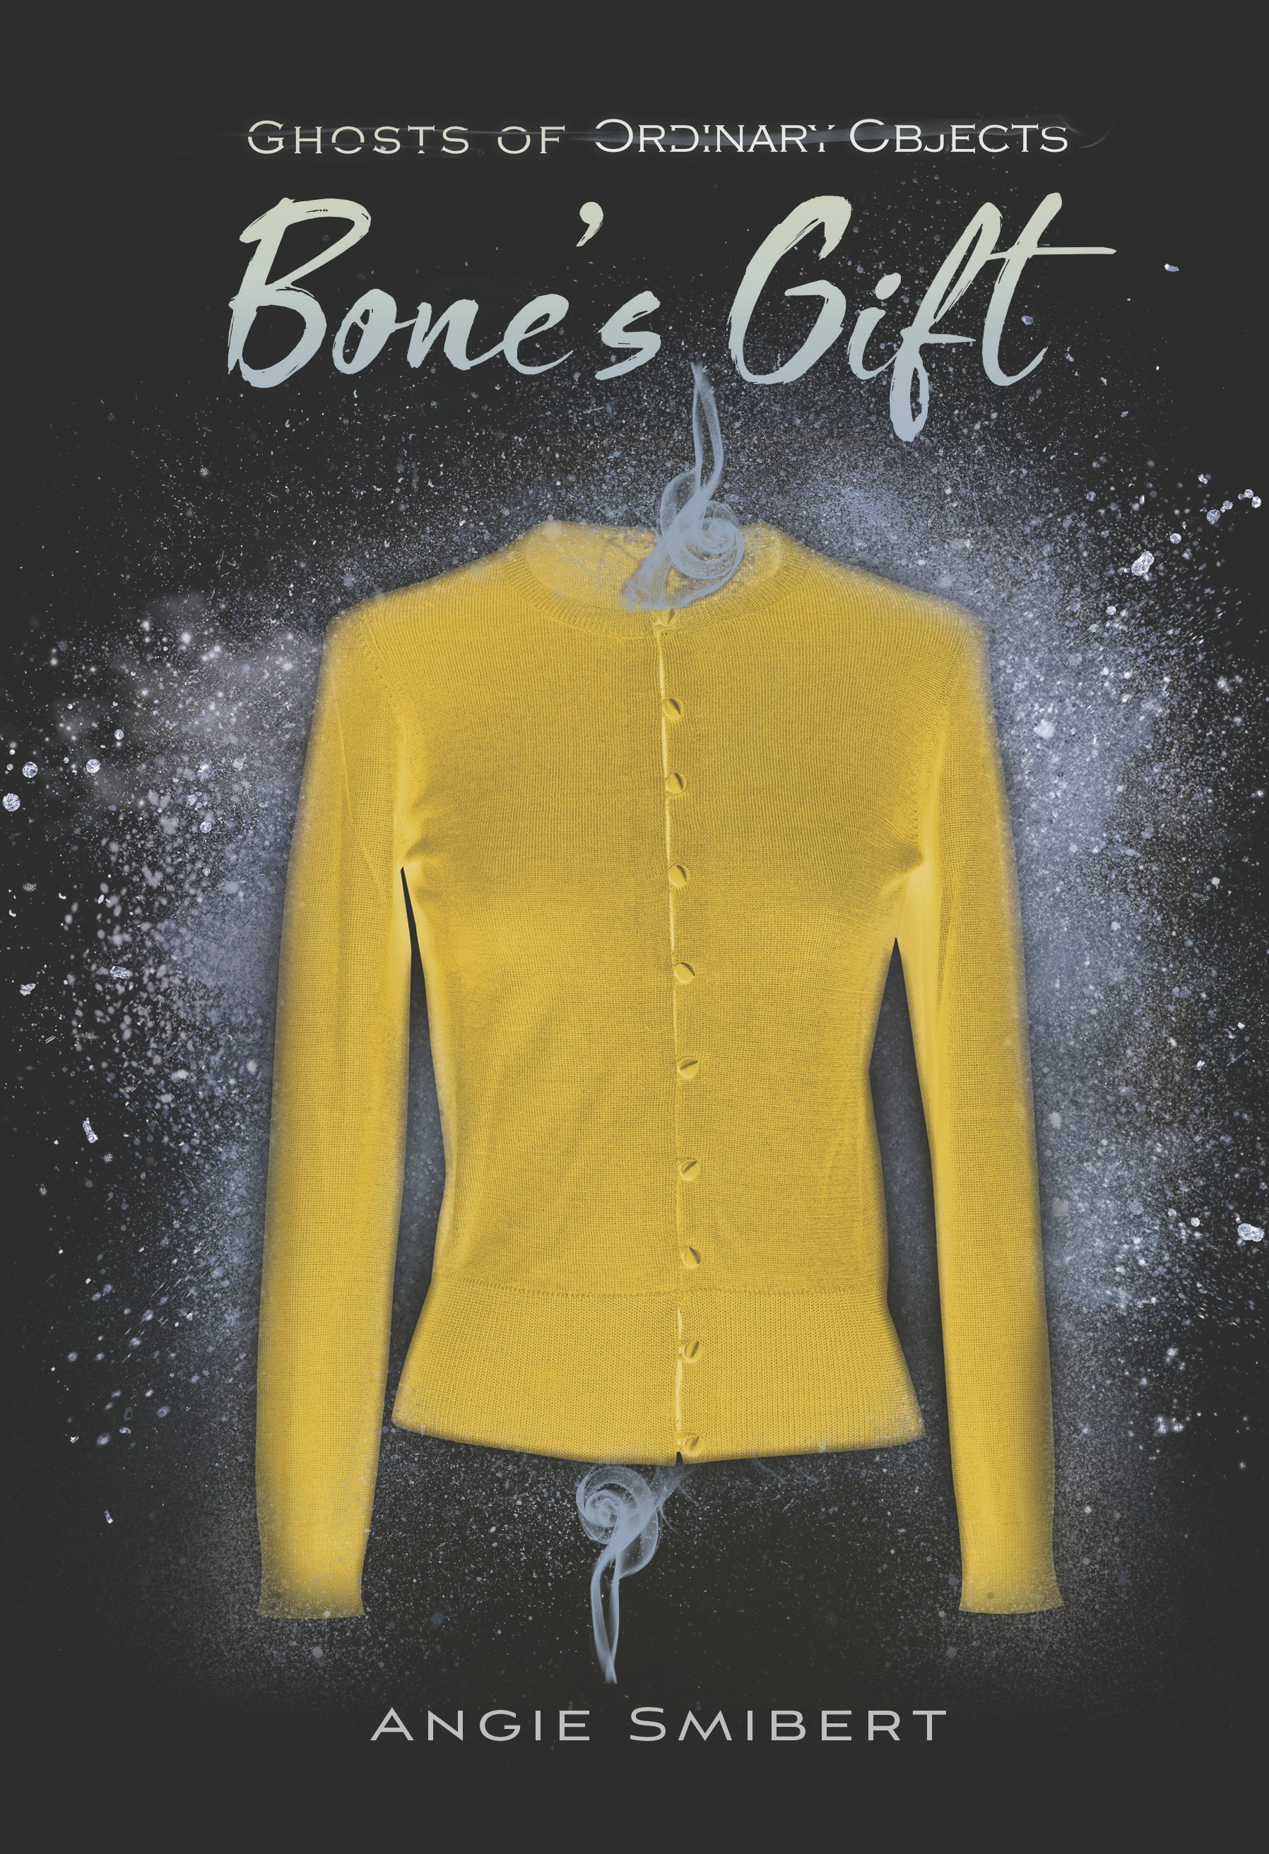  March 2018  Middle Grade fiction (10 and up) Boyds Mills Press/Highlights (US) ISBN TK/hardcover | The first entry in a new historical series with a touch of magical realism  GHOSTS OF ORDINARY OBJECTS: BONE’S GIFT  Angie Smibert  Twelve year old Bone Phillips can see the stories in ordinary objects—and she doesn’t much like it. It’s her family Gift, as her Mamaw calls it. In a jelly jar, fiddle or even a butter yellow sweater, Bone sees tales of loss, grief, love and hope. But these aren’t the stories Bone likes to tell. She’d much rather spin yarns of gypsies or talking animals. Bone’s Mama had the Gift too, but Bone doesn’t know much about her; she died when Bone was young. But when Bone finds a note saying that the Gift killed her mother, she knows it’s time to learn more.  BONE’S GIFT weaves Bone’s story and the mystery of her mother’s death into a beautifully resonant tale about the power of story.  Angie Smibert is the author of three young adult novels, including MEMENTO NORA (2011), which Horn Book called “taut and lean” and was nominated for YALSA’s Best Fiction for Young Adults. www.angiesmibert.com  Review materials: Edited manuscript; typeset pages PDF available Fall 2017 | NEW TITLE
TYRE, Lisa | MIDDLE GRADE FICTION
Spring 2018  Middle Grade fiction (12 and up) Nancy Paulsen Books/Penguin RH ISBN tk/hardcover | A poignant—and funny—tale of a girl finding her place in the world  HOPE IN THE HOLLER  Lisa Tyre  Right before Wavie’s mom died, she gave Wavie a list of instructions to help her find her way in life, including this one:  Be brave, Wavie B!  You got as much right to a good life as anybody, so find it!  More than ever, Wavie takes these words to heart, because with her mom gone, she falls under the care of her domineering aunt, Samantha Rose. Living with her aunt is no picnic, but at least she has her “Convict Holler” friends. When Wavie uncovers a shocking family secret, she’ll need their help to prevent her aunt from becoming her legal guardian forever.  Praise for Lisa Lewis Tyre’s Last in a Long Line of Rebels:  ★ “An accomplished debut.”—Publishers Weekly, starred review “A compelling mix of mystery and history.”—Horn Book Guide  Lisa Lewis Tyre lives in Atlanta, Georgia. HOPE IN THE HOLLER is her second book.  Review materials: Copyedited manuscript | NEW TITLE
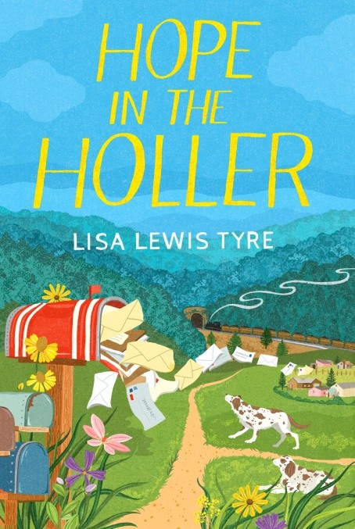

Inquiries: rights@upstartcrowliterary.com p. 7

WEST, Jacqueline | MIDDLE GRADE FICTION
September 2018  Middle Grade Fiction (10 and up) HarperCollins/Greenwillow (US) ISBN 9780062691699 | A lush, magical new series from a New York Times bestselling author  THE COLLECTORS  Jacqueline West  Giovanni ‘Van’ Markson is no stranger to loneliness. Traveling the globe with his opera-star mother makes it hard to keep friends. When Van spots a girl and a squirrel stealing pennies from a fountain, he discovers the Collectors—a secret organization that believes wishes are a menace to society. He also meets Ivor Hvalborg, an elderly gentleman with a vast collection of curious trinkets and something more curious still: tiny creatures known as Wish Eaters, who feed on the energy of wishes. Van is plunged into a war over the fate of the Wish Eaters and must choose sides. But who can he trust and who simply wants to use him for their own ends? Van will have to do a little wishing of his own … but all wishes have consequences, and there is always a price.  Jacqueline West is the author of the New York Times–bestselling Books of Elsewhere series, as well as a poet and fiction writer twice nominated for the Pushcart Prize. She lives in Minnesota. www.jacquelinewest.com  Review materials: Edited manuscript; typeset pages PDF available Fall 2017 | NEW TITLE
ALLEN, Rachael | TEEN FICTION
January 2018  Teen fiction (12 and up) Amulet Books / Abrams (US) ISBN 1419725416/hardcover | A swoon-worthy read for fans of Jennifer E. Smith and Jandy Nelson  A TAXONOMY OF LOVE  Rachael Allen  When Spencer meets Hope the summer before seventh grade, it’s . . . something at first sight. The pair become fast friends, and suddenly, after years of being teased because of his Tourette’s Syndrome, Spencer finally feels like he belongs.  Through sibling feuds and family tragedies, new relationships and broken hearts, the two grow together and apart, and Spencer, an aspiring scientist, tries to map it out using his trusty system of taxonomy. He wants to identify and classify their relationship, but in the end, he finds that life doesn’t always fit into easy-to-manage boxes – and it’s this messy complexity that makes life so rich and beautiful.  Humorous and filled with emails, letters, chats, and charts, A TAXONOMY OF LOVE is will bring to mind international bestseller ONE DAY, as well as the classic film WHEN HARRY MET SALLY.  Rachael Allen is the author of The Revenge Playbook and 17 First She lives in Decatur, Georgia. rachaelallenwrites.blogspot.com  Review materials: typeset pages PDF | NEW TITLE
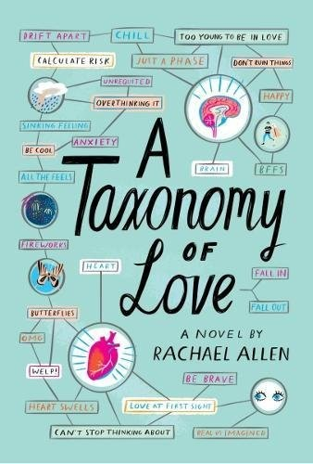

Inquiries: rights@upstartcrowliterary.com p. 8

ISRAEL, Julie | TEEN FICTION
May 2017  Teen fiction (12 and up) Kathy Dawson Books/PRH ISBN 978-0735228177 HC | Funny, warm, and moving—a novel about loss and making our own joy  JUNIPER LEMON’S HAPPINESS INDEX  Julie Israel  Sixty-five days after the death of her older sister, sixteen-year-old Juniper discovers the break-up letter addressed to “You” Camilla wrote the day she died. Juni is shocked—she knew nothing of this You, and now the gaping hole in her life that was her sister feels that much bigger. She’s determined to uncover the identity of You and deliver the letter. But what Juniper doesn’t expect is that in searching for You she will unearth other notes and secrets—and that may be just what she needs to sort out her own mess.  Praise for JUNIPER LEMON’S HAPPINESS INDEX  ★ “Heartwarming . . . A well-told story of teen struggles and grief that will resonate with readers.”—School Library Journal, starred review  “Genuine and satisfying.”—Booklist  Julie Israel lives in Portland, Oregon. This is her debut novel.  Review materials: Finished books; typeset pages PDF  Rights Information: Canada (Editions AdA), France (Casterman Jeunesse), Italy (Mondadori), Poland (Wydawnictwo IUVI), UK (Penguin Random UK) | NEW TITLE
KONEN, Leah | TEEN FICTION
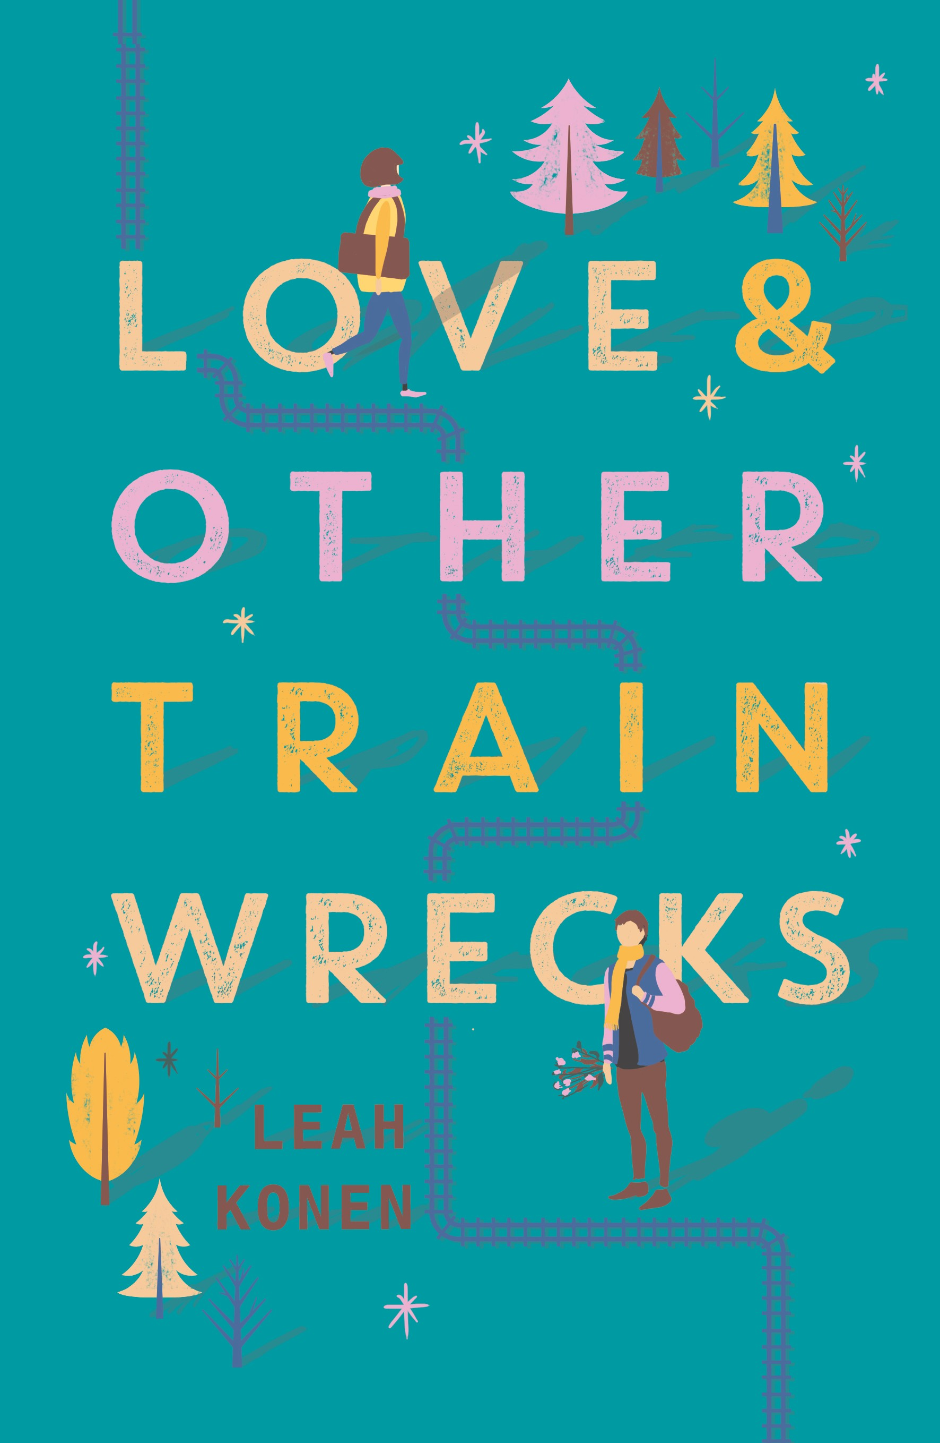  February 2018  Teen fiction (12 and up) Katherine Tegen Books (US) ISBN 9780062402509 HC  9780062402523/ebook | A hilarious rom-com of star-crossed love from the author of THE ROMANTICS  LOVE AND OTHER TRAIN WRECKS  Leah Konen  Seventeen-year old Ammy West is not in the mood for love. She’s on a train, bound for her father’s commitment ceremony in Hudson, and dreading every minute of it. Even worse, her seatmate is a ball cap-wearing bro, who introduces himself as Noah Adler. He’s clutching a bouquet of flowers and prattling on about winning back his ex-girlfriend. When the train breaks down, Noah concocts a crazy plan to get them both to Hudson on time, sending them on a mad-cap adventure through the snowy hills of upstate New York. The day is a disaster, but it’s the most fun Ammy’s had in forever. And with time running out, she doesn’t know which she dreads more—her father’s ceremony, or saying goodbye to Noah.  A hilarious romp, perfect for fans of Rainbow Rowell.  Leah Konen is the author of The Last Time We Were Us and The Romantics and lives in Brooklyn, New York. www.leahkonen.com  Review materials: Copyedited manuscript; typeset pages PDF available Fall 2017 | NEW TITLE

Inquiries: rights@upstartcrowliterary.com p. 9

TOLCSER, Sarah TEEN FICTION
A sweeping, immersive fantasy for fans of Sabaa Tahir and Kristin Cashore  WHISPER OF THE TIDE (Song of the Current, Book 2)  Sarah Tolcser  Caro and Markos have settled into a grim routine: Wake up, eat breakfast, and try to figure out who might attempt to assassinate Markos. Markos’s claim to the throne is shaky without the support of an army. But then a powerful Archon offers Markos the military might he needs in exchange for marrying his daughter. Markos and Caro must decide which is more important: their love for each other or the fate of Akhaia.  Teeming with shipwrecks, lost treasure, enemies old and new, sinister dark magic and breathtaking romance, the second entry in Sarah Tolcser’s epic saga is about chasing fate and charting your own course.  June 2018  Teen fiction (12 and up) Bloomsbury (US & UK) ISBN 978-1681192994 HC  SONG OF THE CURRENT (Song of the Current, Book 2)  Seventeen-year-old Caro is destined for the river, like her father and her grandmother before him. All Caro needs is for the river god to whisper her name, and her fate is sealed. So when pirates burn ships and her father is arrested, Caro volunteers to transport mysterious cargo in exchange for his release.  But the cargo is something unexpected and dangerous, and she finds herself caught in a web of politics and lies. With much more than her father's life at stake, Caro must choose between a future she knows, and one she could have never imagined.  Sarah Tolcser made her debut with this novel and its sequel. She lives in New Orleans, Louisiana. www.sarahtolcser.com  Praise for Song of the Current:  A Goodreads YA Best Books of the Month for June 2017  June 2017 ★ “Tolcser blends the right amount of epic fantasy, sea voyage, and romance for a  Teen fiction (12 and up)  Bloomsbury (US & UK) rollicking, swashbuckling adventure.”—Kirkus Reviews, starred review  Hardcover  ISBN 978-1681192970 ★ “Will take readers on an adventure and leave them craving more. Highly  recommended.”—School Library Journal, starred review  Review materials Finished books or PDF of final typeset pages  Rights Information: World English (Bloomsbury), Spanish in Latin America (V&R Editoras), Brazil (V&R Brazil) | NEW TITLE
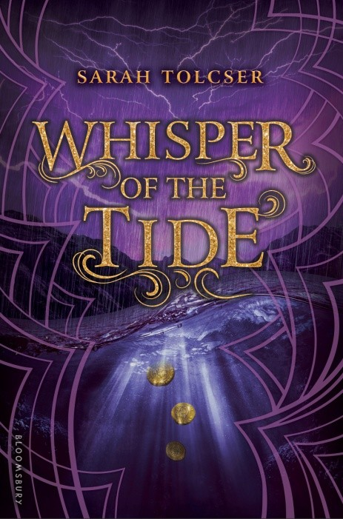
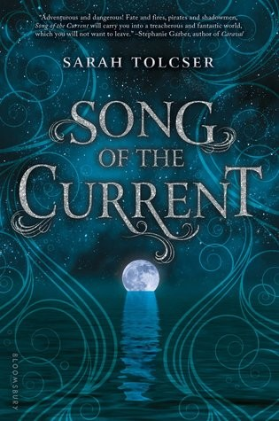
Inquiries: rights@upstartcrowliterary.com p. 10

Upstart Crow Literary &

COMPLETE REPRESENTED BACKLIST

Frankfurt Book Fair September 2017

Upstart Crow Literary The Inkhouse
244 5th Avenue, 11th floor
New York, NY 10001 212.686.5834
Inquiries: michael@upstartcrowliterary.com

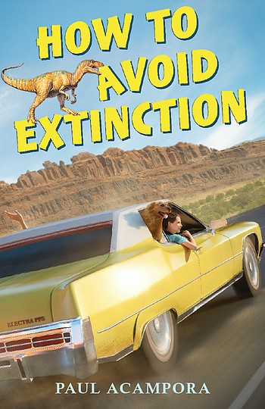

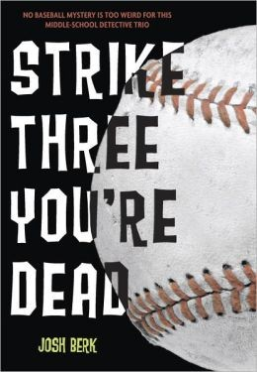
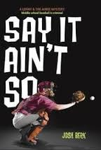
March 2014 (SAY IT AIN’T SO)
Middle grade fiction (10 and up) Knopf/Penguin Random House (US) ISBN 978-0375870095 HC
 | ACAMPORA, Paul | MIDDLE GRADE FICTION
Fall 2016  Middle Grade fiction (12 and up) Scholastic  ISBN 978-0545899062 HC  ISBN 978-0545899079 PB |  | A fast-paced family road-trip story full of humor and heart  HOW TO AVOID EXTINCTION  Paul Acampora  Nothing has been the same for Leo since his Grandfather’s death a year ago. Then, as the one-year anniversary arrives, Leo’s Grandmother takes off—she wants to go across country and see dinosaur bones, something she and her husband always wanted to do together. So Leo, his cousin Abbey, their dog Kermit and Gram, head across country, landing eventually in Utah where they intend to visit the Cleveland Lloyd Dinosaur Quarry. Except that Gram decides to take off on her own and Leo’s got to find his missing grandparent. He can’t lose both of them!  Praise for HOW TO AVOID EXTINCTION  “Memorable characters, intelligent banter, and wry humor reminiscent of Richard Peck or Gary Paulsen make this an authentic and unforgettable journey.”—School Library Journal  “Acampora tucks laughter, tears, light doses of life wisdom, impressive fossils, and any number of appealing characters into this amiable odyssey.”—Booklist  Paul Acampora is the acclaimed author of many novels, including I Kill the Mockingbird (2013). He lives in Pennsylvania. www.paulacampora.com | NEW TO UPSTART’S LIST
BERK, Josh |  | MIDDLE GRADE FICTION

ISBN 978-0307930064 PB

Spring 2013 (STRIKE THREE)
Middle grade fiction (10 and up) Knopf/Penguin Random House (US) ISBN 978-0803734333 HC
ISBN 978-0307930071 PB

A pair of hysterically funny mysteries from an award-winning author

STRIKE THREE, YOU’RE DEAD & SAY IT AIN’T SO
Josh Berk

When Lenny Norbeck realizes his dream—to announce a real, live baseball game— something goes very, very wrong. A young pitcher drops dead on the mound. The official verdict is that he died of a heart attack, but Lenny has a hunch there's something more going on. The suspects are many, and though Lenny barks up the wrong tree a few times, he’s always right on the heels of the real killer. . . .

Josh Berk is the author of Guy Langman: Crime Scene Procrastinator and The Dark Days of Hamburger Halpin, which received multiple starred reviews, a Parent’s Choice Silver Honor Award, and was on the Best of the Year lists from Kirkus and Amazon.

Praise for the series

“Readers should enjoy both the baseball storyline and goofy but realistic characters”—Publishers Weekly

“An enjoyable baseball story that young fans will follow all the way to the bottom of the ninth”—Kirkus

Inquiries: rights@upstartcrowliterary.com p. 12

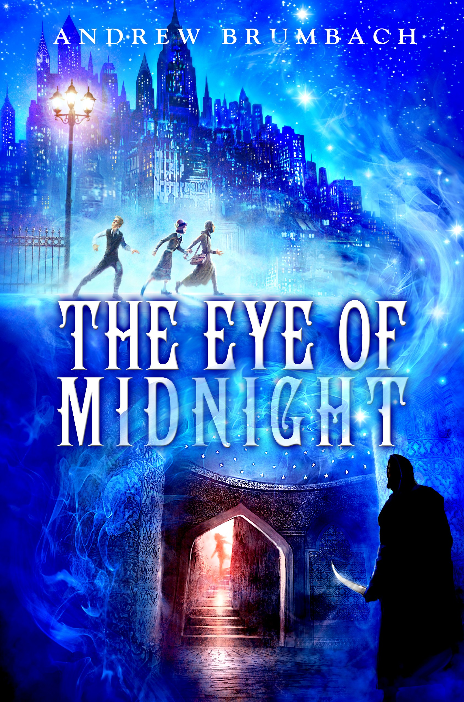
Spring 2016
BRUMACH, Andrew MIDDLE-GRADE FICTION
Middle-grade fiction (10 and up) Delacorte/Penguin Random House (NA) ISBN 978-0385744614 HC
HAUTALA, Beth MIDDLE-GRADE FICTION

An exquisitely written fantasy adventure

THE EYE OF MIDNIGHT
Andrew Brumbach

It is the summer of 1929, and cousins Maxine and William are sent to stay with a grandfather they hardly know. When Grandpa receives a cryptic telegram, he whisks the cousins off to New York City to collect a very important package. But when Grandpa disappears without a trace, Maxine and William must race through the nighttime streets of Manhattan, tussling with gangsters and cold-blooded assassins, in order to save him and recover the mysterious package.

“Reminiscent of Indiana Jones films … this danger-filled novel offers fast-paced action. [L]overs of the Rick Riordan books will enjoy this.”—School Library Journal

Andrew Brumbach is a debut author. A one-time world traveler and former options trader, he now lives in Illinois with his family.

Review materials: Copyedited manuscript * Typeset pages available August 2015

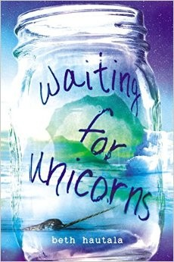
Spring 2015
Middle Grade fiction (10 and up) Philomel/Penguin Random House (US) ISBN 978-0525426318 HC
ISBN 978-0545920155 PB

A gorgeous debut about the power of wishes…

WAITING FOR UNICORNS
Beth Hautala

Talia McQuinn is much too old to believe in magic, yet she keeps a jar of wishes under her bed. When her whale-researcher father drags Tal to the Arctic for the summer following her mother’s death, she brings the jar along. During her stay, Tal learns of the ancient Inuit legend of the narwhal whale—the unicorn of the sea—she forms a plan to make the biggest wish of her life. When the entire population of whales in the Hudson Bay mysteriously disappears and an accident endangers the life of her new friend, Tal must confront the truth: no wish on earth can grant escape from her heartache, or bring her mother back.

“Lyrical and evocative … an author to watch.”—Kirkus

“[An] affecting exploration of grief and the hope that can come through the love of good friends.… This story will stay with readers.”—Publishers Weekly

Beth Hautala is also the author of The Ostrich and Other Lost Things. She lives in Northern Minnesota. www.bethhautala.com

Inquiries: rights@upstartcrowliterary.com p. 13

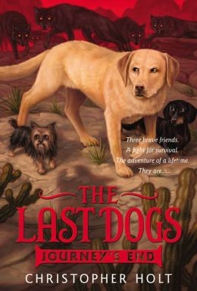

Our three heroes unravel the secret of why the people went away
JOURNEY’S END (Book 4)
Christopher Holt

A science experiment gone horribly awry has granted Max, Rocky, and Gizmo the unique ability to read and understand human words. Armed with this know-how, they continue to journey south, on the lookout for beacons planted by a trusted friend’s owner — beacons that promise to lead the trio to their people.

But danger lies ahead. . . . As their travels take them deep into the spooky swampland, can they discover what’s driven the humans away? Or have they finally reached the end of the long road?

Christopher Holt grew up in a house filled to the rafters with dogs. He lives in Seattle.
HOLT, Christopher MIDDLE-GRADE FICTION
June 2014
Middle-grade (ages 10 and up) Little, Brown (US)
ISBN 978-0316200073 HC
ISBN 978-0316200080 PB

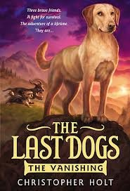
The first three installments of the Last Dogs saga

THE VANISHING (Book 1), DARK WATERS (Book 2) & THE LONG ROAD (Book 3)
Max, a Labrador retriever, joins forces with Rocky, a dachshund, and Gizmo, a Yorkie, to learn what happened to the people of the world.

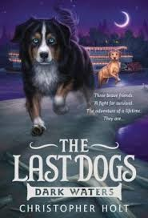
Parents’ Choice Silver Honor Award Winner
Scholastic Book Club and Children’s Book-of-the-month Book Club pick “A post-apocalyptic Animal Farm for young readers”—Kirkus
"With suspense, action-adventure, and some droll touches...[The Last Dogs] offers a fast-paced read”—
Booklist

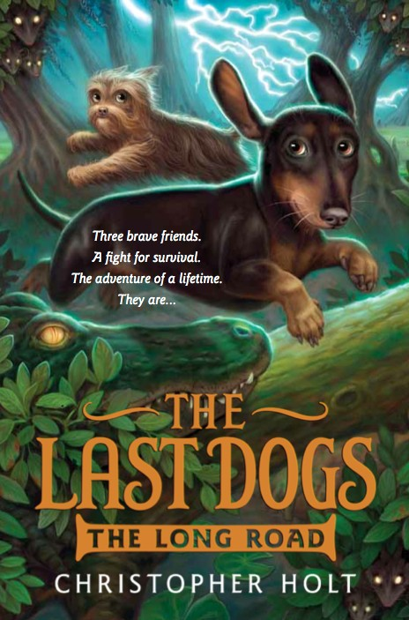
"Fans of animal adventure stories and mysteries will enjoy this exciting look at the resiliency and ingenuity of dogs”—VOYA

THE LAST DOGS: THE VANISHING
September 2012
Middle-grade (ages 10 up) Little, Brown/NA
ISBN 978-0316200059 HC
ISBN 978-0316200042 PB
THE LAST DOGS: DARK WATERS
June 2013
Middle-grade (ages 10 up) Little, Brown/NA
ISBN 978-0316200127 HC
ISBN 978-0316200097 PB
THE LAST DOGS: THE LONG ROAD
June 2013
Middle-grade (ages 10 up) Little, Brown/NA
ISBN 978-0316200134 HC
ISBN 978-0316200097 PB

Rights Information: NA (Little, Brown), France (La Martiniere), Simplified Chinese (Phoenix Hachette)

Inquiries: rights@upstartcrowliterary.com p. 14

LARIVIERE, Sarah | MIDDLE-GRADE FICTION
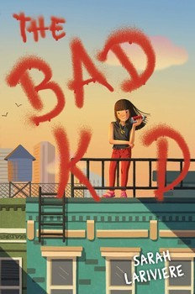  September 2016  Middle Grade fiction (12 and up) Simon & Schuster (US)  ISBN 978-1481435819 HC | A colorful and hilarious mystery reminiscent of Harriet the Spy  THE BAD KID  Sarah Lariviere  2017 Edgar Award (Mystery Writers of America) Finalist!  Claudeline Feng LeBernardin is very good at being bad. Her Grandpa Si was a real- life gangster, and Claude always thought she’d take over the family business when he was gone. Instead, Claude’s dad is in charge—and she’s sure he’s running things into the ground. When a very strange character shows up in the neighborhood, Claude gets closer to the crime life than ever. Before long, she’s swept up in a maddening mystery that’s got her wondering: What does it really mean to be bad?  “Sharp, fun, and optimistic, the novel will have readers rooting for Claude until the end.”—Kirkus Reviews  “A treat.”—Booklist  "The humor, quirky characters, and contemporary New York setting, combined with the gangster lore, make this ideal for middle grade readers who enjoy slightly naughty characters with hearts of gold." – School Library Journal | NEW TO UPSTART’S LIST
MIDDLETON, Dana | MIDDLE-GRADE FICTION
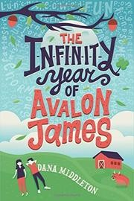  October 2016  Middle Grade fiction (12 and up) Feiwel & Friends / Macmillan ISBN 978-1250085696 HC | “a fine, tenderly nuanced tale of the remarkable power of friendship”*  THE INFINITY YEAR OF AVALON JAMES  Dana Middleton  Avalon James and her best friend Atticus are finally ten years old. They’ve been waiting for this—their Infinity Year—forever. This is the year they’ll each develop a magical power that will disappear the day they turn eleven. No one knows their power until it comes. The only thing certain thing is that the strength of their magic lies in the depth of their own friendship. But then Avalon accidentally betrays Atticus’s deepest secret, and Atticus stops speaking to her. Avalon is desperate for things to return to normal, but it looks like Infinity Magic might be the only thing strong enough to heal their rift.  ★ “Painfully acquired life lessons are related in Avalon's genial, evocative voice… A fine, tenderly nuanced tale of the remarkable power of friendship.”―Kirkus Reviews, starred review*  ★ “Avalon’s first-person narrative is forthright and engaging… A well-knit first novel with an involving, affecting story.” ―Booklist, starred review  Dana Middleton grew up in Georgia and now lives in Hollywood, CA. She is also the author of The Infinity Year of Avalon James. | NEW TO UPSTART’S LIST

Inquiries: rights@upstartcrowliterary.com p. 15

TOUGAS, Shelley | MIDDLE-GRADE FICTION
October 2017  Middle Grade fiction (12 and up) Roaring Brook/Macmillan  ISBN 978-1626724181 HC | One girl’s mom takes her love of the Little House series just a bit too far  LAURA INGALLS IS RUINING MY LIFE  Shelley Tougas  Charlotte’s mom has just moved the family across the country to live in Walnut Grove, “childhood home of pioneer author Laura Ingalls Wilder.” Mom’s idea is that the spirit of Laura Ingalls will help her write a bestselling book. But Charlotte knows better: Walnut Grove is just another town where Mom can avoid responsibility. And this place is worse than everywhere else the family has lived―it’s freezing in the winter, there’s nothing to do, and the people talk about Laura Ingalls all the time.  Charlotte’s convinced her family will not be able to make a life on the prairie―until the spirit of Laura Ingalls starts getting to her, too.  “Strong characters and fast plotting propel readers to a sweet, realistic end… Lovely.”—Kirkus Reviews  Shelley Tougas is an award-winning writer of nonfiction for children, as well as several novels. She lives in Hudson, Wisconsin. | NEW TO UPSTART’S LIST
TYRE, Lisa | MIDDLE GRADE FICTION
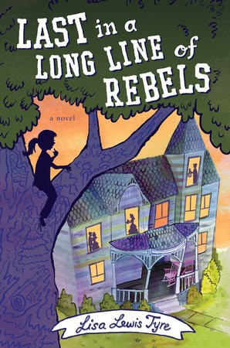  Fall 2015  Middle Grade fiction (12 and up) Nancy Paulsen Books/PRH (US) ISBN 978-0399168383 HC  ISBN 978-0147512031 PB | A young girl in a small town stumbles upon old family secrets  LAST IN A LONG LINE OF REBELS  Lisa Tyre  Lou might be only twelve, but she’s never been one to take things sitting down. So when her Civil War-era house is about to be condemned, she’s determined to save it—either by getting it deemed a historic landmark or by finding the stash of gold rumored to be hidden nearby during the war. As Lou digs into the past, her eyes are opened when she finds that her ancestors ran the gamut of slave owners, renegades, thieves and abolitionists. But those Civil War era prejudices survive even to the present day, and Lou decides it’s never too late to fight injustice.  ★ “An accomplished debut.”—Publishers Weekly, starred review  “Spunky, realistic characters; well-drawn small-town-Tennessee setting; and thought-provoking portrayals of racism, past and present, make for a compelling mix of mystery and history.”—Horn Book Guide  Lisa Lewis Tyre lives in Atlanta, Georgia. This is her debut novel. | NEW TO UPSTART’S LIST

Inquiries: rights@upstartcrowliterary.com p. 10

TOUGAS, Shelley MIDDLE-GRADE FICTION
A PATRON SAINT FOR JUNIOR BRIDESMAIDS  A bully, a wedding, and a larger-than-life family add up to a hilarious and heartfelt middle-grade novel.  Mary Margaret Miller is going to be a junior bridesmaid – that is, if she isn't grounded for the rest of her life. She's feuding with the school bully and her cousin Eden, aka The Bride, is clashing with her grandmother about wedding plans. Mary knows it's her job as a junior bridesmaid to make the day run smoothly, but she sure could use a little help from above.  “A lighthearted summer read about faith, family, and figuring out who you are in the midst of a lot of noise.”—BCCB  October 2016  Middle Grade fiction (12 and up) Roaring Brook/Macmillan (US) ISBN 9781626724037 HC  ISBN 978-1250143754 PB  FINDERS, KEEPERS  Two friends playing finders keepers search for the missing loot of Al Capone.  Christa spends every summer at her family's cabin on Whitefish Lake, WI. Only her dad recently lost his job and her parents have decided to sell the cabin. But not if Christa can help it. Everyone knows there is Al Capone money hidden somewhere in Whitefish Lake, and her friend Alex's cranky grandpa might have the key to finding it. Grumpa says the loot is gone, or worse—cursed!—but Christa knows better. That loot is the only thing that can save her family.  ★ “A charming story of family history and personal connections that is reminiscent of Blue Balliett and the Penderwicks' adventures.”—Booklist, starred review  October 2015  Middle Grade fiction (12 and up) “The fast-paced ending has enough bite to satisfy…. Entertaining and humorous.”  Roaring Brook/Macmillan  ISBN 9781596439900 HC —Kirkus Reviews  ISBN 978-1250090522 PB  THE GRAHAM CRACKER PLOT  Daisy is determined to break Daisy's dad out of prison in this hilarious debut  No one believes her, but Daisy Bauer knows her dad has been wrongfully imprisoned and it's up to her to break him out of jail. She has a plan – she just needs a miniature horse, a getaway truck, and a penny from 1919.  This funny, nail-biter of a novel is about friendship and how to admit when you’re wrong. Novelist Shelley Tougas balances humor and warmth against themes of family, broken trust, and unconditional love against all odds.  “Quite touching.”—BCCB  October 2015  Middle Grade fiction (12 and up) “Readers will find themselves rooting for Daisy and Graham.” —Kirkus Reviews  Roaring Brook/Macmillan  ISBN 9781596439887 HC  ISBN 978-1250068101 PB Shelley Tougas is an award-winning writer of nonfiction for children and the author  of several novels. She lives in Hudson, Wisconsin. | NEW TO UPSTART’S LIST
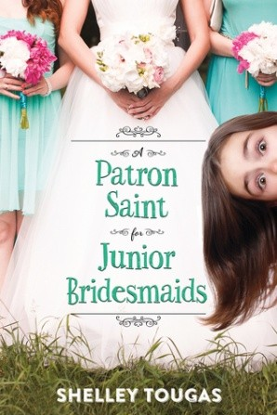
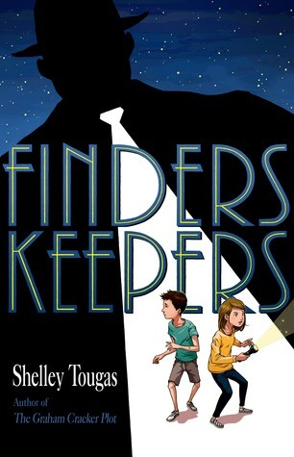

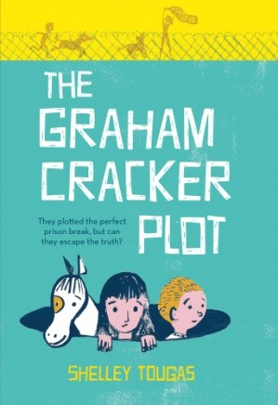
Inquiries: rights@upstartcrowliterary.com p. 17

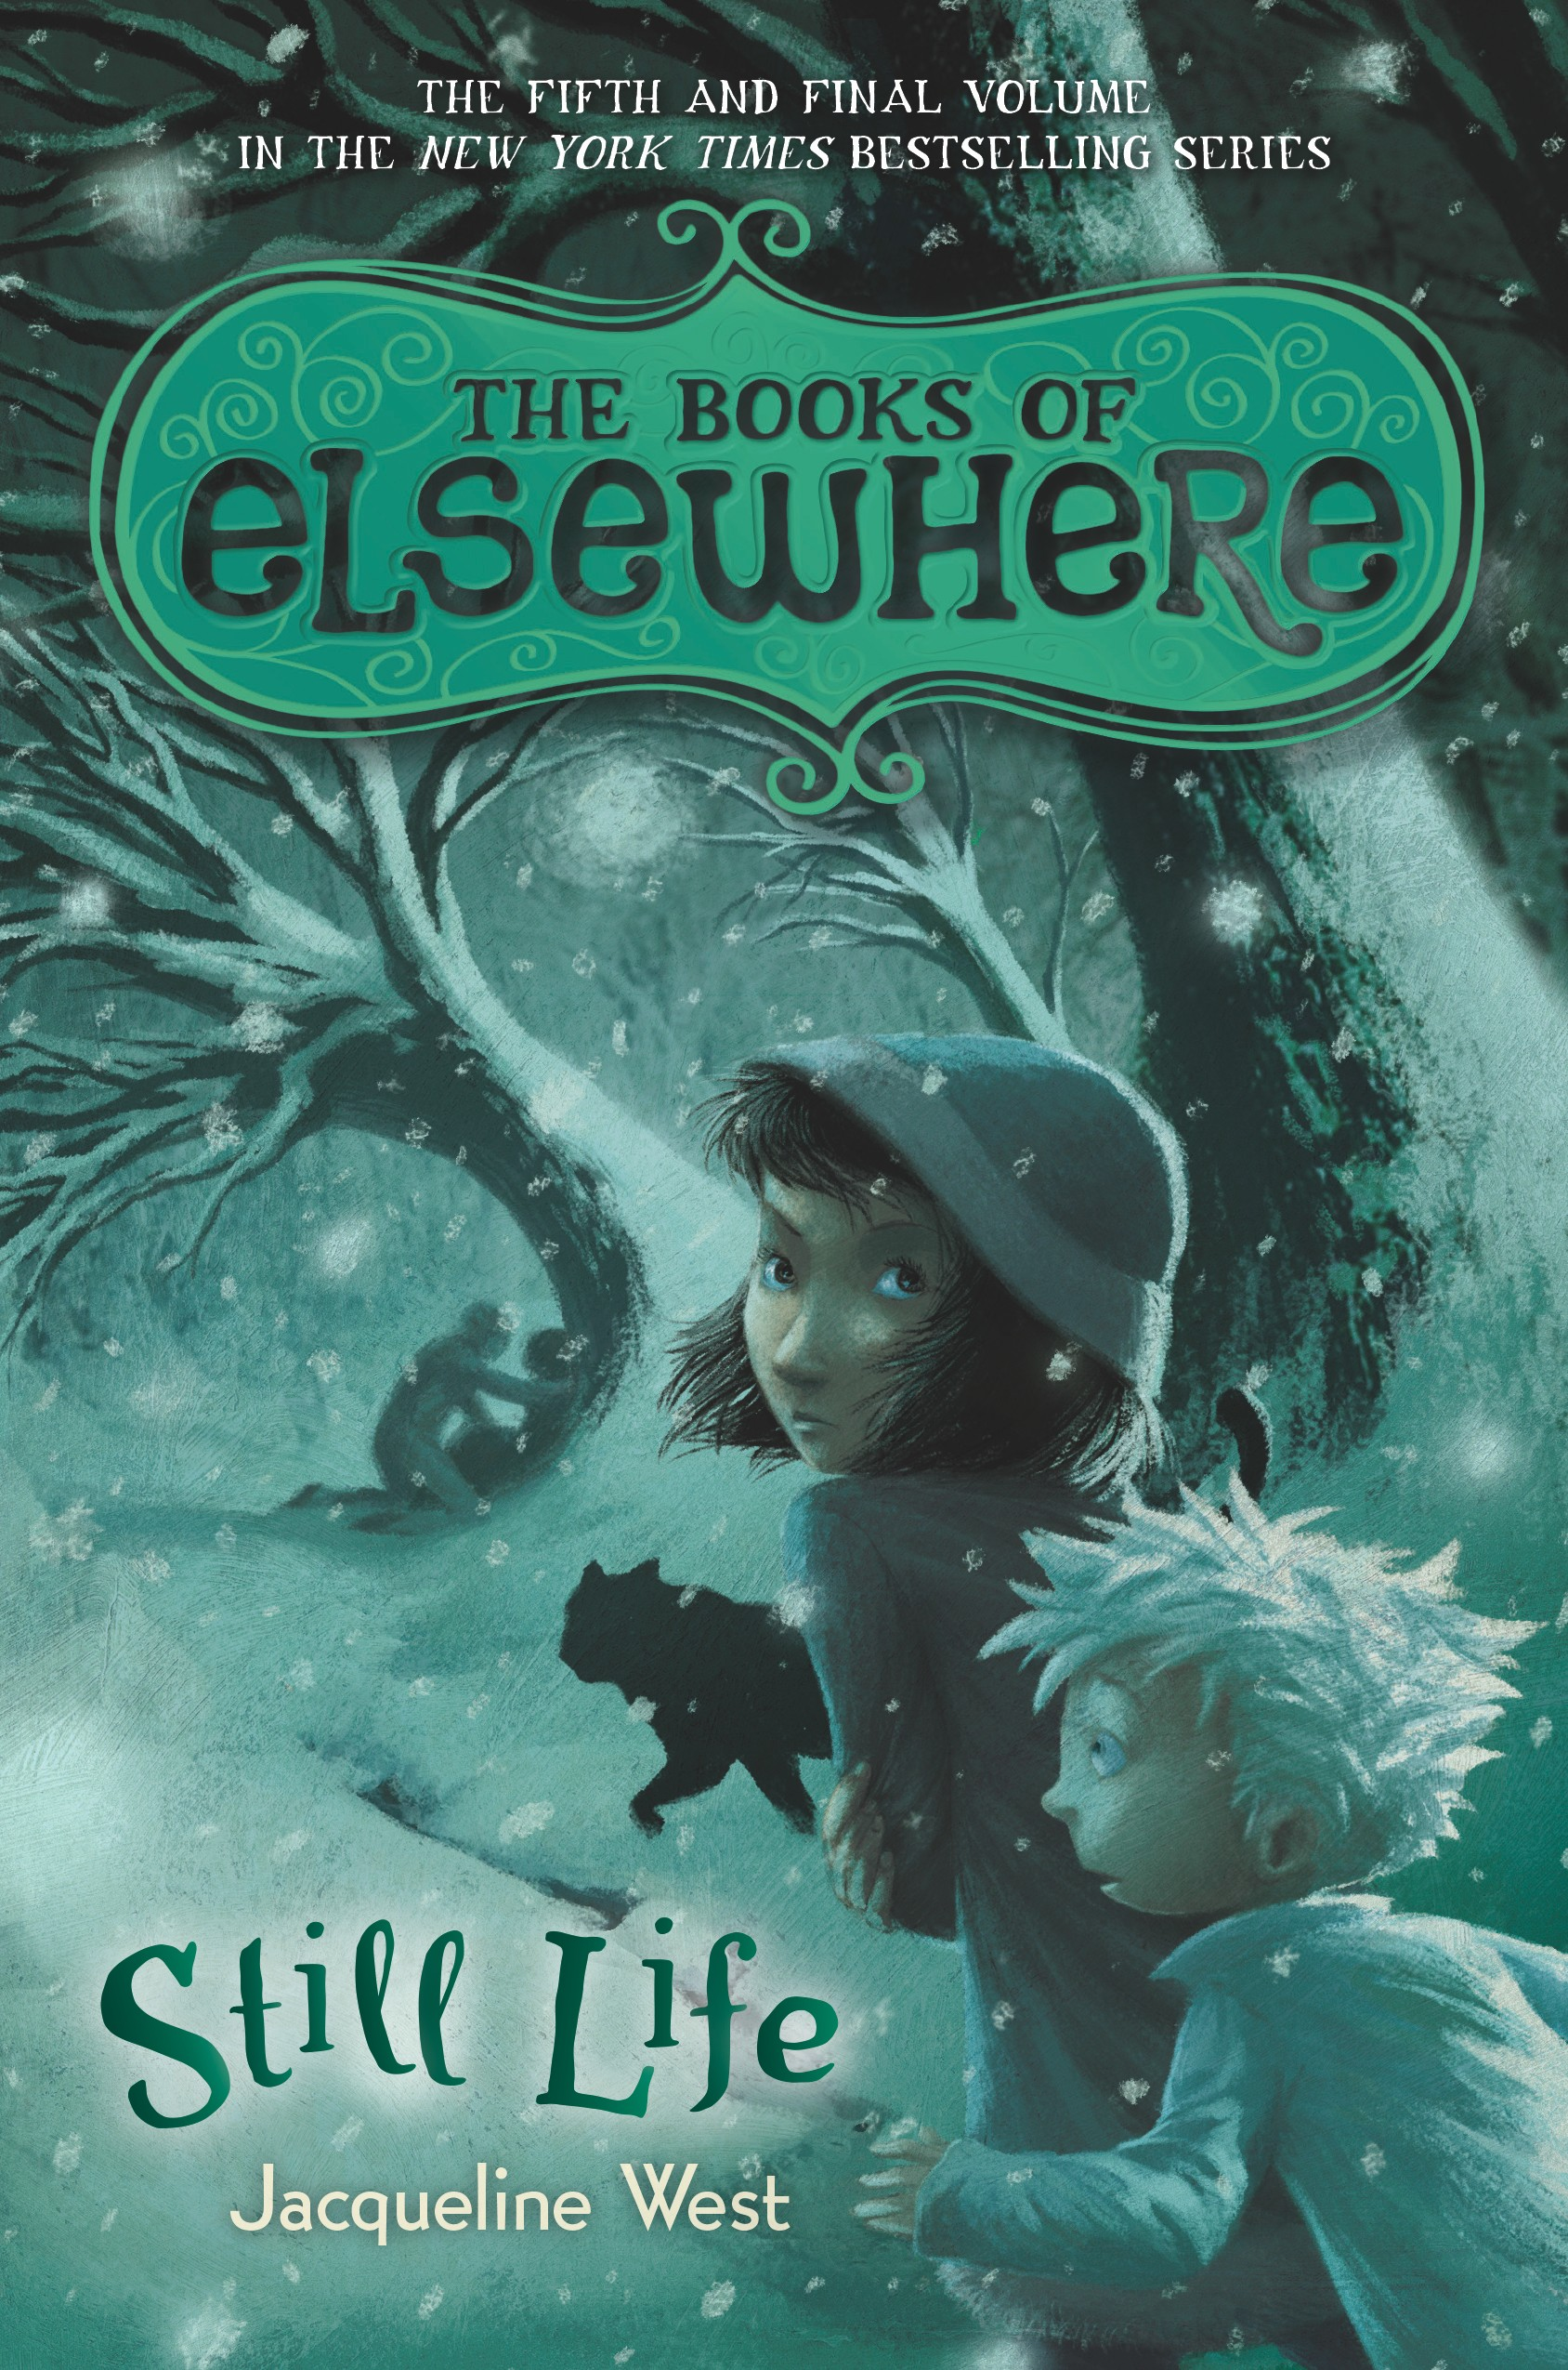

June 2014
WEST, Jacqueline MIDDLE-GRADE FICTION
Middle-grade fiction (10 and up) Penguin/Dial (US)
ISBN 978-0803736917 HC

The New York Times–bestselling series!

STILL LIFE: BOOKS OF ELSEWHERE, BOOK V

Jacqueline West

Olive’s house is keeping one last secret—the most dangerous yet

Annabelle McMartin is gone for good, but something worse lurks just out of sight-- watching, waiting, preparing to strike. Then a field trip to the local art museum reveals a shock. What Olive discovers will create a chain of events that propel her to discoveries she may not wish to uncover, involving Morton's vanished parents and the very deepest, darkest roots of Aldous McMartin's creepy painted world.

In this fifth and final book, Olive must seek the full, complex story of Elsewhere, its magical origins, and its creator, and in so doing, face her own fears and limitations-- and possibly the destruction of Elsewhere itself. How far will Olive go to save the people and home she loves? And what will be the final cost?

Jacqueline West is an award-winning poet and short story writer who has twice been nominated for a Pushcart Prize, as well as the author of The Collectors and Dreamers Often Lie. www.booksofelsewhere.com

ISBN 978-0142422977 PB

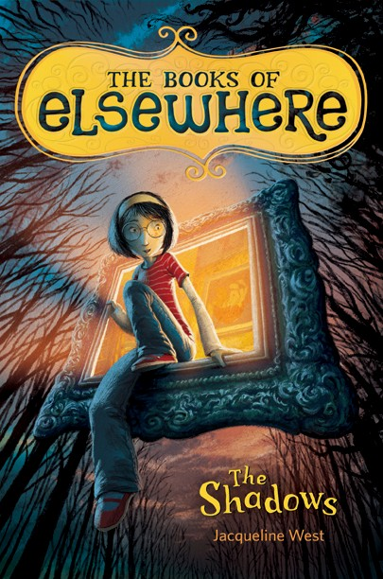
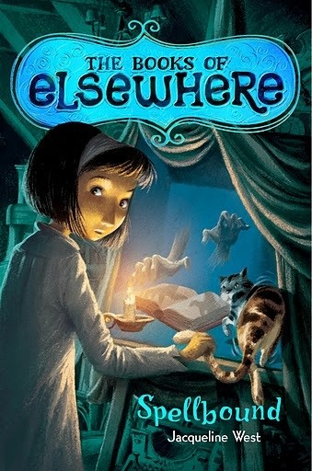
The first four installments in the spellbinding Books of Elsewhere series
THE SHADOWS, SPELLBOUND
THE SECOND SPY & THE STRANGERS

Reviews and Praise for THE BOOKS OF ELSEWHERE

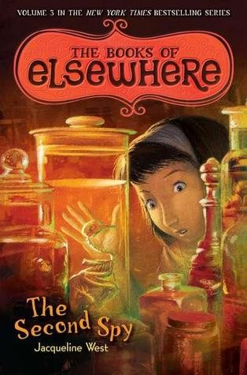
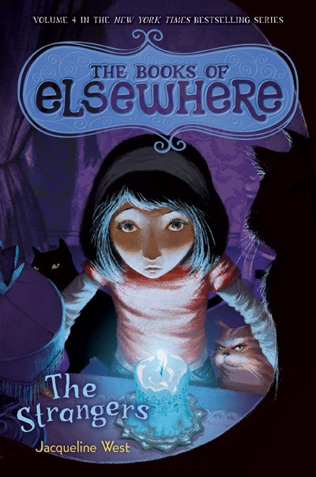
“Suspenseful … Will have readers anxiously awaiting the next book."—Publishers Weekly (starred review)

“Will be a hit with young fantasists ready for a measured helping of menace.”—BCCB (starred review)

“5 out of 5 stars.” —Atlanta Examiner

THE SHADOWS (Book 1)
July 2010
Middle-grade fiction (10 up) Penguin/Dial (US)
ISBN 978-0803734401 HC
ISBN 978-0142418727 PB
SPELLBOUND (Book 2)
July 2011
Middle-grade fiction (10 up) Penguin/Dial (US)
ISBN 978-0803734418 HC
ISBN 978-0142421024 PB

THE SECOND SPY (Book 3)
July 2012
Middle-grade fiction (10 up) Penguin/Dial (US)
ISBN 978-0803736894 HC
ISBN 978-0142426081 PB
THE STRANGERS (Book 4)
July 2013
Middle-grade fiction (10 up) Penguin/Dial (US)
ISBN 978-0803736900 HC
ISBN 978-0142425756 PB

Rights Information: NA (PenguinRH US), Catalan (Grup 62), China (Trustbridge), Germany (Rowohlt), France (Editions du Seuil), Greece (Patakis), Indonesia (UFUK Press), Italy (Piemme), Norway (CappelenDamm), Russia (AST), Spain (Ediciones Siruela), Sweden (B Wahlströms), Turkey (Yayincilik)

Inquiries: rights@upstartcrowliterary.com p. 18

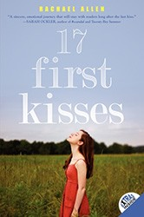

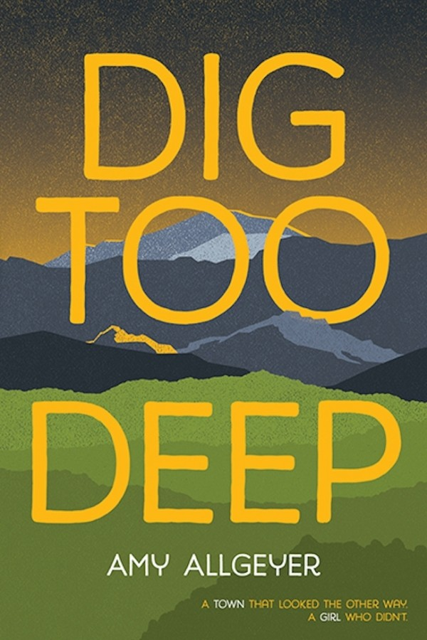
April 2016
Teen fiction (12 and up) Albert Whitman (WE) ISBN 978-0807515808 HC
 | ALLEN, Rachael | TEEN FICTION
 |  | 17 FIRST KISSES | NEW T
 |  | In this incandescent page-turner, sixteen-year-old Claire learns the unfortunate | O U
 |  | truth that sometimes a girl has to kiss a lot of frogs. . . . Brilliantly capturing the | PS
 |  | complexities of friendship and the difficulties of trying to find love in high school, | TA
 |  | Rachael Allen has crafted a rich debut that's impossible to put down. | RT’
 |  | “With perfect pitch, 17 FIRST KISSES delivers laughter, tears, and hopefulness in | S LI
 |  | equal measure. A sincere, emotional journey that will stay with readers long after | ST
 |  | the last kiss.” —Sarah Ockler, author of #scandal and Twenty Boy Summer
June 2014  Teen fiction |  | “As Claire struggles to understand if and when a boy might be worth risking a friendship, readers should find it easy to relate.”—Publishers Weekly
Harper Teen (US
ISBN 978-6228134 PB
 |  | THE REVENGE PLAYBOOK
 |  | In this poignant and hilarious novel, Rachael Allen brilliantly explores the nuances
 |  | of high school hierarchies, the traumas sustained on the path to finding true love,
 |  | and the joy of discovering a friend where you least expect.
 |  | “This loose read alike to E. Lockhart’s The Disreputable History of Frankie Landau
 |  | Banks, celebrates girl power and focuses on challenging “old boys’ clubs”
 |  | traditions… A fun YA title that challenges sexist attitudes in modern day high school
 |  | culture.”—School Library Journal
June 2015 |  | “A deceptively light look at the dark side of football culture.” — Kirkus Reviews
Teen Fiction
Harper Teen (US)
ISBN 978-62281364 PB
ALLGEYER, Amy |  | TEEN FICTION

ISBN 78-0807515815 PB

A teen Erin Brockovich uncovers the dirty secrets of her Southern town

DIG TOO DEEP
Amy Allgeyer

Liberty Briscoe can’t shake the feeling that something’s not quite right in her new hometown of Ebbotsville, Kentucky. Everyone says the water’s safe, yet nobody drinks it. When Granny becomes sick, Liberty starts to dig up the truth about the local coal mining company … and the townspeople promise to do anything to stop her.

Amy Allgeyer is an architect and a writer and lives in Boise, Idaho.

“Lib is a finely drawn character, and the dialogue and pacing of this debut are strong.”—Kirkus Reviews

“Liberty Briscoe is a hero of a narrator: intelligent, spunky, determined, and relatable.”—VOYA

Inquiries: rights@upstartcrowliterary.com p. 19

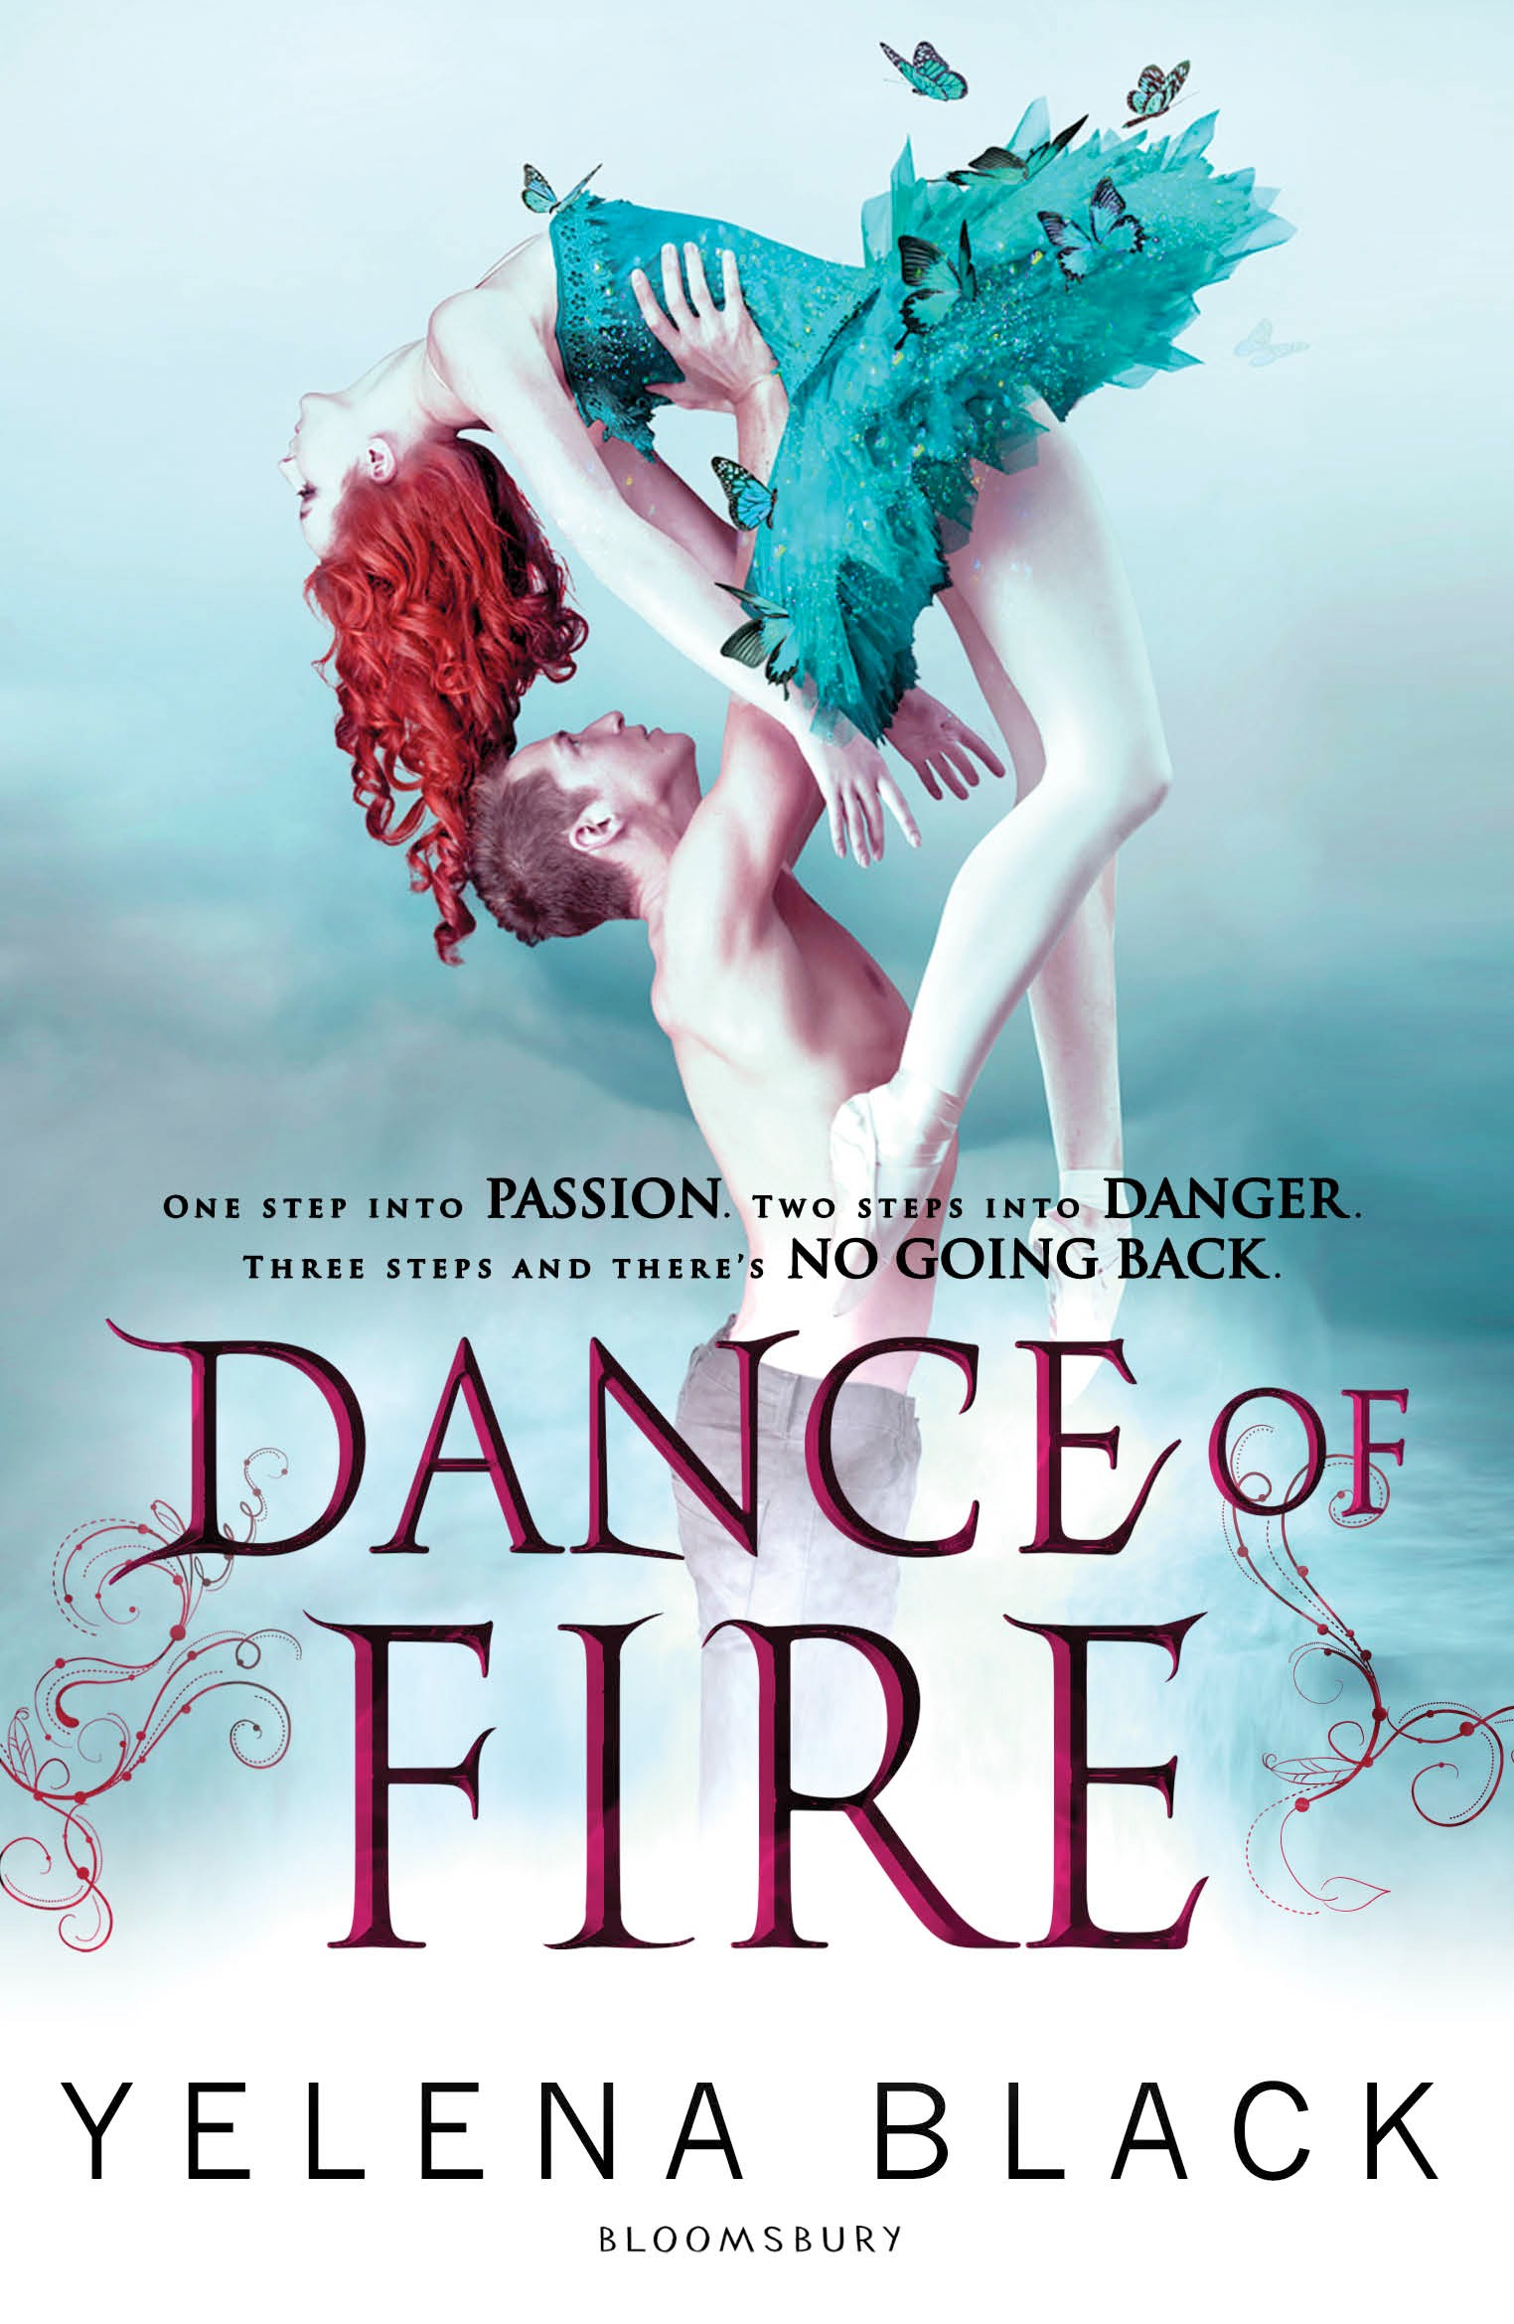

February 2015
BLACK, Yelena TEEN FICTION
Teen fiction (12 and up) Bloomsbury (UK)
ISBN 978-1408829981 PB

The breathtaking—and terrifying—Dance Diabolical duet

DANCE OF FIRE
Yelena Black

All dancers dream of the chance to try out for the Royal Court Ballet Company. Only two dancers from the elite New York Ballet Academy will have this honor. Vanessa is one of them. She dances with grace and elegance, and a fury that is unmatched. Justin—strong, sexy and caring—will be her partner.

But the thrill of travelling to London for this once-in-a-lifetime competition is shrouded by their past and the demands of an ancient organization. The Lyric Elite needs them to win the contest and to infiltrate the Royal Court Ballet in order to seek out a dark society of Necrodancers. Vanessa will dance like she has never danced before, but not for them. Vanessa is there for another reason, and she won't let anything stop her from finding her missing sister, Margaret.

Fierce rivals, dark forces, and hidden motives weave together in a gripping thriller for fans of Black Swan and Cassandra Clare's Mortal Instruments.

Yelena Black is a recent MFA graduate of Columbia University. She currently resides in New York City and is a full-time writer. She has a keen interest in dance and all things devilish.

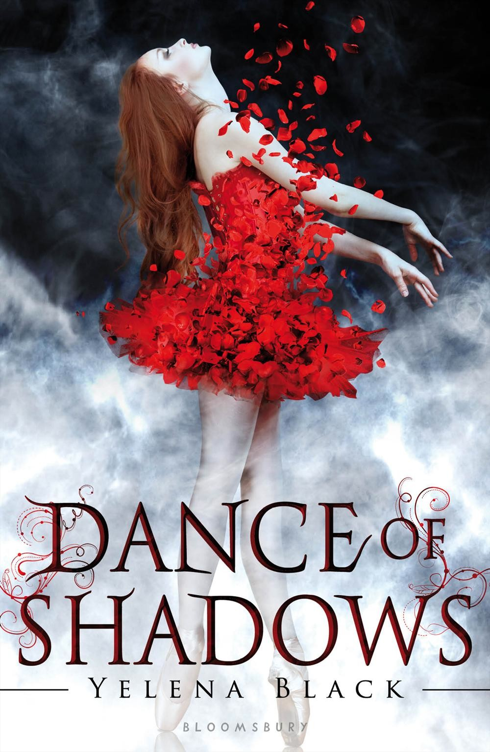
February 2013
Teen fiction (12 and up) Bloomsbury (US)
ISBN 978-1599909400 HC
ISBN 978-1619631854 PB

The heart-stopping beginning of the saga
DANCE OF SHADOWS
Yelena Black

“This debut novel is the first in a new series and is written so dynamically that the reader quickly becomes absorbed in the world of a highly competitive ballet academy combined with an occult element … The author has cleverly combined both worlds so that this book has appeal for both teen boys and girls”—VOYA

“Black pulls off an enticingly eerie conclusion, setting the stage for the next book”—Publisher’s Weekly

“[Dance of Shadows] mixes high-stakes ballet education with the occult”—Kirkus Reviews

Rights Information: US (Bloomsbury), US Audio (Audible), Brazil (Novo Conceito) UK (Bloomsbury), Finland (Albatros), France (Pocket Jeunesse), Germany (Ars Edition), Taiwan (Linking), Netherlands (Moon) Portugal (Planeta)

Inquiries: rights@upstartcrowliterary.com Film: sean@haalit.com p. 20

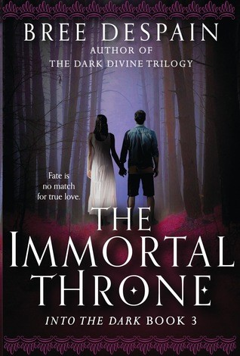
October 2016
DESPAIN, Bree TEEN FICTION
Teen Fiction (12 and up) Lerner (US)
ISBN 978-1512405835

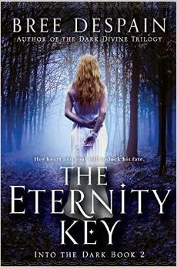
Spring 2014
Teen fiction (12 and up) Lerner (US)
ISBN: 978-1606844460 HC
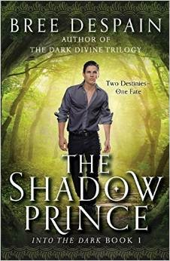
Spring 2013
Teen fiction (12 and up) Lerner (US)
ISBN: 978-1606842478 HC
ISBN: 978-1606845677 PB

The romantic Into the Dark trilogy by the author of The Dark Divine

THE IMMORTAL THRONE (Into the Dark, Book 3)
Bree Despain

Haden Lord, the disgraced Prince of the Underrealm, has chosen love over honor and will do everything in his power to protect Daphne Raines, the human girl he was supposed to bring to the Underrealm. Haden’s choice is put to the test as the Skylords and a figure from his past arrive in Olympus Hills with a plan that could destroy all of the realms.

A dark, romantic new series that explores destiny vs. choice, love vs. duty, and what it truly means to have honor.

Bree Despain is the author of the Dark Divine trilogy, which has been optioned for film by 1019 Pictures and has been translated into more than fifteen languages

The first two entries in the series…

THE SHADOW PRINCE & THE ETERNITY KEY

A re-imagining of the Persephone myth told from alternating perspectives: Haden, who must leave purgatory and bring back a mortal girl in order to claim his right to rule, and Daphne, a teenager with troubles of her own who wants— above all—to make music.

“Hits all the right notes. . . Rich world-building and swoon-worthy romance will thrill fans of mythology-based sagas and will keep readers anticipating the conclusion.”—School Library Journal

“Alternating perspectives, relatively short chapters, and quickly escalating stakes keep the pages turning…. Satisfying, and the book ends with a cliff-hanger that expertly does its job.”—Booklist

Inquiries: rights@upstartcrowliterary.com p. 21

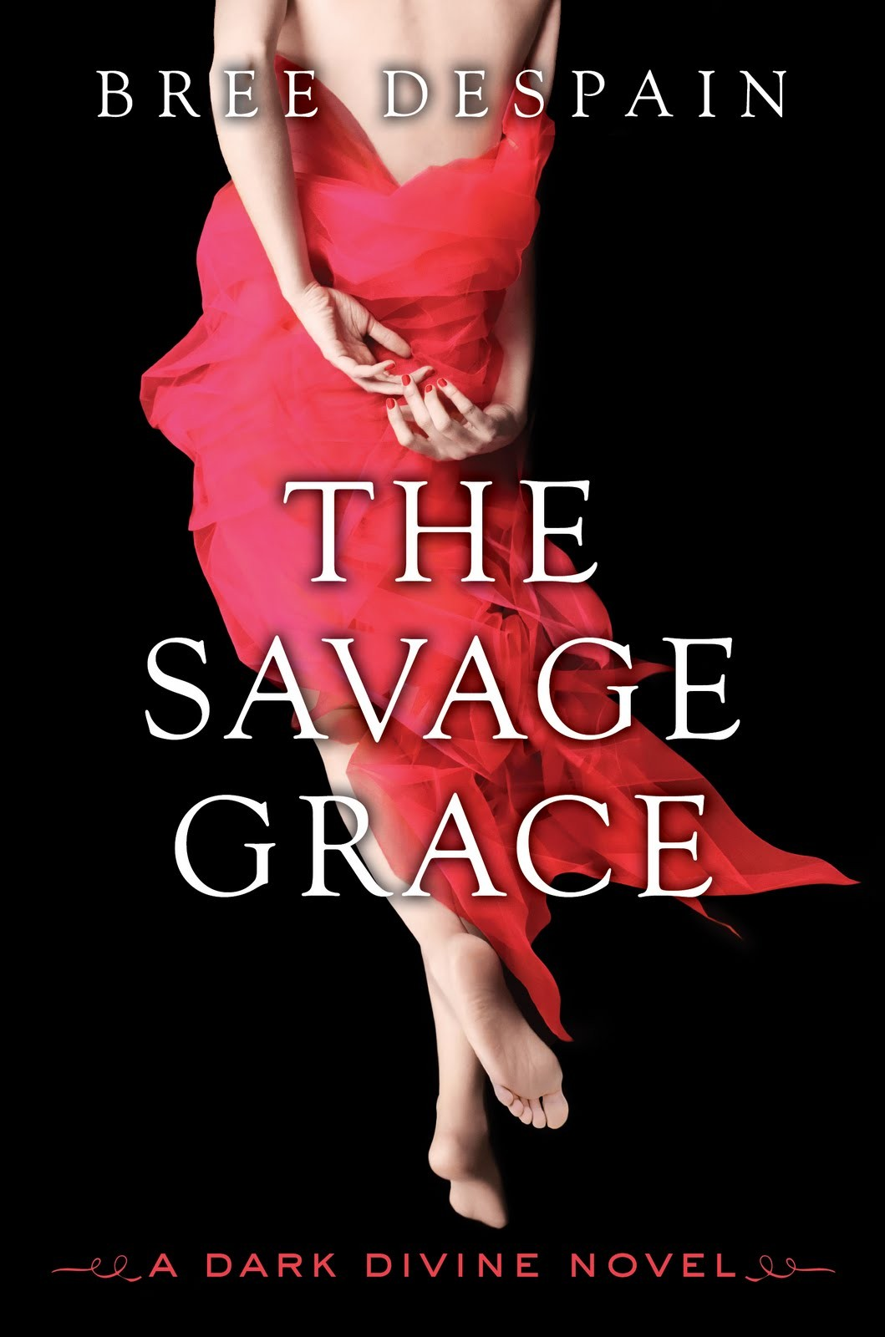
March 2012
Teen fiction (12 and up) EgmontUSA (US)
Hardcover ISBN 978-­‐1606842218

The final installment in the Dark Divine trilogy

THE SAVAGE GRACE: THE DARK DIVINE, BOOK 3
Bree Despain

Grace's life is a mess. Daniel is still a werewolf, Talbot can't be trusted, and Caleb is still out there. With Sirhan's impending death, war seems imminent. Will Grace give in to the wolf to save her family? What will happen to Daniel . . . and can their love survive one last test?

“Bree Despain takes familiar myths and legends and wraps them elegantly around a haunting story of love, loss, family and forgiveness. Beautiful." -­‐Lesley Livingston, author of Wondrous Strange

Bree Despain lives in Salt Lake City. The Dark Divine was her first novel. www.breedespain.com

Review materials
Finished book

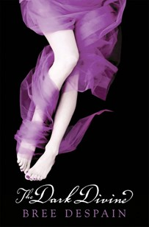
The first two entries in the thrilling paranormal series
THE DARK DIVINE & THE LOST SAINT

“Atmospheric and compelling, Despain’s first novel will be popular, and a sequel eagerly anticipated.”—Booklist

“A book that had everything I wanted... Darkly comic and surprising, this paranormal rises to the top.”—Becca Fitzpatrick, New York Times bestseller

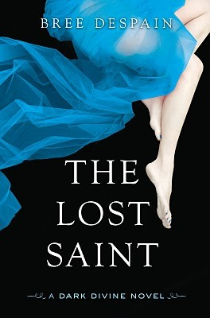
THE DARK DIVINE (Book 1)
December 2009
Teen fiction (12 and up) Egmont USA (US)
Hardcover ISBN 978-­‐1606840573 Paperback ISBN 978-­‐1606841549

Audio rights sold
- NA Audio
- Film/TV: 1019 Pictures
THE LOST SAINT (Book 2)
December 2010
Teen fiction (12 and up) Egmont USA (US)
Hardcover ISBN 978-­‐1606842003 Paperback ISBN 978-­‐1606842355

DESPAIN, Bree TEEN FICTION

Rights Information: US (Egmont USA), Brazil (V&R Editoras), Bulgaria (ERA Media), China (Beijing Booky; Complex Chinese Character), Estonia (Pegasus), France (La Martiniere), Germany (Edel), Hungary (Könyvmoly), Indonesia (PT Gramedia), Italy (Sperling), Poland (Galeria Ksiazki), Russia (Eksmo), Serbia (Evro Giunti), Spain (Ediciones B), Taiwan (Global Group), Thailand (Amarin), Turkey (Pegasus), UK (Egmont UK)

Inquiries: rights@upstartcrowliterary.com Film/TV inquiries: eddie@gotham-­‐group.com

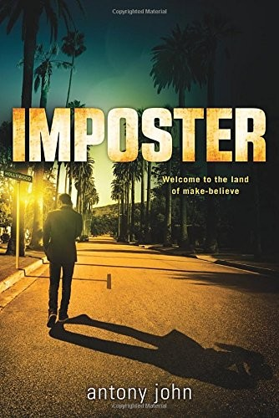
Fall 2015
JOHN, Antony TEEN FICTION
Teen fiction (12 and up)
Penguin Random House/Dial (US) ISBN 978-0803741243 HC
JOHN, Antony TEEN FICTION

A new thriller from an ALA Schneider Award-winning author

IMPOSTER

Antony John

Seth Crane has hit rock bottom. So when a producer shows up at his community theater production and offers him the lead role in an Indie film with major Hollywood buzz, it seems like the answer to all Seth’s problems. But Seth quickly learns that there is a price to fame—and he may have to pay it with his life.

Antony John was born in England and received his B.A. from Oxford University and a Ph.D. from Duke University. He is the author of Five Flavors of Dumb and the Elemental trilogy. antonyjohn.net

Praise for Antony John (Five Flavors of Dumb):

“The drama is high and the action is fast and frequent…. An intriguing and glamorous conspiracy full of makeouts and fake outs.”—School Library Journal

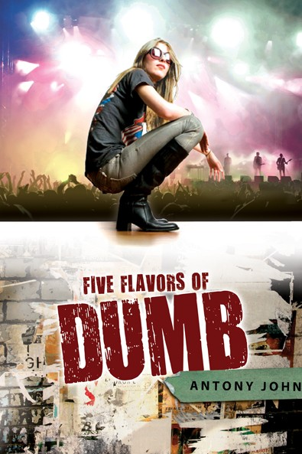
Fall 2010
Teen fiction (12 and up) Penguin/Dial (US)
ISBN 978-0803734333 HC
ISBN 978-0142419434 PB

The hilarious ALA Schneider Award winner
FIVE FLAVORS OF DUMB

Antony John

High school senior Piper Vaughn is unpopular, friendless, and deaf as a rock— but that doesn’t stop her from becoming manager for her high school's popular rock band, Dumb. Piper must rely on her wit—and the help of her genius friend Ed—to navigate the murky waters of Dumb's ascent to semi-stardom. Piper Vaughn's life just got weirder, and it might not be a bad thing.

Antony John was born in England and received his B.A. from Oxford University and a Ph.D. from Duke University. He is the author of Busted. Five Flavors of Dumb is his second novel. antonyjohn.net

American Library Association/2011 Schneider Family Book Award Winner

« “Complex characterizations, authentic dialogue and realistic ups-and-downs give this title chart-topping potential.”—Kirkus, Starred Review

“Witty yet thoughtful.”—Publishers Weekly

Inquiries: rights@upstartcrowliterary.com p. 23

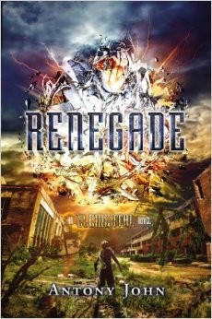
Fall 2014
JOHN, Antony TEEN FICTION
Teen fiction (12 and up) Dial/Penguin RH (US) ISBN 978-0803736825 HC

NYT bestseller James Dashner calls the Elemental trilogy “Fantastic!”

RENEGADE
Antony John

The finale to the dystopian fantasy trilogy has a daring escape from pirates, life-or- death rescue missions, and a heartbreaking romance.

With the help of an unlikely ally and the newly discovered ability to combine elements, Thom must summon the full extent of his power to end this battle for their home once and for all.

Antony John was born in England and received his B.A. from Oxford University and a Ph.D. from Duke University. www.antonyjohn.net

“A page-turner with a dose of mystery and adventure, this series will interest fans of fantasy, history, and romance”—VOYA

“The fast-paced action is balanced throughout, and the cliff-hanger ending will leave fans waiting impatiently for Thomas's fate”—School Library Journal

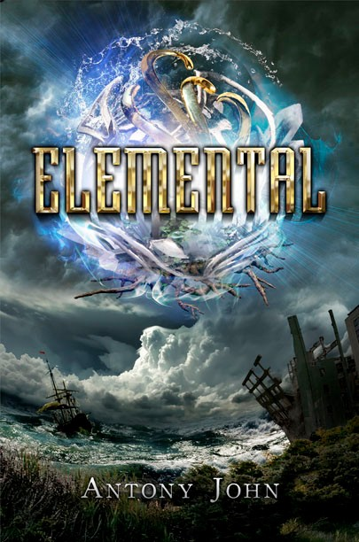
The first two installments in the ELEMENTAL trilogy

ELEMENTAL (Book 1) & FIREBRAND (Book 2)

Reviews and Praise for ELEMENTAL

“An absolutely fantastic start to a new series. Completely gripping and full of intrigue, revelation, mystery, and suspense. I highly recommend this book”—James Dashner, New York Times bestselling author of The Maze Runner

“[John] creates engaging characters and provides plenty of mystery, adventure, and action”—Publishers Weekly

“[An] exciting story of survival”—Kirkus Reviews

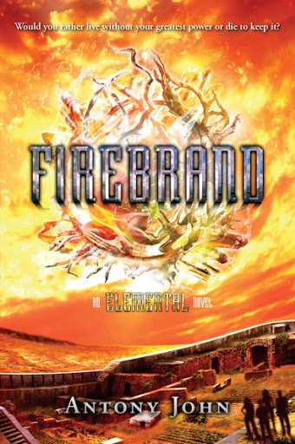
ELEMENTAL
Fall 2012
Teen fiction (12 and up) Dial/Penguin RH (US) ISBN 978-0803736825 HC
ISBN 9780142425169 PB
FIREBRAND
Fall 2013
Teen fiction (12 and up) Dial/Penguin RH (US) ISBN 978-0803736825 HC

KATE, Lauren TEEN FICTION

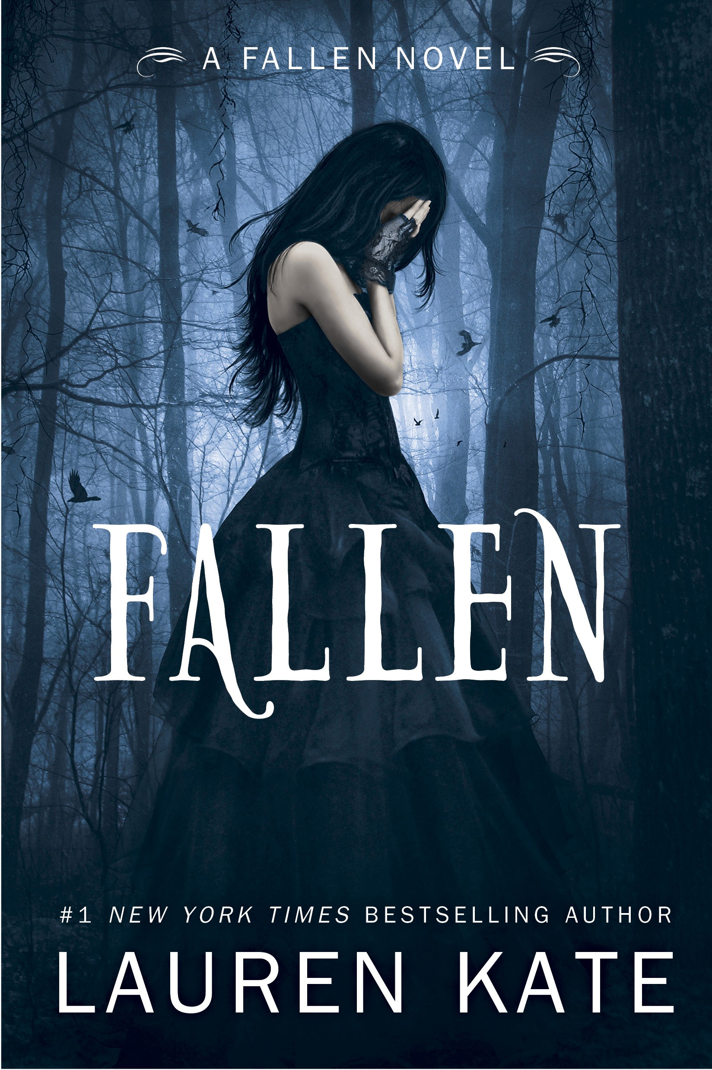
The worldwide bestsellers that inspired the recent motion picture

FALLEN
The spellbinding sequence of FALLEN novels, in which angels and demons battle over the fate of the earth—and one girl’s heart—has just been released in theaters around the world by Mayhem Pictures/Inferno Entertainment.

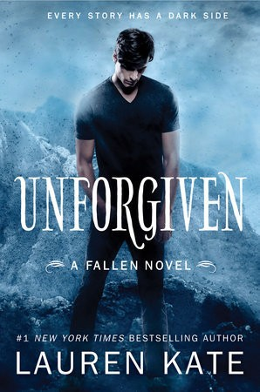
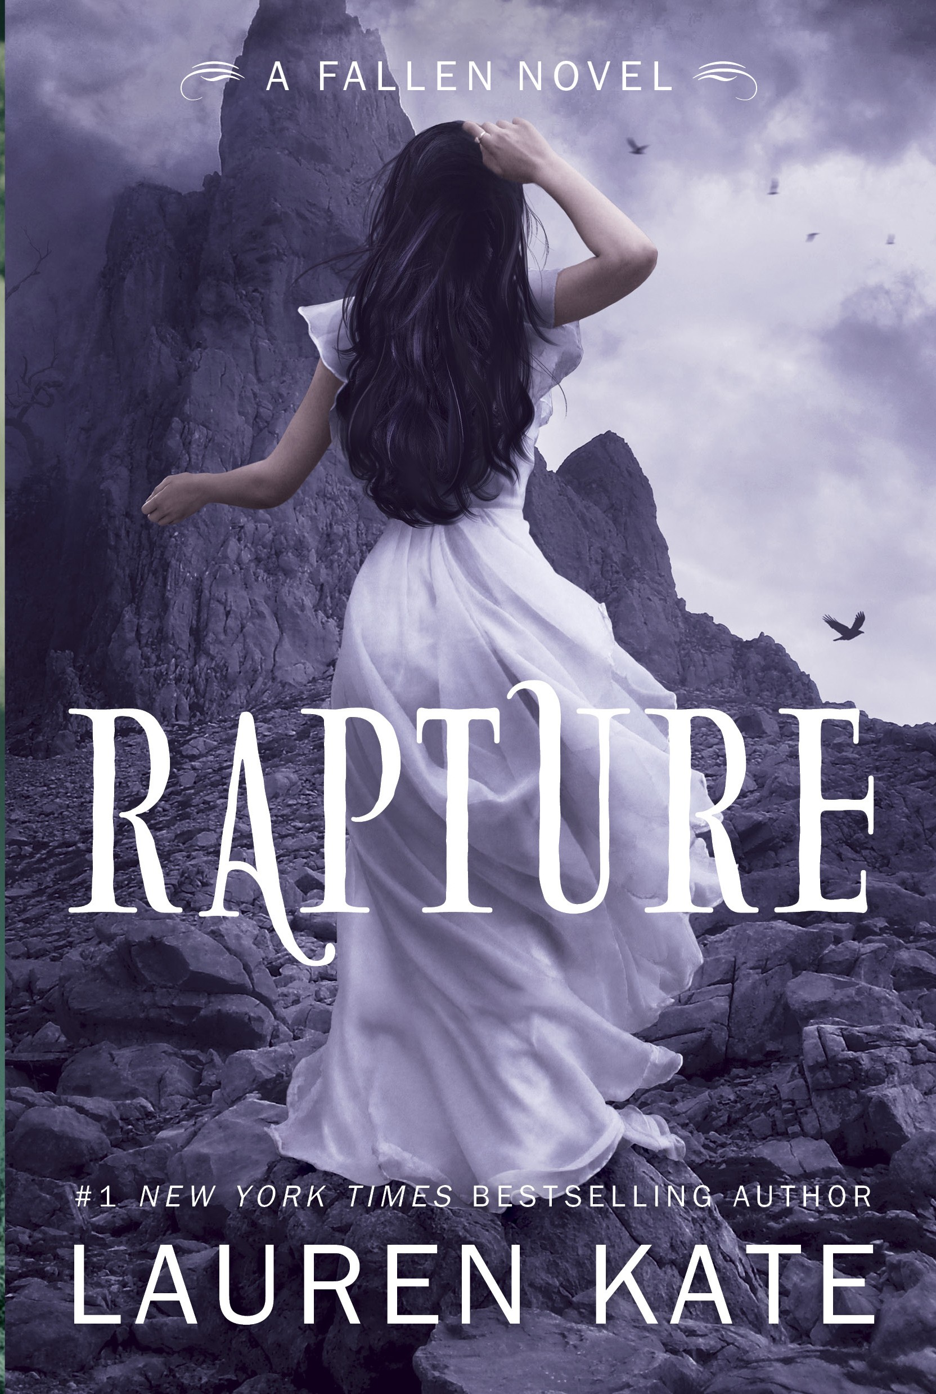
The internationally bestselling series
FALLEN, TORMENT, PASSION, RAPTURE, FALLEN IN LOVE & UNFORGIVEN

FALLEN (Book 1)
December 2009
Hardcover 978-0385738934
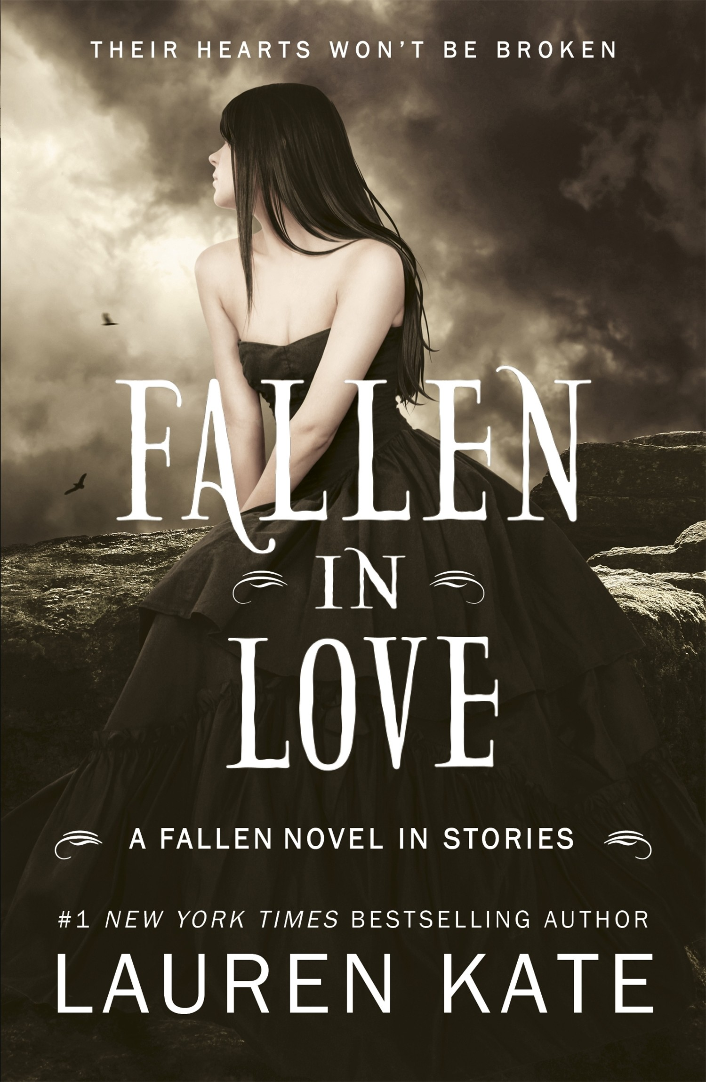
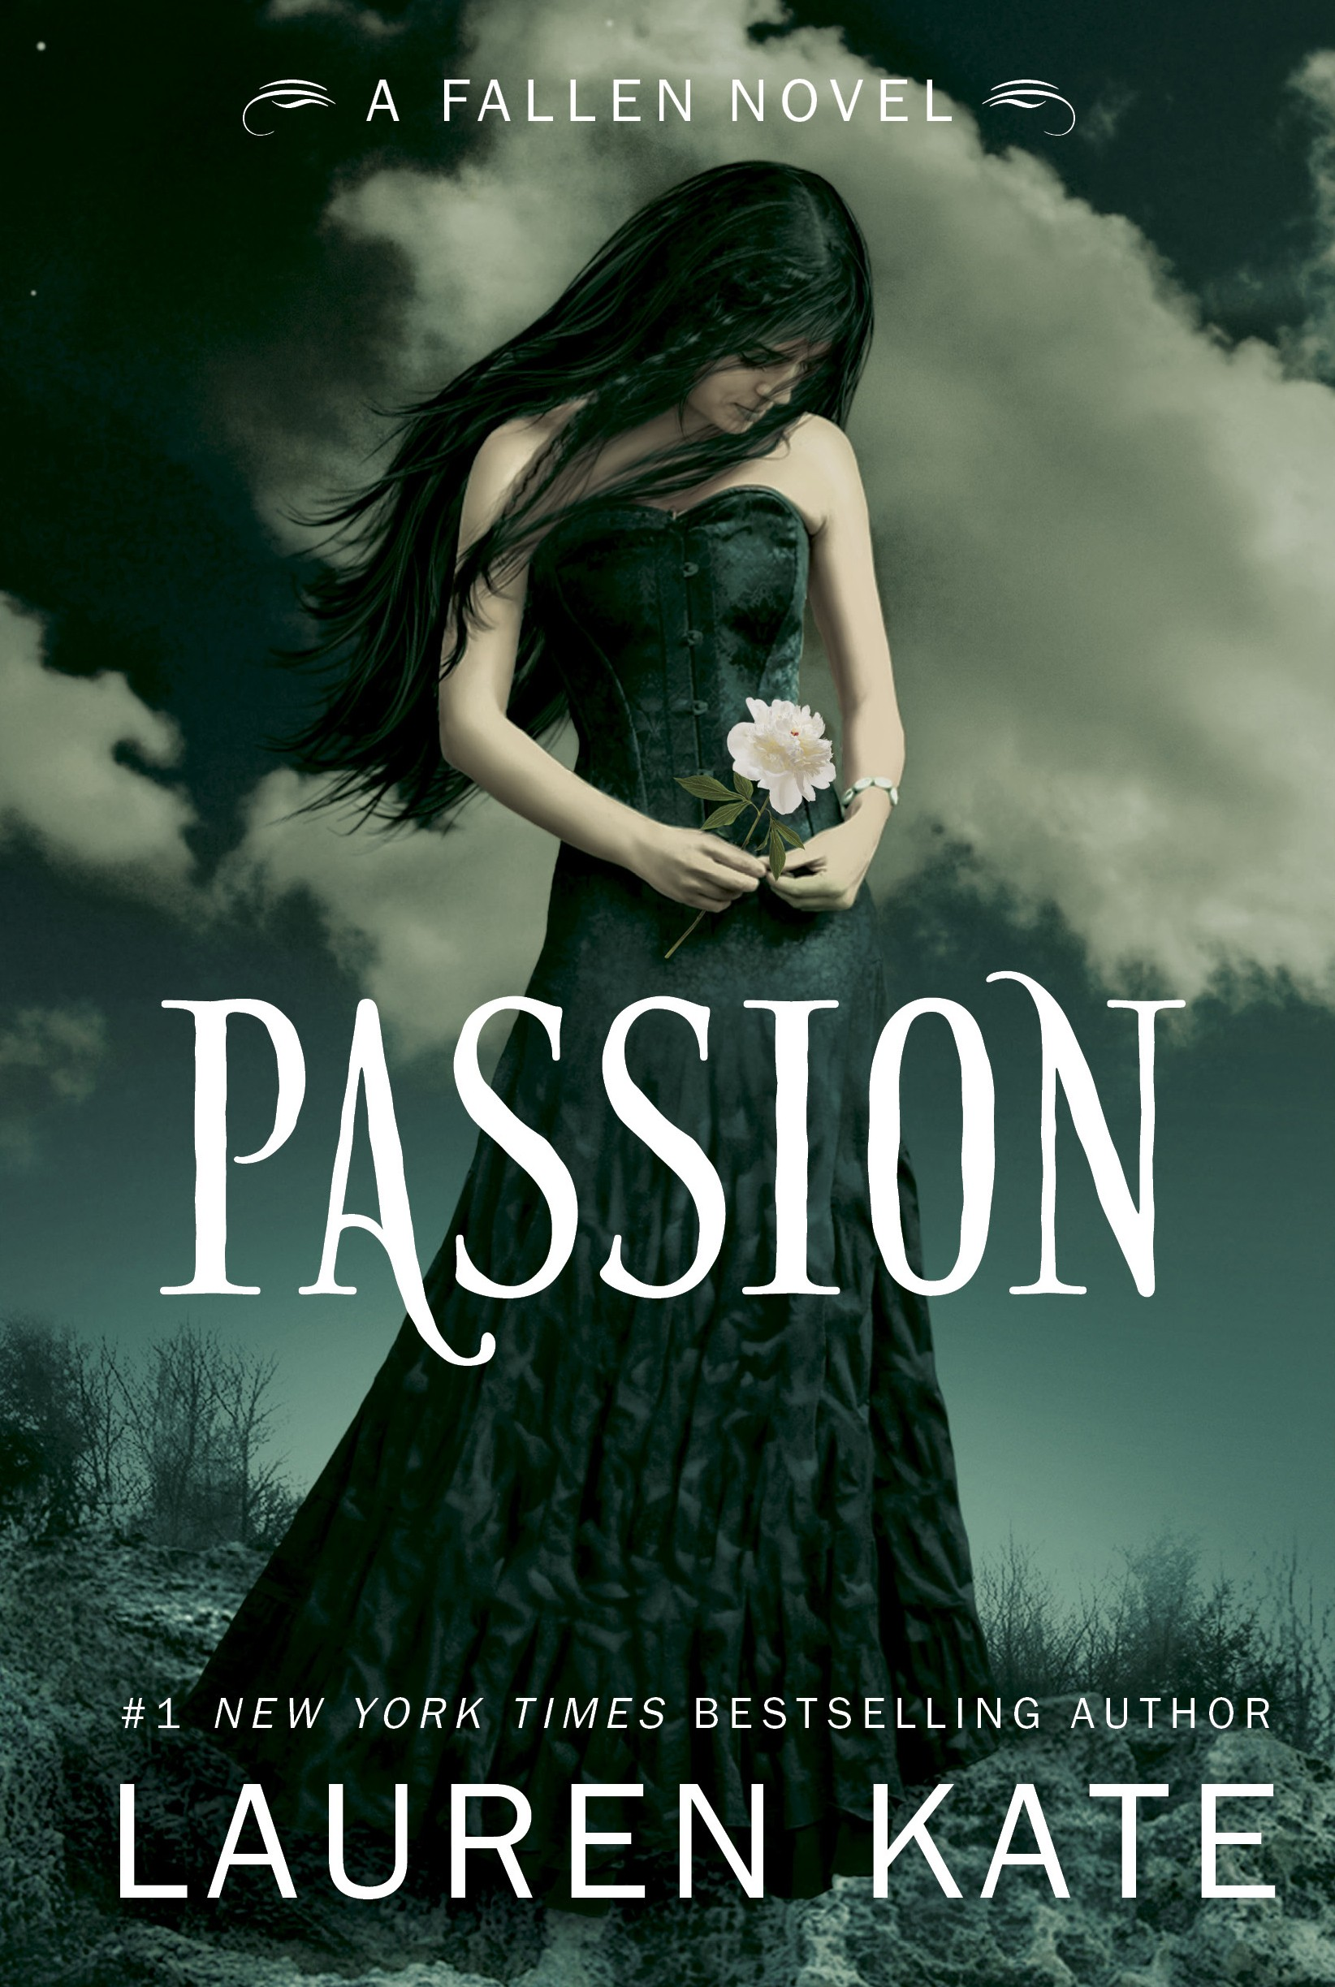
Paperback 978-0385739139

PASSION (Book 3)
June 2011
Hardcover 978-0385739160
Paperback 978-0385739177

RAPTURE (Book 4)
June 2012
Random House/Delacorte (US) Hardcover 978-0385739184
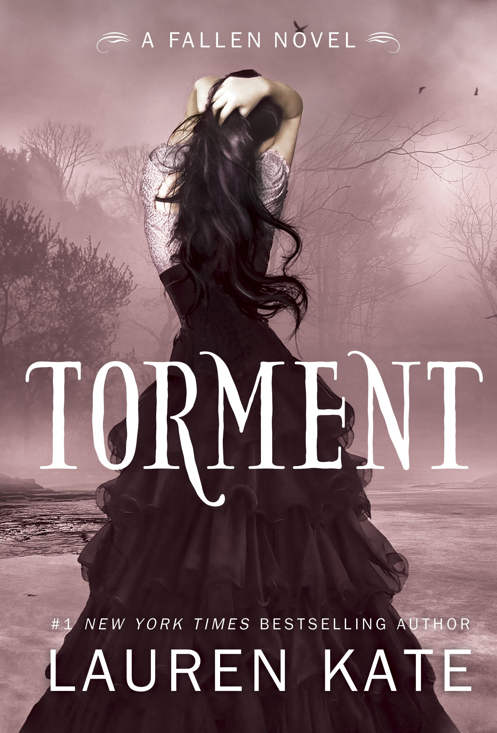
Paperback 978-0385739191
TORMENT (Book 2)
September 2010
Hardcover 978-0385739146
Paperback 978-0385739153

FALLEN IN LOVE (Book 3.5)
January 2012
Hardcover 978-0385742610
Paperback 978-0385742627

UNFORGIVEN (Book 5)
Fall 2015
Teen fiction (12 and up) Random House/Delacorte (US) Hardcover ISBN tk

Rights Information: Brazil (Editora Record), Bulgaria (Intense/Locus Books), Catalan language (Grup Editorial 62, China (Citic), Croatia (Zansje), Czech Republic (Euromedia), Denmark (Tellerup), Estonia (Pegasus), Film/Television (Mayhem Pictures/Inferno), Finland (WSOY), France (Bayard), Germany (Bertelsmann), Greece (Psichogios Publications), Hungary (Könyvmoly), Indonesia (PT Gramedia Pustaka Utama), Israel (Hakibbutz Hameuhad), Italy (Rizzoli), Japan (Softbank), Korea (Random House Korea), Latvia (Zvaigzne ABC), Lithuania (Media Incognito), Macedonia (Prosvetno Delo), Netherlands/Dutch language (Van Goor), Poland (MAG), Portugal (Planeta), Romania (Editura Litera), Russia (Eksmo), Serbia (Evro-Giunti), Slovak Republic (IKAR), Slovenia (Zalozba Alicia), Spain (RH/Mondadori), Taiwan (Sun Color Culture), Thailand (Post), Turkey (Epsilon), UK Audio (RHUK), US Audio (Listening Library), UK (RHUK (Doubleday), Vietnam (Tan Viet)

Inquiries: rights@upstartcrowliterary.com p. 25

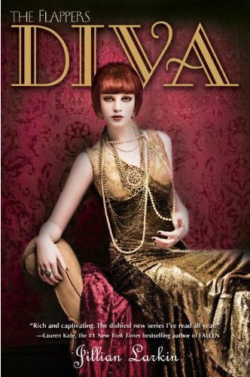

July 2012
LARKIN, Jillian TEEN FICTION
Teen fiction (12 and up) Random House/Delacorte (US) ISBN 978-0385740418 HC
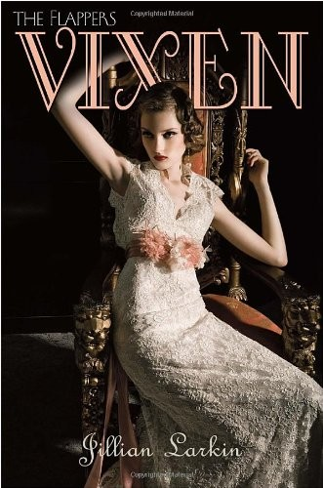
ISBN 978-0385740425 PB

The conclusion of the sexy, dangerous, and ridiculously romantic series

DIVA: THE FLAPPERS, BOOK 3
Jillian Larkin

Parties, bad boys, speakeasies—life in Manhattan has become a woozy blur for Clara Knowles, Lorraine Dyer, and Gloria Carmody. But all of that is about to change when their best friend, Marcus Eastman, gets engaged.

But the betrothed is not who she appears to be, and uncovering her lies—and stopping the wedding—leads the girls into adventures every bit as scandalous and heady as those in the first two novels.

Jillian Larkin is a graduate of NYU. She works as an assistant literary and film scout in New York City. The Flappers series are her first novels.

Review materials
Finished book

The first two entries in the dishy series about teens in the roaring 20s
VIXEN & INGENUE

“Frothy ... [full of] forbidden romance, followed by betrayal and scandal. Chick lit for the Gossip Girl crowd.”—Publishers Weekly

“Filled with wicked fun.” —Tales of the Ravenous Reader

“The Luxe plus A Great and Terrible Beauty smacked into the 1920s. I really, really loved it.”—Bloggers [Heart] Books

“Everything I hoped it would be—fun, flirty, sexy, naughty, and full of surprises.” —
Examiner.com

“A minxes-and-mayhem cross between Friends and Boardwalk Empire.” —Booklist

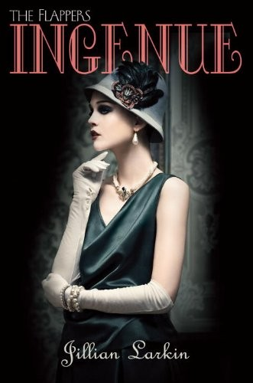
VIXEN (Book 1)
December 2010
Teen fiction (12 and up) Random House/Delacorte (US)
Hardcover ISBN 978-0385740340
Paperback ISBN 978-0385740357
INGENUE (Book 2)
August 2011
Teen fiction (12 and up) Random House/Delacorte (US)
Hardcover ISBN 978-0385740364
Paperback ISBN 978-TK

Rights Information: NA (RH/Delacorte), Audio US (Listening Library), UK (RH/Corgi), France (Bayard), Turkey (Epsilon Yayincilik), Russia (Family Leisure Club)

Inquiries: rights@upstartcrowliterary.com p. 26

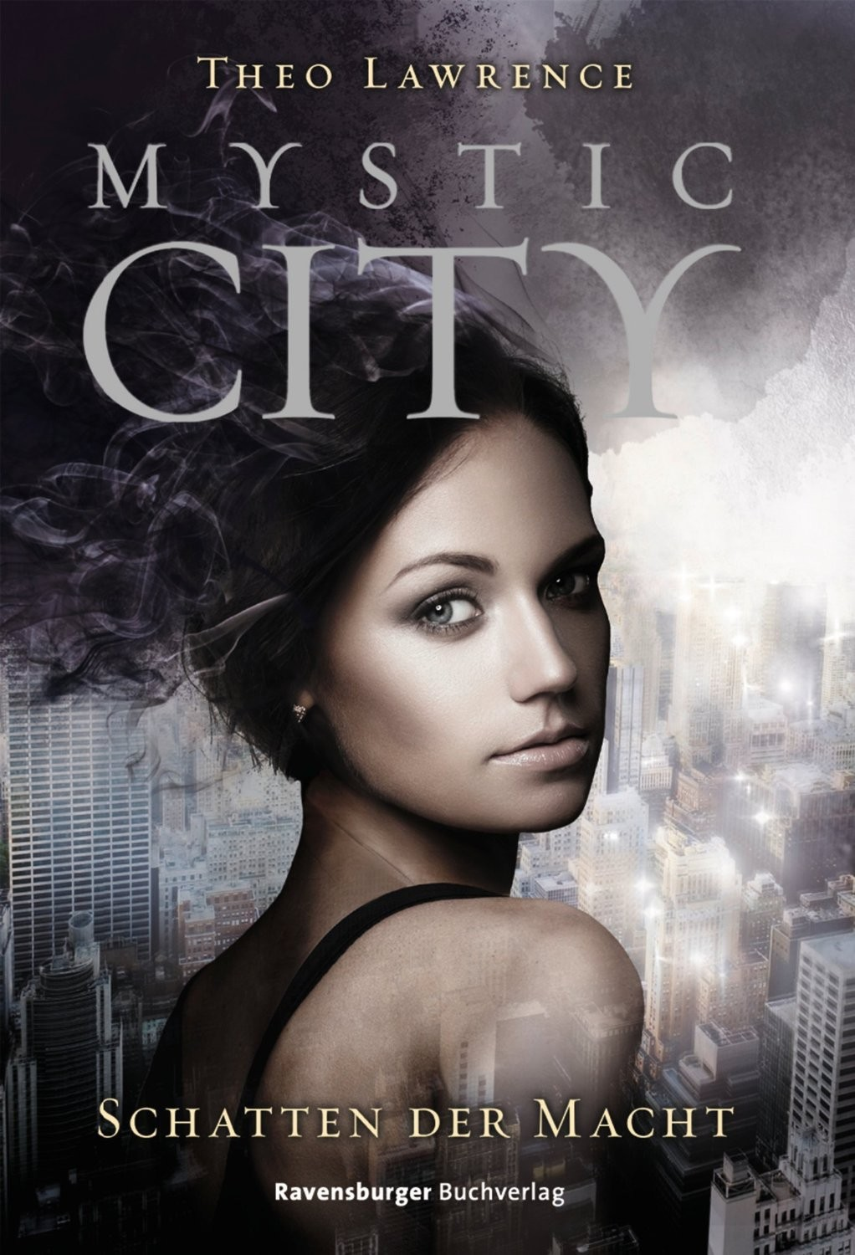
Teen fiction (12 and up)
LAWRENCE, Theo TEEN FICTION

The stunning conclusion of the Mystic City trilogy

BODY ELECTRIC, BOOK 3
Theo Lawrence

Aria Rose now has mystic powers surging through her body, all thanks to the powerful mystic heart she ingested. But with great power comes great danger, as the energy coursing through Aria’s veins is actually killing her.

Along with the mystic rebels, Aria must use her remaining time in Manhattan to stop her brother Kyle from destroying the city and everything she cares about—all before she takes her very last breath.

The stunning conclusion of the Mystic City trilogy is sure to leave readers breathless.

Theo Lawrence lives in New York City. Mystic City was his debut novel.

Delacorte/Penguin Random House (US)
ISBN TK

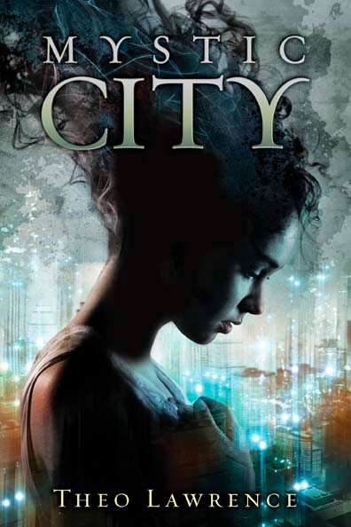
The first two entries in the romantic MYSTIC CITY trilogy
MYSTIC CITY and TOXIC HEART

"An electric, futuristic fantasy with loads of action, heartbreak and one delicious gold-lamé cat suit.”—Kirkus

"This novel is for fans of mind games, rebels, heartache and intrigue.”—USAToday.com

"A gripping Romeo-and-Juliet exploration of deception, espionage, revolution, the greater good and love conquering all—with the aid of magical green lights and a peculiar little locket.”—Kirkus

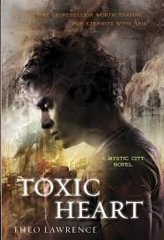
Mystic City (Book 1) October 2012
Teen fiction (12 and up)
Penguin Random House/Delacorte (US) Hardcover ISBN 978-0385741606
Paperback ISBN 978-0385741613
TOXIC HEART (Book 2)
April 2014
Teen fiction (12 and up)
Penguin Random House/Delacorte (US) Hardcover ISBN 978-0385741620
Paperback ISBN 978-0385741637

Rights Information: NA (Random House/Delacorte), NA Audio (Recorded Books), UK/AUS (Random House UK), Spain (Random House Mondadori), Brazil (Novo Conceito), France (Pocket Jeunesse), Germany (Ravensburger), Italy (Mondadori), Complex Chinese (Sharp Point), Poland (Mag), Finland (Korisko)

Inquiries: rights@upstartcrowliterary.com Film/TV inquiries: CAA p. 27

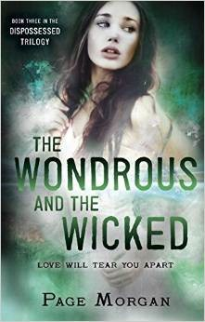
April 2015
MORGAN, Page TEEN FICTION
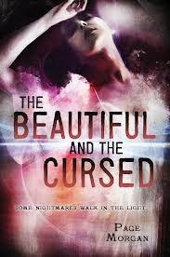
Teen fiction (12 and up) Delacorte/PRH (US) ISBN 978-038574315 HC

The conclusion of The Dispossessed trilogy for fans of Lauren Kate
THE WONDROUS AND THE WICKED, BOOK 3
Page Morgan

Targeted by vengeful gargoyles, Gabby has been exiled to London for her own protection. Meanwhile, the gargoyle castes are in disarray, divided between those who want Luc to lead them and those who resent him and his fondness for humans. The Alliance is crumbling from the inside as well, its members turning against one another, and possibly against the Waverlys, too.

Axia has promised that the world will burn. And now, unable to trust the Alliance, separated from Luc, Gabby, and her twin, Grayson, Ingrid is left to face the demon uprising alone.

Page Morgan has been fascinated with les grotesques ever since she came across an old black-and-white photograph of a Notre Dame gargoyle. Page lives in New Hampshire with her husband and their three children.

The first two entries in the heart-stopping Dispossessed trilogy
THE BEAUTIFUL & THE CURSED (Book 1) and THE LOVELY & THE LOST (Book 2)
“Forbidden romance and hot kissing abound.”—Kirkus Reviews

“Emotions and atmosphere are perfectly conveyed.”—SLJ

“Combines fantasy with gothic romance in this well-crafted standout.”—Booklist

“Has the magnetic attributes necessary to fuel a successful series.”—Barnes and Noble, editor’s recommendation

“Morgan expands the paranormal genre with her creative twists on the fine line separating the supernatural from the human.”—VOYA

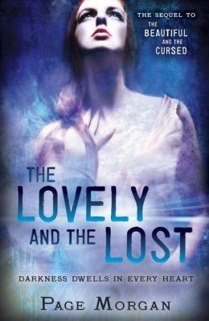
THE BEAUTIFUL AND THE CURSED (Book 1) May 2013
Teen fiction (12 and up)
Penguin Random House/Delacorte (US) ISBN 978-0385743112 HC
ISBN 978-0385743129 PB

THE LOVELY AND THE LOST (Book 2) May 2014
Teen fiction (12 and up)
Penguin Random House/Delacorte (US) ISBN 978-0385743136 HC
ISBN 978-0385743143

Rights Information: US (Delacorte/Random House); US Audio (Listening Library); UK/AUS (Hot Key); Germany (Heyne); France (Bayard); Spain (RH Mondadori); Portugal (Planeta)

Inquiries: rights@upstartcrowliterary.com Film/TV inquiries: CAA p. 28

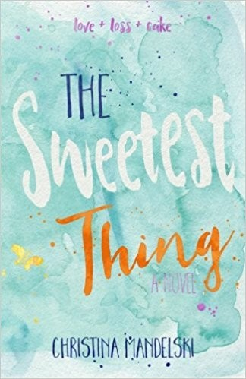
May 2011
MANDELSKI, Christina TEEN FICTION
Teen fiction (10 and up) Egmont (US)
ISBN 978-1606841297 HC

A funny, sweet, smart debut a la Sarah Dessen...

THE SWEETEST THING
Christina Mandelski

A genius at the art of decorating cakes, teen Sheridan Wells is less-than-brilliant at the art of life—she keeps choosing the wrong boy, the wrong friends, and the wrong ways to track down the absentee mother she is certain will fix everything in her life that’s gone wrong. As her father’s restaurant becomes the focus of a reality TV show, Sheridan finds herself in trouble with everyone she loves.

Christina Mandelski lives in Texas. The Sweetest Thing is her debut. www.christinamandelski.com

“Family drama, cute boy drama, and lots of cake (drama) make this a sweet read.”—Fresh Fiction

“Aimed squarely at teenage girls, this sensitive story explores the need to embrace the reality rather than the fantasy of love.”—Kirkus Reviews

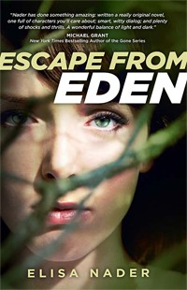
August 2013
NADER, Elisa TEEN FICTION
Teen fiction (12 and up) Adams/Merit (US)
ISBN 978-1440563928 HC

A page-turning suspense thriller about life in a cult

ESCAPE FROM EDEN

Elisa Nader

Sixteen-year-old Mia spent her life in a religious commune called Edenton, but has always questioned the teachings of the Reverend. Gabriel is a new arrival, and when he persuades Mia to sneak out, they discover the commune is based on a secret more sinister than she could have imagined.

As Edenton’s scandalous secrets unravel, Mia must race against the clock to save her family and friends and battle against the only world she’s ever known.

Elisa Nader is a writer and web designer. www.elisanader.com

« [Escape from Eden’s] rewards are many; fast-moving action, a capable heroine and a resolution that leaves plenty of room for a sequel. Gripping.” –Kirkus, starred review

Inquiries: rights@upstartcrowliterary.com p. 29

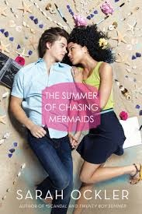

June 2015
OCKLER, Sarah TEEN FICTION
Teen fiction (12 and up)
Simon and Schuster/Simon Pulse (US) ISBN 978-1481401272 HC
ISBN 978-1481401289 PB

A romantic teen novel from the author of Twenty Boy Summer

THE SUMMER OF CHASING MERMAIDS
Sarah Ockler

Elyse d’Abreau was destined for stardom—until a boating accident took everything from her. Now, the most beautiful singer in Tobago can’t sing. She can’t even speak.

Seeking quiet solitude, Elyse accepts a friend’s invitation to Oregon’s seaside town, Atargatis Cove. There she meets Christian Kane, a notorious playboy who may be the only person who can help Elyse find her inner voice. But can she trust him with her heart?

Sarah Ockler is the author of Twenty Boy Summer, Fixing Delilah, Bittersweet, The Book of Broken Hearts, and #scandal. www.sarahockler.com

“Lyrical and authentic... Ockler's breezy, seaside romance offers a modern spin on the classic tale of 'The Little Mermaid.'"—School Library Journal

"Elyse's journey and struggles to assimilate her disability—portrayed with compassion and insight—are compelling and original. A beach read with depth that will keep readers engaged.”—Kirkus Reviews

June 2014
OCKLER, Sarah TEEN FICTION
Teen fiction (12 and up) S&S/Pulse (US)
ISBN 978-1481401246 HC
ISBN 978-1481401258 PB

Love in the time of social media …

#scandal

Sarah Ockler

When a Facebook scandal explodes, it’s up to Lucy to deal with her newfound reputation at school, and her Hollywood sister’s return home—all while staying true to herself.

Sarah Ockler is the bestselling author of Twenty Boy Summer, Fixing Delilah, and
Bittersweet. She lives in Colorado. www.sarahockler.com

“The classic "I'm in love with my best friend's boyfriend" story with a 21st-century twist and lots of heart.”—School Library Journal

Rights Information: NA (Simon Pulse), NA Audio (Listening Library), France (Nathan), Germany (Bertelsmann)

Inquiries: rights@upstartcrowliterary.com p. 30

January 2012
OCKLER, Sarah TEEN FICTION
Teen fiction (12 and up) S&S/Pulse (US)
ISBN 978-1442430358 HC
ISBN 978-1442430365 PB

A small-town girl with Olympic-sized ice-skating dreams...
BITTERSWEET

Sarah Ockler

When her father took off three years ago, Hudson Avery put her expensive figure skating dreams on ice, taking refuge in a mixing bowl in Mom’s fading rustbelt diner. Now, a skating competition for a scholarship rekindles her dreams—this could be her golden ticket to a better tomorrow. But Hudson faces an impossible decision: go for the gold? or sacrifice her last shot at a pro-skating career to save her broken family and the diner?

Sarah Ockler is the bestselling author of Twenty Boy Summer and Fixing Delilah. She lives in Colorado. www.sarahockler.com

ALA Best Fiction for Young Adults nominee “Heart-wrenchingly real.”—Publishers Weekly
“An entertaining read with an engaging, relatable protagonist.”—Booklist

“Bittersweet is a book worth recommending.”—School Library Journal

May 2013
OCKLER, Sarah TEEN FICTION
Teen fiction (12 and up) S&S/Pulse (US)
Hardcover ISBN: 978-1442430389

A contemporary love story for fans of Elkeles’ Perfect Chemistry

THE BOOK OF BROKEN HEARTS

Sarah Ockler

Jude has learned a lot from her older sisters, but the most important thing is this: The Vargas brothers are notorious heartbreakers. Never date one.

Now Jude is spending the summer helping her ailing father restore his vintage motorcycle—which means hiring a mechanic to help out. Is it Jude’s fault he happens to be cute? And surprisingly sweet? And a Vargas?

When it comes to love, some promises might be worth breaking.

“An emotional read about the power, love, and support of family.”—Booklist “[A] frequently humorous and often touching coming-of-age story.”—SLJ

Rights sold: US (Simon Pulse); US Audio (Listening Library); Germany (Bertelsmann Juvenile); France (La Martiniere)

Inquiries: rights@upstartcrowliterary.com p. 31

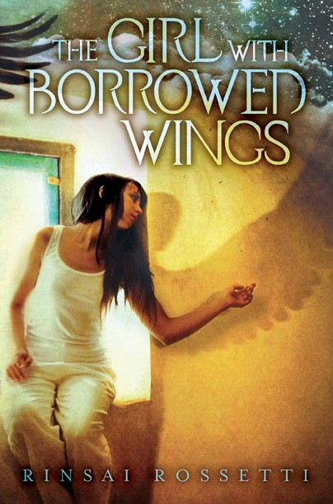

Summer 2012
ROSSETTI, Rinsai TEEN FICTION
Teen fiction (12 and up) Penguin/Dial (World English) ISBN 978-0803735668 HC

A riveting love story with a magical twist

THE GIRL WITH BORROWED WINGS
Rinsai Rossetti

Sixteen year-old westerner Frenenqer Paje’s life in the Middle East is a series of cages, but Frenenqer’s life changes forever when she rescues a dying cat from the marketplace. The cat is actually a boy named Sangris, and the two embark on many nighttime adventures. But when their friendship blossoms into something more, Frenenqer must face her greatest fear—her father—or risk losing Sangris forever.

Rinsai Rossetti lives in France. www.rinsairossetti.com

Booklist Best Books of 2012 * Kirkus Best Books of 2012

- “With taut, lush writing a stunningly imagined setting, and a premise that’s unique, this one feels like a breeze in the desert.” –Booklist, starred review

«"A breath of fresh air.”—Publishers Weekly, starred review

- “Infused with an urgent hope, this glimmering love story exhilarates and refreshes.” –
Kirkus, starred review

SAMPSON, Jeff TEEN FICTION

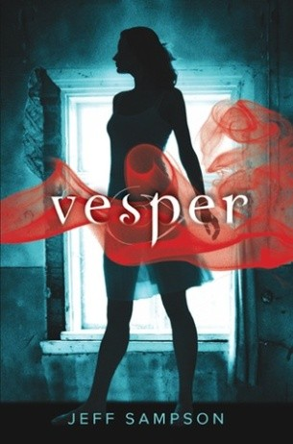
The pulse-pounding DEVIANTS trilogy
VESPER & HAVOC & RAVAGE

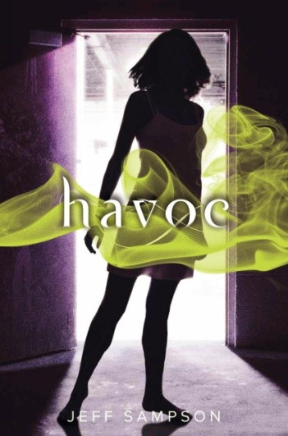
Emily Webb is a geek. She’s never been the kind of girl who sneaks out for midnight parties or . who starts fights with strangers. Until one night Emily finds herself doing exactly that . . . the same night one of her classmates—also named Emily—is found mysteriously murdered. Emily doesn’t know why she’s doing any of this. And suddenly her body can do things it never could before: she is now strong, fast, and utterly fearless. Is she bewitched by the soul of the other, murdered Emily? Or is Emily Webb becoming something else entirely— something not human?

“Sampson’s quick-paced YA debut … should leave readers eager for the next book.”—
Publishers Weekly

“Addictive and surprising. I couldn’t wait for night to fall to see what Emily would do next!”—
Lauren Kate, New York Times bestselling author of Fallen

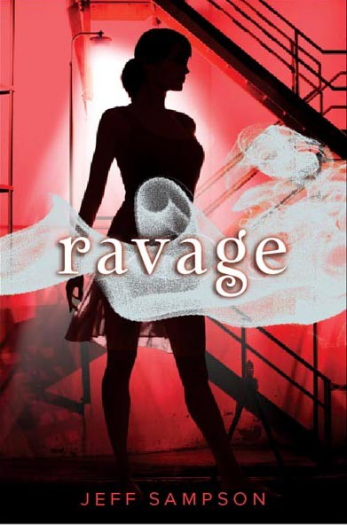
“Exciting, witty, and impossible to put down. The best kind of page turner.”—Michael Grant,
New York Times bestselling author of the Gone series

VESPER (book one) January 2011
Teen fiction (12 and up) HarperCollins Children's (US) ISBN 978-0061992766 HC
ISBN 978-0061992773 PB
HAVOC (book two) January 2012
Teen fiction (12 and up) HarperCollins Children's (US) ISBN 978-0061992780 HC
RAVAGE (book two) January 2013
Teen fiction (12 and up) HarperCollins Children's (US) ISBN 978-0061992803 HC

Rights Information: US (HarperCollins/Balzer + Bray), France (Milan/Bayard), Germany (Blanvalet), Turkey (Epsilon)

Inquiries:rights@upstartcrowliterary.com p. 32

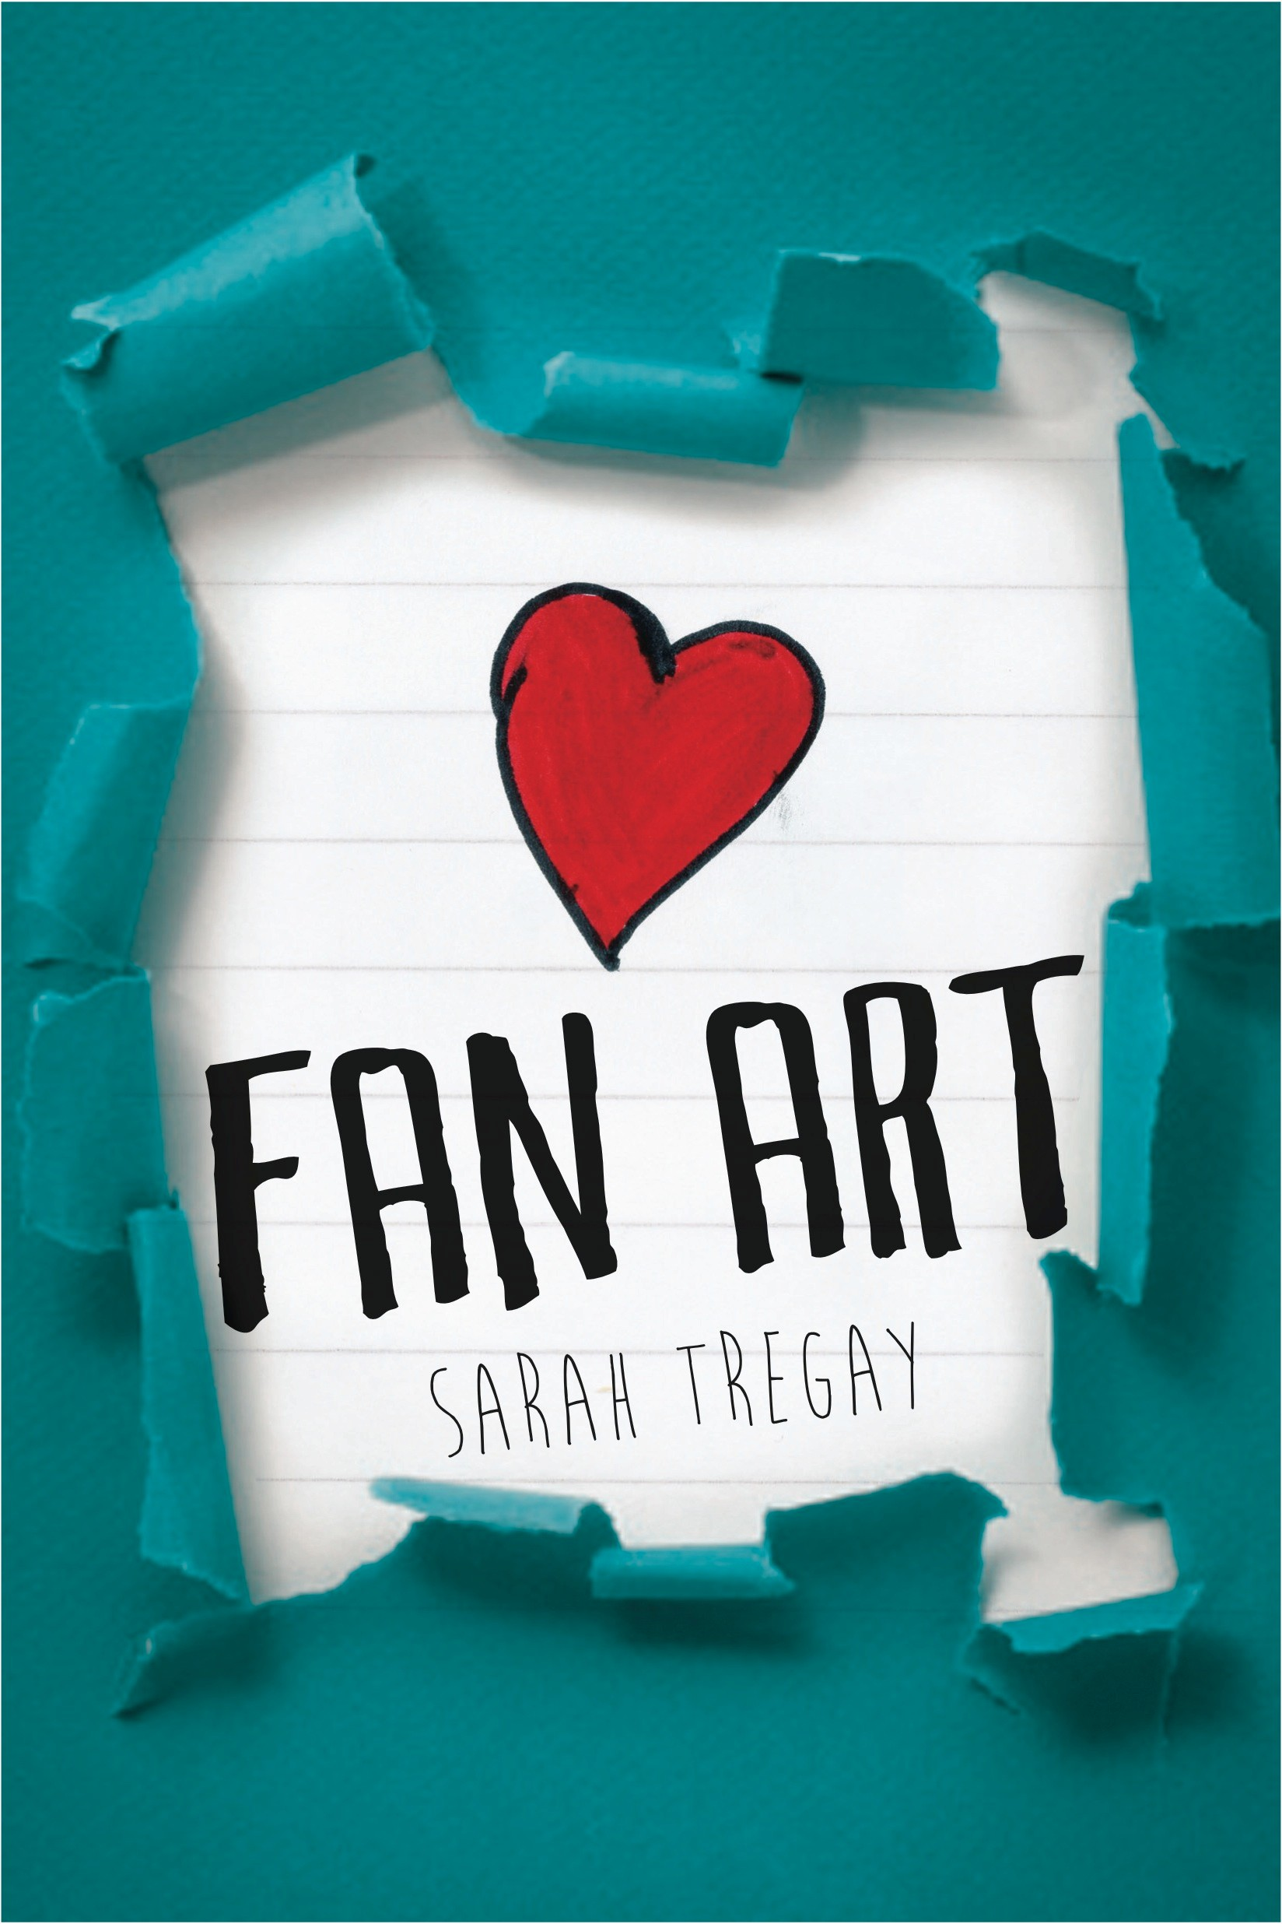

Spring 2015
TREGAY, Sarah TEEN FICTION
Teen fiction (12 and up) HarperCollins/ Tegen Books ISBN 978-0062243157 HC
ISBN 978-0062243164 PB
TREGAY, Sarah TEEN FICTION

A picture is worth a thousand words…

FAN ART

Sarah Tregay
Jamie has one goal at the end of his senior year: come out to his best friend Mason. Except lately, Jamie’s feelings for Mason are much more than friendly, leaving him tongue-tied.

When a friend’s romantic drawing of Jamie and Mason falls into the wrong hands and causes a scandal at graduation, Jamie must face the entire school as his true self. Will his best friend hate him forever, or maybe—just maybe— Mason is ready to admit some secrets of his own?

“A breezy romance with just enough light drama to keep its feet on the ground.”—Booklist

Sarah Tregay is the author of the novel-in-verse Love and Leftovers, a YALSA 2013 Best Fiction selection. She lives in Idaho. www.sarahtregay.com

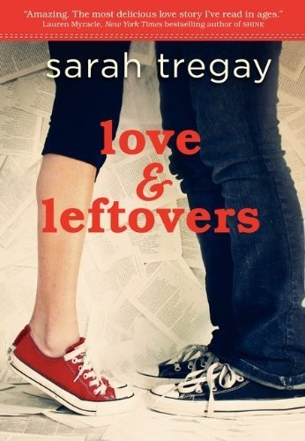
Spring 2014
Teen Fiction (12 and up) Katherine Tegen Books (NA) ISBN 9780062023605 PB

Sarah Tregay’s acclaimed debut

LOVE AND LEFTOVERS
Over summer break, Marcie Foster trades her friends—a group of freaks and geeks called the Leftovers—for a cute jock with a Prince Harry grin.

Praise for Love and Leftovers

YALSA Best Fiction for Young Adults 2013 Selection

« “A realistic look at the emotional roller coaster that is first love.” —School Library Journal, starred review

“This first novel may make teenage readers’ hearts beat a bit faster.” –Booklist “A verse novel with real depth to accompany all that white space.” –Kirkus
“Although the words are simple, the themes of Love and Leftovers are not.” –VOYA

“[Marcie’s] story is thus as credible as her voice, and readers will relate to her complicated but accessible heartbreak.”—BCCB

Inquiries: rights@upstartcrowliterary.com p. 33

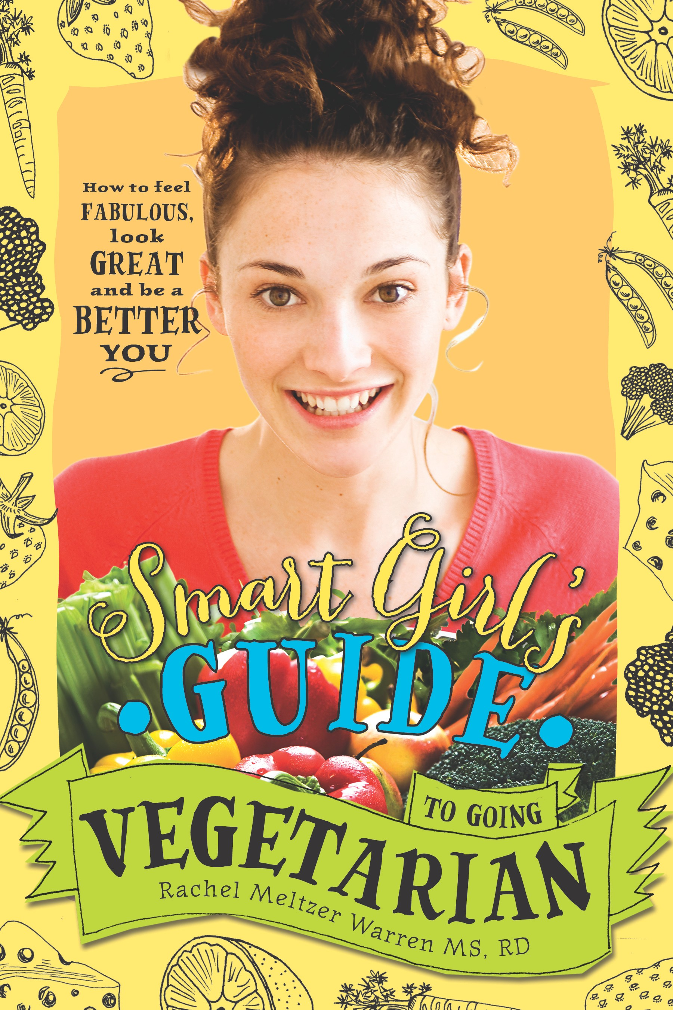
Spring 2014
WARREN, Rachel Meltzer TEEN NONFICTION
Teen Nonfiction (12 and up) Sourcebooks (World English) ISBN 978-1402284915 PB

Look fabulous, feel great, and be a better you

THE SMART GIRL’S GUIDE TO GOING VEGETARIAN
Rachel Meltzer Warren

In this helpful book, dietitian Rachel Meltzer Warren guides veg-curious readers through the social, familial, and nutritional steps of becoming a vegetarian. Filled with fun quizzes, real-world advice about making smart food choices at school (and everywhere else), this book is the perfect tool to help young readers make empowered decisions about their health and their diets.

Rachel Meltzer Warren is a registered dietitian (RD) and nutrition writer. www.smartgirlveg.com

“An upbeat, informative resource that will come in handy for many a teen.”—Kirkus Reviews

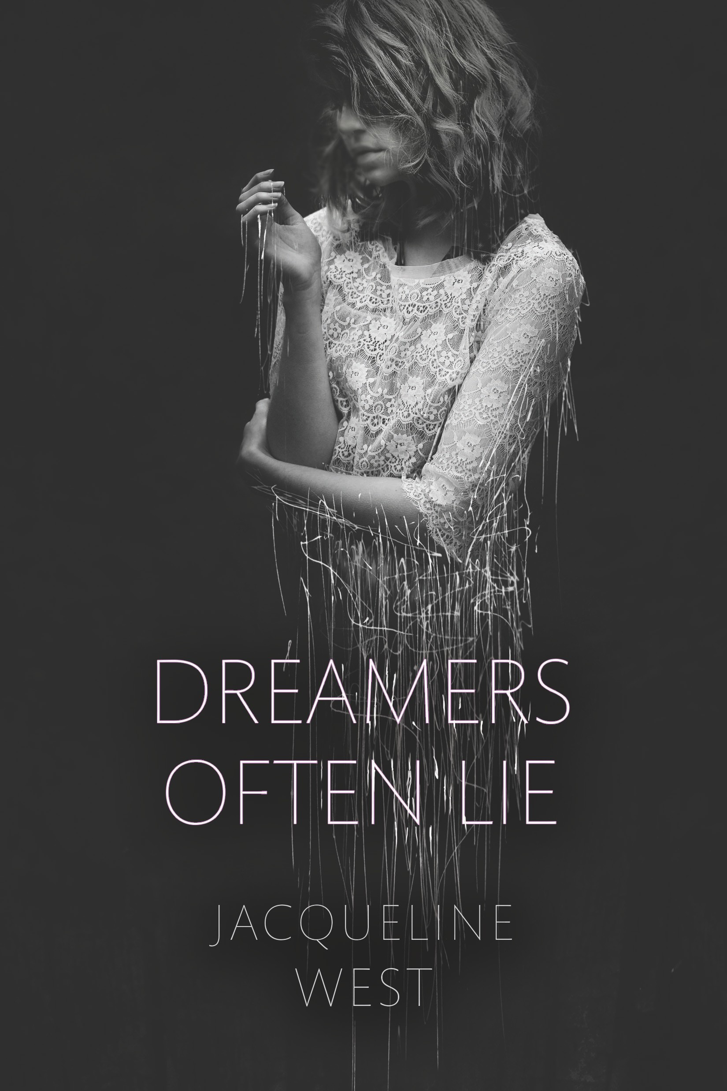

April 2016
WEST, Jacqueline TEEN FICTION
Teen fiction (12 and up) Dial/Penguin RH(US)
ISBN 978-0803738638 HC
ZINN, Bridget TEEN FICTION

The debut teen novel from a New York Times bestseller

DREAMERS OFTEN LIE
Jacqueline West

After a skiing accident, Jaye is left with a splitting headache and strong delusions. She must keep these delusions secret from her family, doctors, and everyone at school in order to keep her starring part in the school production of A Midsummer Night’s Dream — even though visions of Shakespeare and his characters have been following her around. Black Swan meets Romeo and Juliet in this Shakespeare- inspired young adult novel.

Jacqueline West is the author of the middle grade series The Books of Elsewhere and
The Collectors. www.jacquelinewest.com

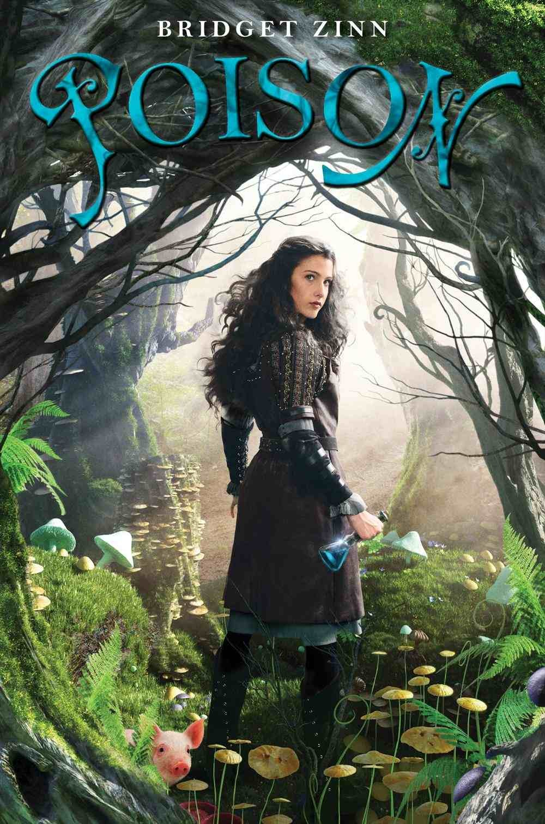

Winter 2013
Teen fiction (12 and up) Disney Hyperion
ISBN 978-1423139935 HC
ISBN 978-1423153306 PB

A girl, a boy, and the magical piglet who brings them together.

POISON
Bridget Zinn

Kyra is a former-potioner-turned-would-be-assassin who intends to kill the princess. Her only help is an enchanted wee piglet. And then on the road she and her pig are joined by a fellow traveler named Fred, who, like Kyra, is much more than he appears.
Bridget Zinn was a part-time librarian. Poison is her first novel. “Extraordinary.”—Jennifer L. Holm, New York Times best-selling author
“No grimdark teen fantasy or angst-y heroines here; just a frothy confection of a fairy tale…. Good silly fun—a refreshing antidote to a genre overflowing with gloom.” —Kirkus Reviews
"Zinn has crafted a marvelous tale, more Harry Potter than Twilight."—The Horn Book

Inquiries: rights@upstartcrowliterary.com p. 34

